Accessibility Report — giftCardSuccess
Tarih: 01.04.2026 10:40 | Platform: ANDROID

Element ID | Page | Type | Label / Text | Value | Resource ID | Status | New Status
giftCardSuccess_element_1 | MainActivity | ViewGroup | Ticket No, 2144202222455 |  |  | ID Yok | ID Eklenecek (Waiting Dev)
giftCardSuccess_element_2 | MainActivity | ViewGroup | Go to Home |  |  | ID Yok | ID Eklenecek (Waiting Dev)
giftCardSuccess_element_3 | MainActivity | View |  |  | statusBarBackground | ID Var
giftCardSuccess_element_4 | MainActivity | View |  |  | navigationBarBackground | ID Var
giftCardSuccess_element_5 | MainActivity | FrameLayout |  |  | content | ID Var
giftCardSuccess_element_6 | MainActivity | LinearLayout |  |  | action_bar_root | ID Var

📸 Ekran Görüntüsü
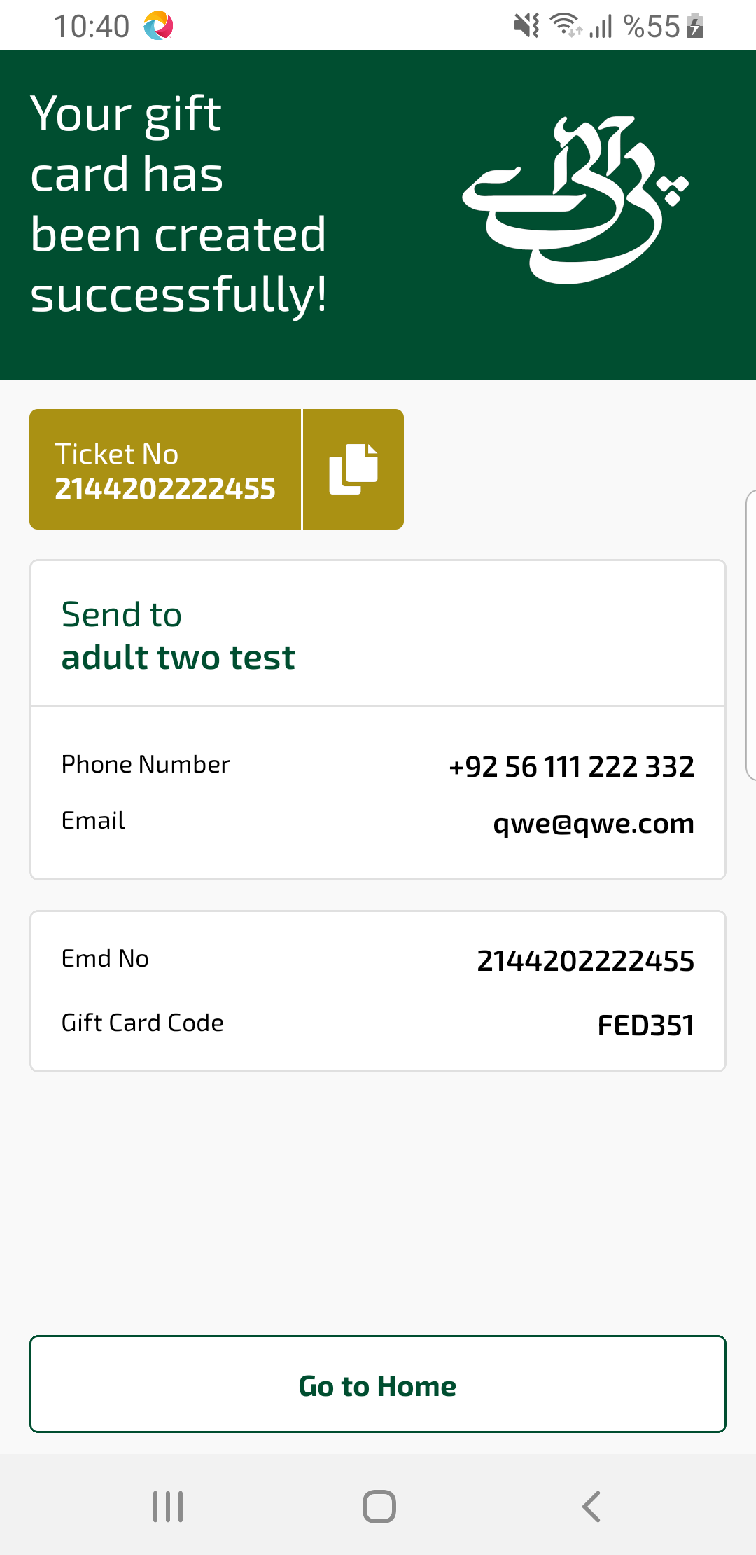
giftCardSuccess sayfası ekran görüntüsü

