Accessibility Report — home
Tarih: 01.04.2026 10:21 | Platform: ANDROID

Element ID | Page | Type | Label / Text | Value | Resource ID | Status | New Status
home_element_1 | MainActivity | View | Home |  |  | ID Yok | ID Eklenecek (Waiting Dev)
home_element_2 | MainActivity | View | Book |  |  | ID Yok | ID Eklenecek (Waiting Dev)
home_element_3 | MainActivity | View | Manage |  |  | ID Yok | ID Eklenecek (Waiting Dev)
home_element_4 | MainActivity | View | Check-in |  |  | ID Yok | ID Eklenecek (Waiting Dev)
home_element_5 | MainActivity | View | Profile |  |  | ID Yok | ID Eklenecek (Waiting Dev)
home_element_6 | MainActivity | ViewGroup | Test Operational Notice For Testing In UAT1 Test Operational Notice For Testing In UAT2 |  |  | ID Yok | ID Eklenecek (Waiting Dev)
home_element_7 | MainActivity | View |  |  | statusBarBackground | ID Var
home_element_8 | MainActivity | View |  |  | navigationBarBackground | ID Var
home_element_9 | MainActivity | ViewGroup |  |  | home_header | ID Var
home_element_10 | MainActivity | ViewGroup |  |  | __CAROUSEL_ITEM_1__ | ID Var
home_element_11 | MainActivity | ViewGroup |  |  | __CAROUSEL_ITEM_0__ | ID Var
home_element_12 | MainActivity | FrameLayout |  |  | content | ID Var
home_element_13 | MainActivity | LinearLayout |  |  | action_bar_root | ID Var

📸 Ekran Görüntüsü
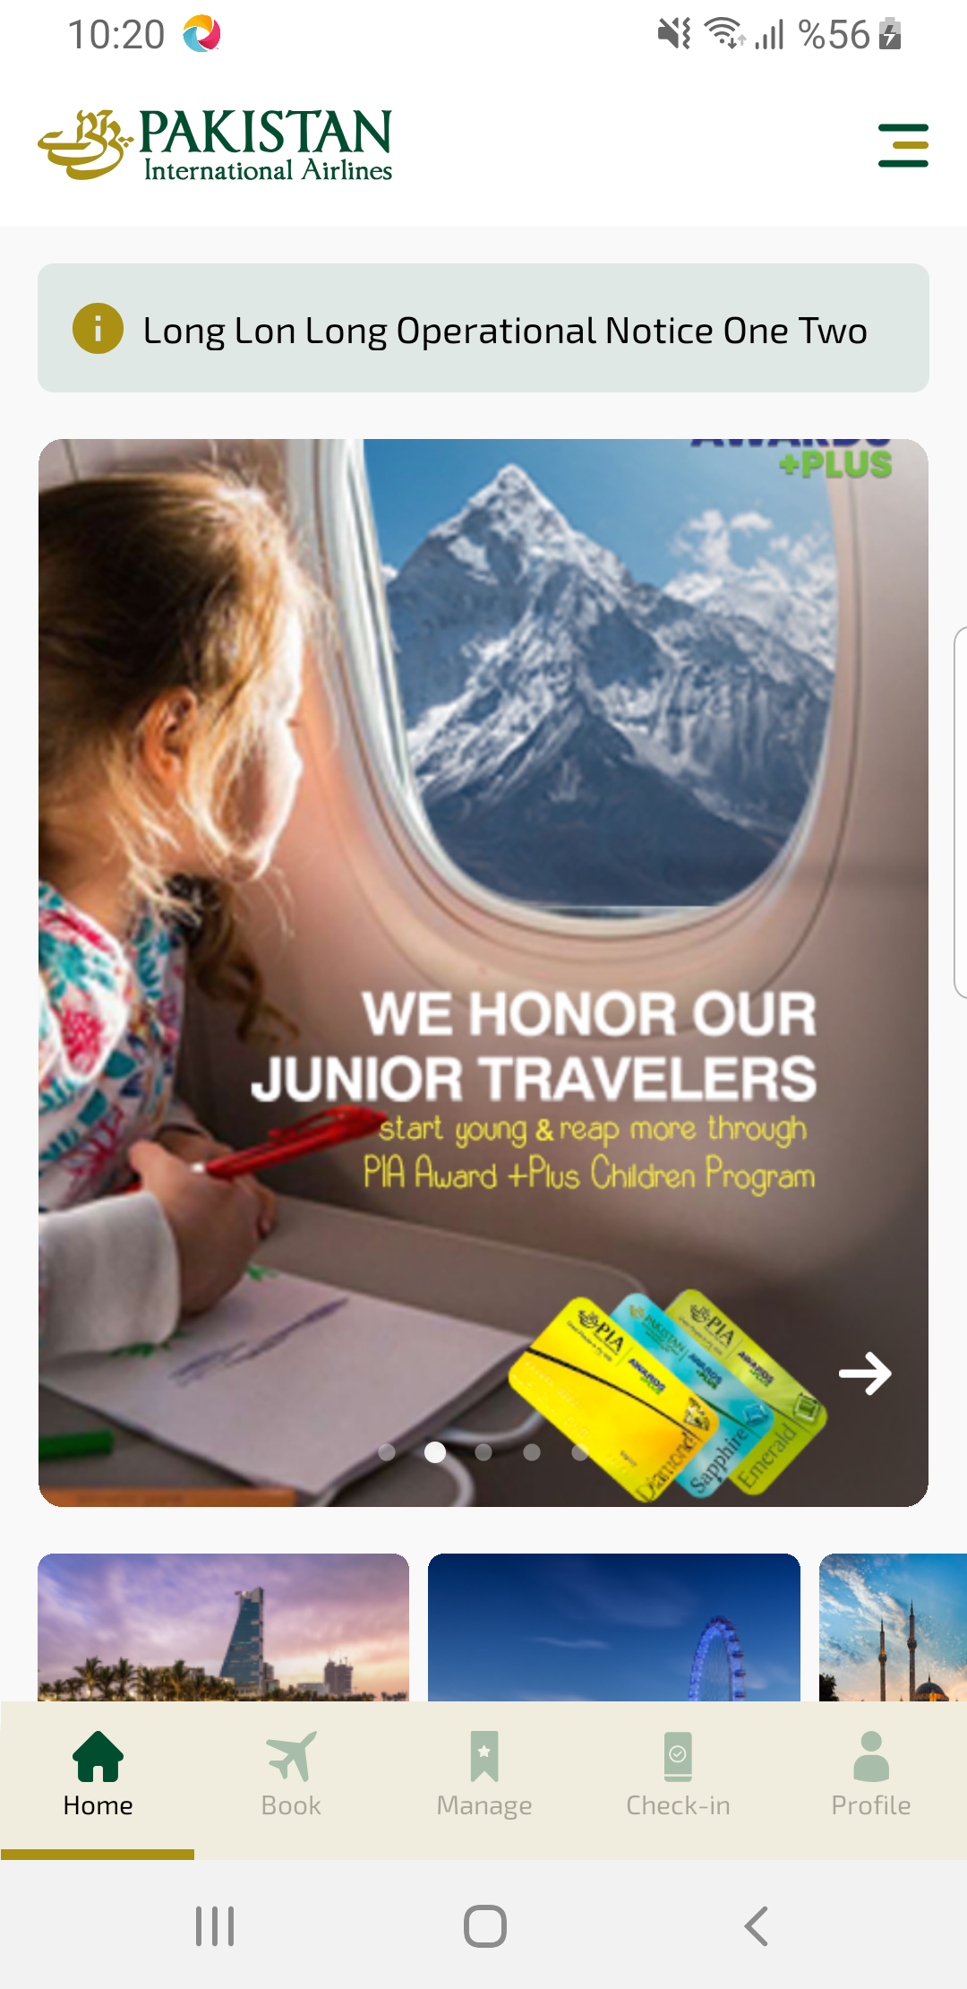
home sayfası ekran görüntüsü

