Accessibility Report — mbMyFlights
Tarih: 01.04.2026 13:45 | Platform: ANDROID

Element ID | Page | Type | Label / Text | Value | Resource ID | Status | New Status
mbMyFlights_element_1 | MainActivity | ViewGroup | Karachi (KHI) to Faisalabad (LYP), Fri, 10 Apr - 21:00, 1h 45min - PK 340, ECONOMY |  |  | ID Yok | ID Eklenecek (Waiting Dev)
mbMyFlights_element_2 | MainActivity | ViewGroup | Direct |  |  | ID Yok | ID Eklenecek (Waiting Dev)
mbMyFlights_element_3 | MainActivity | ViewGroup | My Flight(s) |  | mbk_home_switch_item | Duplicate | ID Eklenecek (Waiting Dev)
mbMyFlights_element_4 | MainActivity | ViewGroup | Passengers |  | mbk_home_switch_item | Duplicate | ID Eklenecek (Waiting Dev)
mbMyFlights_element_5 | MainActivity | ViewGroup |  |  | mbk_home_header | ID Var
mbMyFlights_element_6 | MainActivity | ViewGroup | Change Flight |  | mbk_action_change_flight_button | ID Var
mbMyFlights_element_7 | MainActivity | ViewGroup | Buy  Service+ |  | mbk_action_flight_extras_button | ID Var
mbMyFlights_element_8 | MainActivity | ViewGroup | Cancel  Flight |  | mbk_action_cancel_flight_button | ID Var
mbMyFlights_element_9 | MainActivity | ViewGroup | Online Check-in |  | mbk_action_check_in_button | ID Var

📸 Ekran Görüntüsü
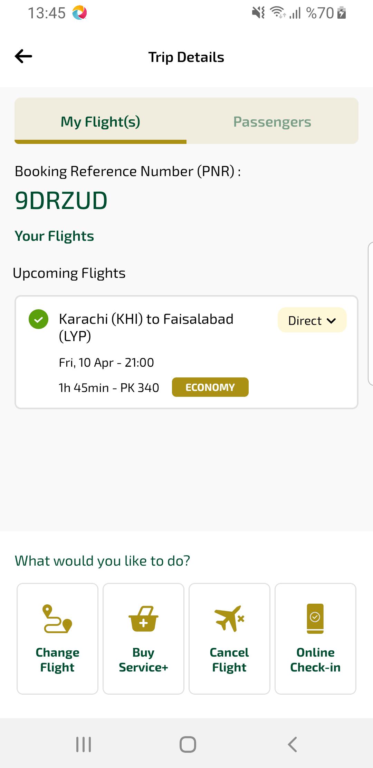
mbMyFlights sayfası ekran görüntüsü

