Accessibility Report — mbOptionalPnr
Tarih: 01.04.2026 13:53 | Platform: ANDROID

Element ID | Page | Type | Label / Text | Value | Resource ID | Status | New Status
mbOptionalPnr_element_1 | MainActivity | ViewGroup | Karachi (KHI) to Faisalabad (LYP), Fri, 10 Apr - 21:00, 1h 45min - PK 340, ECONOMY |  |  | ID Yok | ID Eklenecek (Waiting Dev)
mbOptionalPnr_element_2 | MainActivity | ViewGroup | Direct |  |  | ID Yok | ID Eklenecek (Waiting Dev)
mbOptionalPnr_element_3 | MainActivity | ViewGroup | My Flight(s) |  | mbk_home_switch_item | Duplicate | ID Eklenecek (Waiting Dev)
mbOptionalPnr_element_4 | MainActivity | ViewGroup | Passengers |  | mbk_home_switch_item | Duplicate | ID Eklenecek (Waiting Dev)
mbOptionalPnr_element_5 | MainActivity | ViewGroup |  |  | mbk_home_header | ID Var
mbOptionalPnr_element_6 | MainActivity | ViewGroup |  |  | optional_pnr_warning | ID Var
mbOptionalPnr_element_7 | MainActivity | ViewGroup | Purchase  Reservation |  | mbk_action_confirm_reservation_button | ID Var
mbOptionalPnr_element_8 | MainActivity | ViewGroup | Change Flight |  | mbk_action_change_flight_button | ID Var

📸 Ekran Görüntüsü
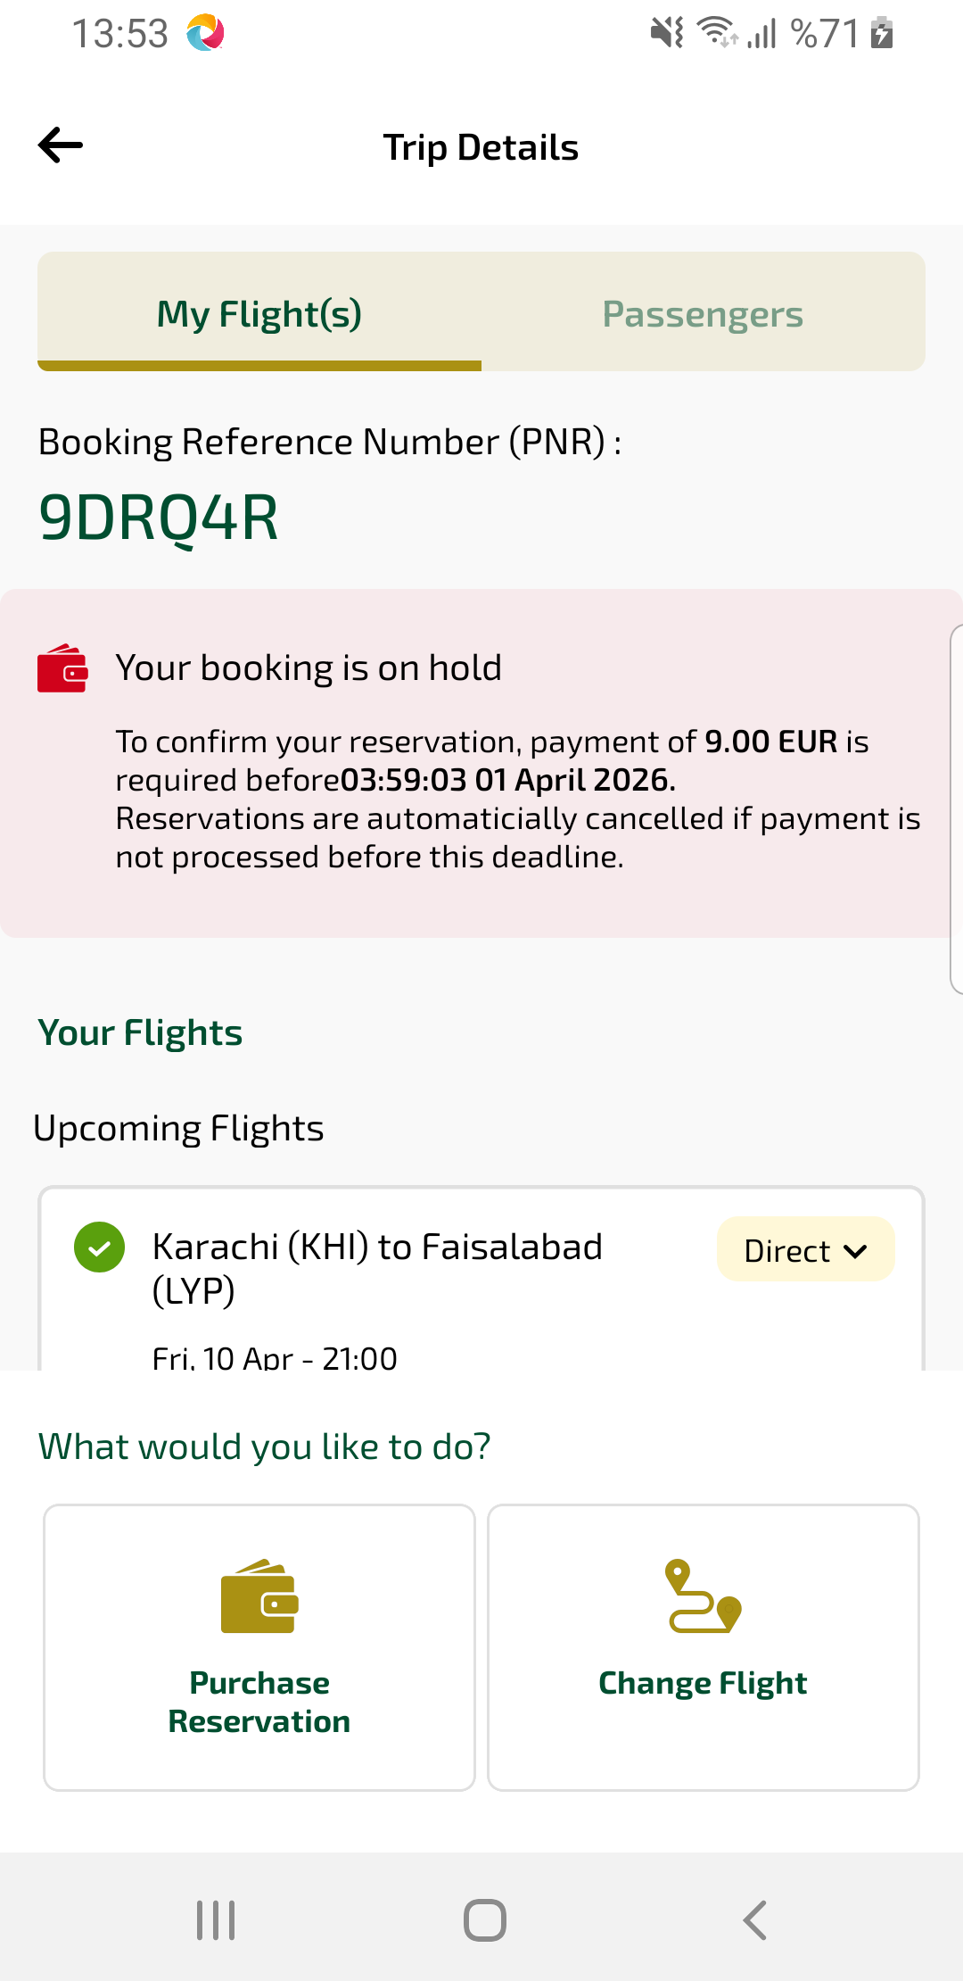
mbOptionalPnr sayfası ekran görüntüsü

