Accessibility Report — mbPassengersTab1
Tarih: 01.04.2026 12:04 | Platform: ANDROID

Element ID | Page | Type | Label / Text | Value | Resource ID | Status | New Status
mbPassengersTab1_element_1 | MainActivity | EditText | 123 | 123 |  | ID Yok | ID Eklenecek (Waiting Dev)
mbPassengersTab1_element_2 | MainActivity | ViewGroup | Enter your Award Plus membership number, Karachi - , Faisalabad, Not Checked-in, Check-in Unavailable, Included In Your Package, WCHR Support , Flight Extras, 4A, 5 KG, Faisalabad - , Karachi, Not Checked-in, Check-in Unavailable, Included In Your Package, 20 KG, WCHR Support |  |  | ID Yok | ID Eklenecek (Waiting Dev)
mbPassengersTab1_element_3 | MainActivity | ViewGroup | Adult One Automation, E-Ticket Number:, 2142431221178 |  |  | ID Yok | ID Eklenecek (Waiting Dev)
mbPassengersTab1_element_4 | MainActivity | ViewGroup | Add |  |  | ID Yok | ID Eklenecek (Waiting Dev)
mbPassengersTab1_element_5 | MainActivity | ViewGroup | My Flight(s) |  | mbk_home_switch_item | Duplicate | ID Eklenecek (Waiting Dev)
mbPassengersTab1_element_6 | MainActivity | ViewGroup | Passengers |  | mbk_home_switch_item | Duplicate | ID Eklenecek (Waiting Dev)
mbPassengersTab1_element_7 | MainActivity | ViewGroup |  |  | mbk_home_header | ID Var

📸 Ekran Görüntüsü
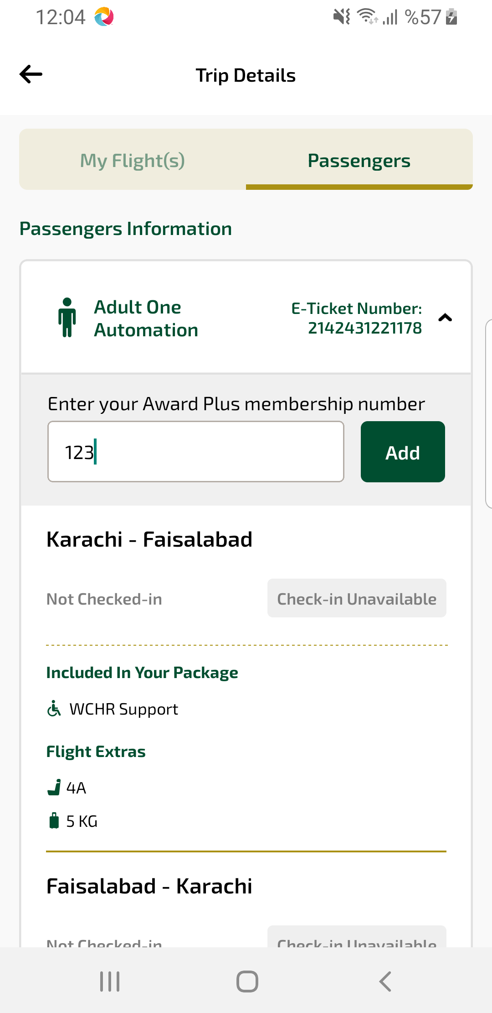
mbPassengersTab1 sayfası ekran görüntüsü

