Accessibility Report — mbPassengersTab2
Tarih: 01.04.2026 12:05 | Platform: ANDROID

Element ID | Page | Type | Label / Text | Value | Resource ID | Status | New Status
mbPassengersTab2_element_1 | MainActivity | ViewGroup | Testtt Denemeee, E-Ticket Number:, 2142431221179 |  |  | ID Yok | ID Eklenecek (Waiting Dev)
mbPassengersTab2_element_2 | MainActivity | ViewGroup | Dasd Dsad, E-Ticket Number:, 2142431221180 |  |  | ID Yok | ID Eklenecek (Waiting Dev)
mbPassengersTab2_element_3 | MainActivity | ViewGroup | Infant Deneme, E-Ticket Number:, 2142431221181 |  |  | ID Yok | ID Eklenecek (Waiting Dev)
mbPassengersTab2_element_4 | MainActivity | ViewGroup | Adult One Automation, +92 56 55555555, yunus.sahin@testinium.com |  |  | ID Yok | ID Eklenecek (Waiting Dev)
mbPassengersTab2_element_5 | MainActivity | ViewGroup | My Flight(s) |  | mbk_home_switch_item | Duplicate | ID Eklenecek (Waiting Dev)
mbPassengersTab2_element_6 | MainActivity | ViewGroup | Passengers |  | mbk_home_switch_item | Duplicate | ID Eklenecek (Waiting Dev)
mbPassengersTab2_element_7 | MainActivity | ViewGroup |  |  | mbk_home_header | ID Var
mbPassengersTab2_element_8 | MainActivity | ViewGroup | Change Contact Person |  | mbk_home_change_contact_button | ID Var

📸 Ekran Görüntüsü
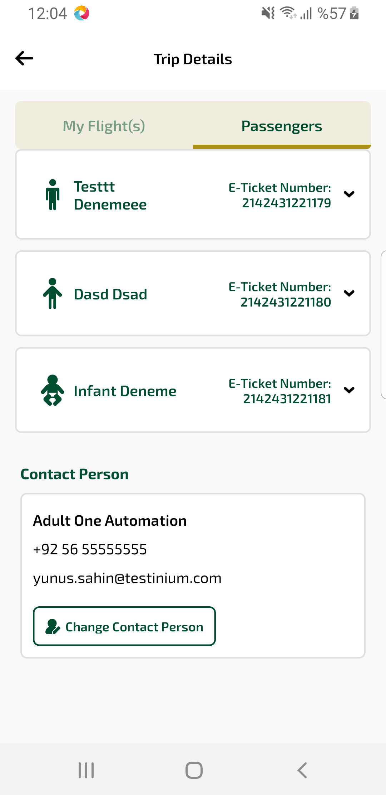
mbPassengersTab2 sayfası ekran görüntüsü

