Accessibility Report — mbSearch
Tarih: 01.04.2026 13:55 | Platform: ANDROID

Element ID | Page | Type | Label / Text | Value | Resource ID | Status | New Status
mbSearch_element_1 | MainActivity | View | Home |  |  | ID Yok | ID Eklenecek (Waiting Dev)
mbSearch_element_2 | MainActivity | View | Book |  |  | ID Yok | ID Eklenecek (Waiting Dev)
mbSearch_element_3 | MainActivity | View | Manage |  |  | ID Yok | ID Eklenecek (Waiting Dev)
mbSearch_element_4 | MainActivity | View | Check-in |  |  | ID Yok | ID Eklenecek (Waiting Dev)
mbSearch_element_5 | MainActivity | View | Profile |  |  | ID Yok | ID Eklenecek (Waiting Dev)
mbSearch_element_6 | MainActivity | ViewGroup | Test Operational Notice For Testing In UAT1 Test Operational Notice For Testing In UAT2 |  |  | ID Yok | ID Eklenecek (Waiting Dev)
mbSearch_element_7 | MainActivity | EditText | Surname | Surname | mbk_search_text_field_surname | ID Var
mbSearch_element_8 | MainActivity | EditText | Enter | Enter | mbk_search_text_field_bookingId | ID Var
mbSearch_element_9 | MainActivity | ViewGroup | Manage |  | mbk_search_find_button | ID Var
mbSearch_element_10 | MainActivity | TextView | Manage Booking | Manage Booking | mbk_search_header | ID Var

📸 Ekran Görüntüsü
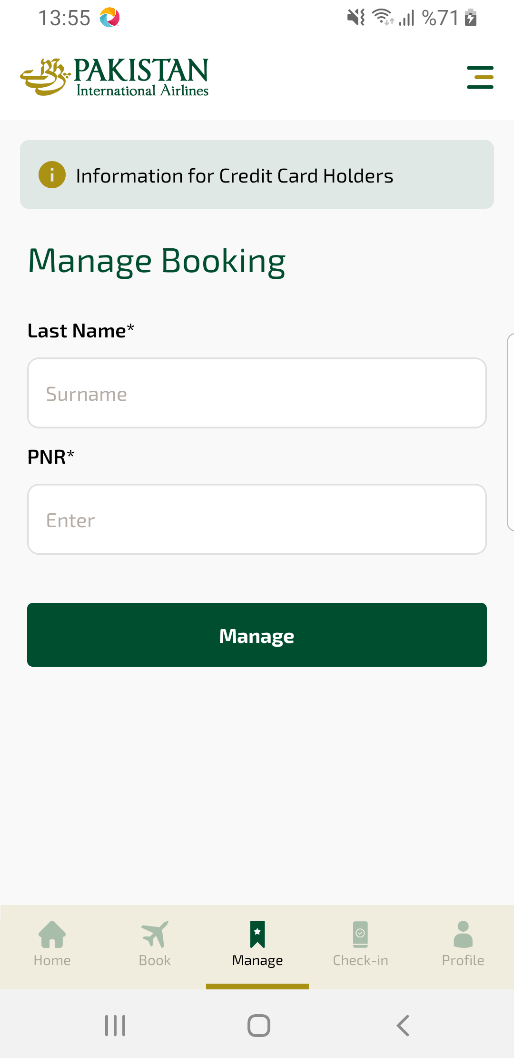
mbSearch sayfası ekran görüntüsü

