Accessibility Report — passengerInfo1
Tarih: 01.04.2026 11:28 | Platform: ANDROID

Element ID | Page | Type | Label / Text | Value | Resource ID | Status | New Status
passengerInfo1_element_1 | MainActivity | EditText | MRS | MRS |  | ID Yok | ID Eklenecek (Waiting Dev)
passengerInfo1_element_2 | MainActivity | EditText | 15/05/2002 | 15/05/2002 |  | ID Yok | ID Eklenecek (Waiting Dev)
passengerInfo1_element_3 | MainActivity | EditText | Pakistan | Pakistan |  | ID Yok | ID Eklenecek (Waiting Dev)
passengerInfo1_element_4 | MainActivity | ViewGroup | Male |  |  | ID Yok | ID Eklenecek (Waiting Dev)
passengerInfo1_element_5 | MainActivity | ViewGroup | Female |  |  | ID Yok | ID Eklenecek (Waiting Dev)
passengerInfo1_element_6 | MainActivity | ViewGroup | Total , 123,582.00￼PKR |  |  | ID Yok | ID Eklenecek (Waiting Dev)
passengerInfo1_element_7 | MainActivity | ViewGroup | Adult 1 |  | pax_form_tab_bar_item | Duplicate | ID Eklenecek (Waiting Dev)
passengerInfo1_element_8 | MainActivity | ViewGroup | Adult 2 |  | pax_form_tab_bar_item | Duplicate | ID Eklenecek (Waiting Dev)
passengerInfo1_element_9 | MainActivity | ViewGroup | Child 1 |  | pax_form_tab_bar_item | Duplicate | ID Eklenecek (Waiting Dev)
passengerInfo1_element_10 | MainActivity | EditText | Adult one | Adult one | pax_form_text_field_givenName | ID Var
passengerInfo1_element_11 | MainActivity | EditText | Automation | Automation | pax_form_text_field_surname | ID Var
passengerInfo1_element_12 | MainActivity | ViewGroup |  |  | pax_form_header | ID Var
passengerInfo1_element_13 | MainActivity | ViewGroup |  |  | pax_form_back_button | ID Var
passengerInfo1_element_14 | MainActivity | ViewGroup |  |  | pax_form_menu_card_title | ID Var
passengerInfo1_element_15 | MainActivity | ViewGroup | Date of Birth* |  | pax_form_date_card_birthDate | ID Var
passengerInfo1_element_16 | MainActivity | ViewGroup | Nationality* |  | pax_form_country_card_nationality | ID Var
passengerInfo1_element_17 | MainActivity | ViewGroup | Proceed to  Passenger 2 |  | pax_form_continue_button | ID Var

📸 Ekran Görüntüsü
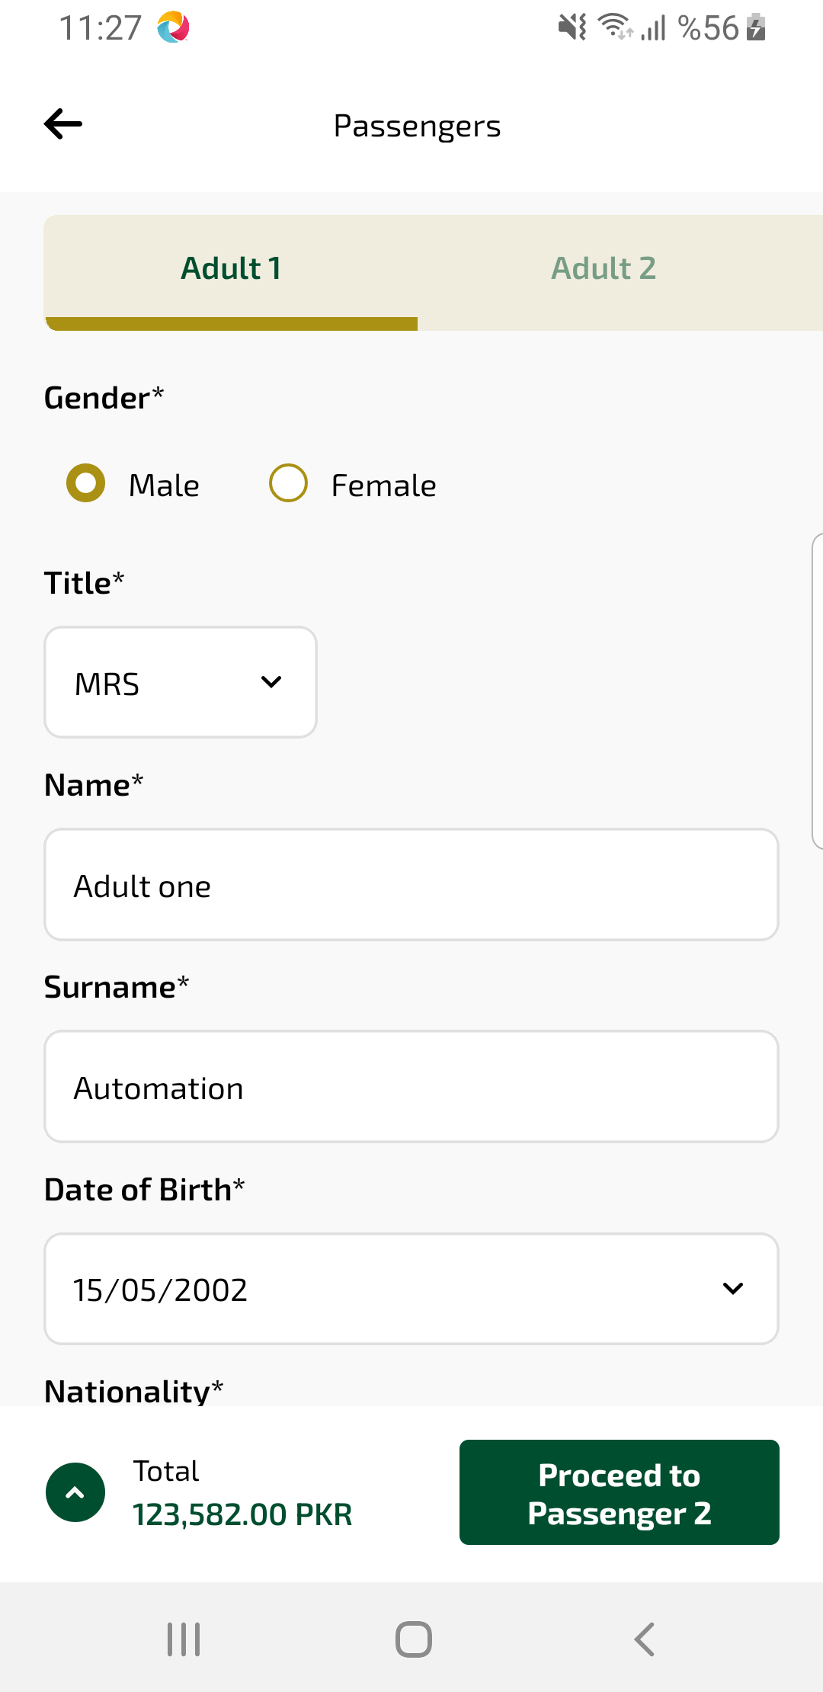
passengerInfo1 sayfası ekran görüntüsü

