Accessibility Report — passengerInfo3
Tarih: 01.04.2026 11:29 | Platform: ANDROID

Element ID | Page | Type | Label / Text | Value | Resource ID | Status | New Status
passengerInfo3_element_1 | MainActivity | ViewGroup | Save Passenger Info |  |  | ID Yok | ID Eklenecek (Waiting Dev)
passengerInfo3_element_2 | MainActivity | ViewGroup | Select as a Contact Person |  |  | ID Yok | ID Eklenecek (Waiting Dev)
passengerInfo3_element_3 | MainActivity | ViewGroup | Total , 123,582.00￼PKR |  |  | ID Yok | ID Eklenecek (Waiting Dev)
passengerInfo3_element_4 | MainActivity | ViewGroup | Adult 1 |  | pax_form_tab_bar_item | Duplicate | ID Eklenecek (Waiting Dev)
passengerInfo3_element_5 | MainActivity | ViewGroup | Adult 2 |  | pax_form_tab_bar_item | Duplicate | ID Eklenecek (Waiting Dev)
passengerInfo3_element_6 | MainActivity | ViewGroup | Child 1 |  | pax_form_tab_bar_item | Duplicate | ID Eklenecek (Waiting Dev)
passengerInfo3_element_7 | MainActivity | ViewGroup | Can walk and move independently (WCHR) |  | pax_form_special_wheelchair_item | Duplicate | ID Eklenecek (Waiting Dev)
passengerInfo3_element_8 | MainActivity | ViewGroup | Can not walk at all and have to be carried to my seat(WCHC) |  | pax_form_special_wheelchair_item | Duplicate | ID Eklenecek (Waiting Dev)
passengerInfo3_element_9 | MainActivity | EditText | Award Plus Member ID | Award Plus Member ID | pax_form_text_field_membershipId | ID Var
passengerInfo3_element_10 | MainActivity | ViewGroup |  |  | pax_form_header | ID Var
passengerInfo3_element_11 | MainActivity | ViewGroup |  |  | pax_form_back_button | ID Var
passengerInfo3_element_12 | MainActivity | ViewGroup |  |  | pax_form_check_box_savePaxDetails | ID Var
passengerInfo3_element_13 | MainActivity | ViewGroup | Medical Assistance |  | pax_form_special_assistance | ID Var
passengerInfo3_element_14 | MainActivity | ViewGroup | Wheelchair |  | pax_form_special_wheelchair | ID Var
passengerInfo3_element_15 | MainActivity | ViewGroup |  |  | pax_form_check_box_contactPersonAssign | ID Var
passengerInfo3_element_16 | MainActivity | ViewGroup | Proceed to  Passenger 2 |  | pax_form_continue_button | ID Var

📸 Ekran Görüntüsü
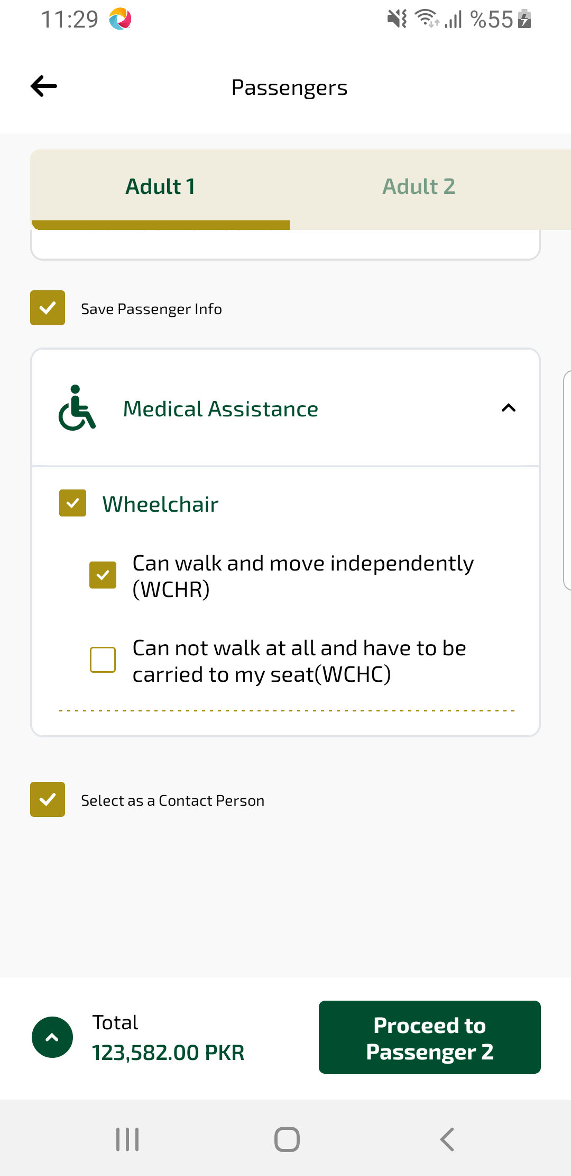
passengerInfo3 sayfası ekran görüntüsü

