Accessibility Report — passengerInfoInfant2
Tarih: 01.04.2026 11:32 | Platform: ANDROID

Element ID | Page | Type | Label / Text | Value | Resource ID | Status | New Status
passengerInfoInfant2_element_1 | MainActivity | EditText | 18/05/2025 | 18/05/2025 |  | ID Yok | ID Eklenecek (Waiting Dev)
passengerInfoInfant2_element_2 | MainActivity | EditText | Algeria | Algeria |  | ID Yok | ID Eklenecek (Waiting Dev)
passengerInfoInfant2_element_3 | MainActivity | EditText | American Samoa | American Samoa |  | ID Yok | ID Eklenecek (Waiting Dev)
passengerInfoInfant2_element_4 | MainActivity | EditText | 01/04/2027 | 01/04/2027 |  | ID Yok | ID Eklenecek (Waiting Dev)
passengerInfoInfant2_element_5 | MainActivity | ViewGroup | Total , 123,582.00￼PKR |  |  | ID Yok | ID Eklenecek (Waiting Dev)
passengerInfoInfant2_element_6 | MainActivity | ViewGroup | Child 1 |  | pax_form_tab_bar_item | Duplicate | ID Eklenecek (Waiting Dev)
passengerInfoInfant2_element_7 | MainActivity | ViewGroup | Infant 1 |  | pax_form_tab_bar_item | Duplicate | ID Eklenecek (Waiting Dev)
passengerInfoInfant2_element_8 | MainActivity | ViewGroup | Contact Person |  | pax_form_tab_bar_item | Duplicate | ID Eklenecek (Waiting Dev)
passengerInfoInfant2_element_9 | MainActivity | EditText | Deneme | Deneme | pax_form_text_field_surname | ID Var
passengerInfoInfant2_element_10 | MainActivity | EditText | p123 | p123 | pax_form_text_field_passportNumber | ID Var
passengerInfoInfant2_element_11 | MainActivity | ViewGroup |  |  | pax_form_header | ID Var
passengerInfoInfant2_element_12 | MainActivity | ViewGroup |  |  | pax_form_back_button | ID Var
passengerInfoInfant2_element_13 | MainActivity | ViewGroup | Date of Birth* |  | pax_form_date_card_birthDate | ID Var
passengerInfoInfant2_element_14 | MainActivity | ViewGroup | Nationality* |  | pax_form_country_card_nationality | ID Var
passengerInfoInfant2_element_15 | MainActivity | ViewGroup | Passport Issue Country* |  | pax_form_country_card_docIssueCountry | ID Var
passengerInfoInfant2_element_16 | MainActivity | ViewGroup | Passport Expire Date* |  | pax_form_date_card_docExpireDate | ID Var
passengerInfoInfant2_element_17 | MainActivity | ViewGroup | Continue |  | pax_form_continue_button | ID Var

📸 Ekran Görüntüsü
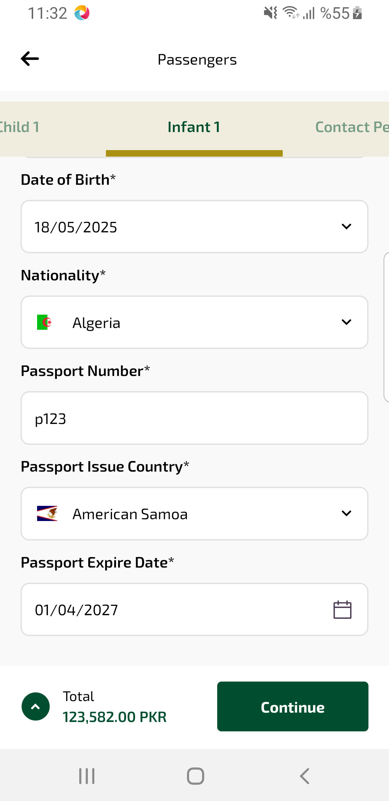
passengerInfoInfant2 sayfası ekran görüntüsü

