Accessibility Report — passengersDetailFamilySelect
Tarih: 01.04.2026 13:49 | Platform: ANDROID

Element ID | Page | Type | Label / Text | Value | Resource ID | Status | New Status
passengersDetailFamilySelect_element_1 | MainActivity | EditText | PROF | PROF |  | ID Yok | ID Eklenecek (Waiting Dev)
passengersDetailFamilySelect_element_2 | MainActivity | ViewGroup | Yunus E Sahin |  |  | ID Yok | ID Eklenecek (Waiting Dev)
passengersDetailFamilySelect_element_3 | MainActivity | ViewGroup | ZARIFE ZEYNEP SAHIN |  |  | ID Yok | ID Eklenecek (Waiting Dev)
passengersDetailFamilySelect_element_4 | MainActivity | ViewGroup | Male |  |  | ID Yok | ID Eklenecek (Waiting Dev)
passengersDetailFamilySelect_element_5 | MainActivity | ViewGroup | Female |  |  | ID Yok | ID Eklenecek (Waiting Dev)
passengersDetailFamilySelect_element_6 | MainActivity | ViewGroup | Total , 11,000￼Miles +, 9.00￼EUR |  |  | ID Yok | ID Eklenecek (Waiting Dev)
passengersDetailFamilySelect_element_7 | MainActivity | ViewGroup | Adult 1 |  | pax_form_tab_bar_item | Duplicate | ID Eklenecek (Waiting Dev)
passengersDetailFamilySelect_element_8 | MainActivity | ViewGroup | Contact Person |  | pax_form_tab_bar_item | Duplicate | ID Eklenecek (Waiting Dev)
passengersDetailFamilySelect_element_9 | MainActivity | EditText | Yunus E | Yunus E | pax_form_text_field_givenName | ID Var
passengersDetailFamilySelect_element_10 | MainActivity | EditText | Sahin | Sahin | pax_form_text_field_surname | ID Var
passengersDetailFamilySelect_element_11 | MainActivity | ViewGroup |  |  | pax_form_header | ID Var
passengersDetailFamilySelect_element_12 | MainActivity | ViewGroup |  |  | pax_form_back_button | ID Var
passengersDetailFamilySelect_element_13 | MainActivity | ViewGroup |  |  | pax_form_menu_card_title | ID Var
passengersDetailFamilySelect_element_14 | MainActivity | ViewGroup | Date of Birth* |  | pax_form_date_card_birthDate | ID Var
passengersDetailFamilySelect_element_15 | MainActivity | ViewGroup | Continue |  | pax_form_continue_button | ID Var

📸 Ekran Görüntüsü
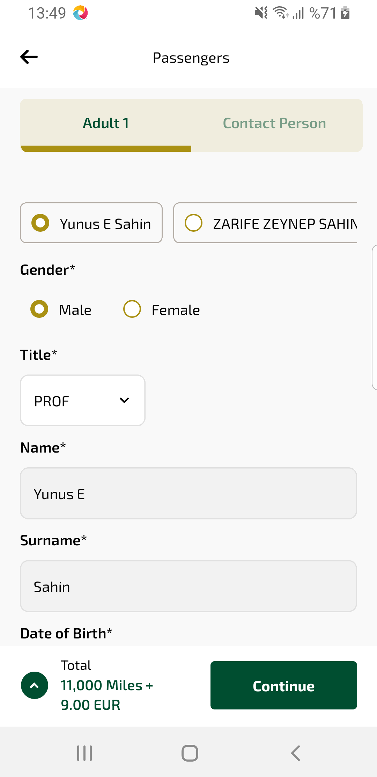
passengersDetailFamilySelect sayfası ekran görüntüsü

