Accessibility Report — paylaterSuccess
Tarih: 01.04.2026 13:52 | Platform: ANDROID

Element ID | Page | Type | Label / Text | Value | Resource ID | Status | New Status
paylaterSuccess_element_1 | MainActivity | ViewGroup | PNR No, 9DRQ4R |  |  | ID Yok | ID Eklenecek (Waiting Dev)
paylaterSuccess_element_2 | MainActivity | ViewGroup | Karachi (KHI) to Faisalabad (LYP), Fri, 10 Apr - 21:00, 1h 45min - PK 340, ECONOMY |  |  | ID Yok | ID Eklenecek (Waiting Dev)
paylaterSuccess_element_3 | MainActivity | ViewGroup | Direct |  |  | ID Yok | ID Eklenecek (Waiting Dev)
paylaterSuccess_element_4 | MainActivity | ViewGroup | Yunus E Sahin |  |  | ID Yok | ID Eklenecek (Waiting Dev)
paylaterSuccess_element_5 | MainActivity | ViewGroup | Go to Manage Booking |  | payment_success_mbk_button | ID Var

📸 Ekran Görüntüsü
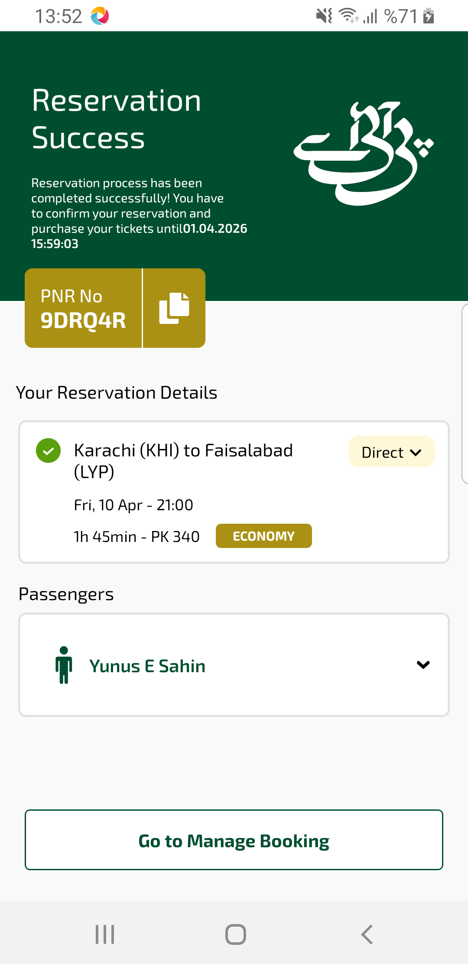
paylaterSuccess sayfası ekran görüntüsü

