Accessibility Report — seatDelete
Tarih: 01.04.2026 11:35 | Platform: ANDROID

Element ID | Page | Type | Label / Text | Value | Resource ID | Status | New Status
seatDelete_element_1 | MainActivity | ViewGroup | 4A |  |  | ID Yok | ID Eklenecek (Waiting Dev)
seatDelete_element_2 | MainActivity | ViewGroup | Karachi (KHI) to Faisalabad (LYP), Fri, 15 May - 21:00 |  |  | ID Yok | ID Eklenecek (Waiting Dev)
seatDelete_element_3 | MainActivity | ViewGroup | Faisalabad (LYP) to Karachi (KHI), Sun, 17 May - 17:30 |  |  | ID Yok | ID Eklenecek (Waiting Dev)
seatDelete_element_4 | MainActivity | ViewGroup | AA |  |  | ID Yok | ID Eklenecek (Waiting Dev)
seatDelete_element_5 | MainActivity | ViewGroup | Total , 118,744.00￼PKR |  |  | ID Yok | ID Eklenecek (Waiting Dev)
seatDelete_element_6 | MainActivity | ViewGroup |  |  | seat_selection_seat_item | Duplicate | ID Eklenecek (Waiting Dev)
seatDelete_element_7 | MainActivity | ViewGroup |  |  | seat_selection_seat_item | Duplicate | ID Eklenecek (Waiting Dev)
seatDelete_element_8 | MainActivity | ViewGroup |  |  | seat_selection_seat_item | Duplicate | ID Eklenecek (Waiting Dev)
seatDelete_element_9 | MainActivity | ViewGroup |  |  | seat_selection_seat_item | Duplicate | ID Eklenecek (Waiting Dev)
seatDelete_element_10 | MainActivity | ViewGroup |  |  | seat_selection_seat_item | Duplicate | ID Eklenecek (Waiting Dev)
seatDelete_element_11 | MainActivity | ViewGroup |  |  | seat_selection_seat_item | Duplicate | ID Eklenecek (Waiting Dev)
seatDelete_element_12 | MainActivity | ViewGroup |  |  | seat_selection_seat_item | Duplicate | ID Eklenecek (Waiting Dev)
seatDelete_element_13 | MainActivity | ViewGroup |  |  | seat_selection_seat_item | Duplicate | ID Eklenecek (Waiting Dev)
seatDelete_element_14 | MainActivity | ViewGroup |  |  | seat_selection_seat_item | Duplicate | ID Eklenecek (Waiting Dev)
seatDelete_element_15 | MainActivity | ViewGroup |  |  | seat_selection_seat_item | Duplicate | ID Eklenecek (Waiting Dev)
seatDelete_element_16 | MainActivity | ViewGroup |  |  | seat_selection_seat_item | Duplicate | ID Eklenecek (Waiting Dev)
seatDelete_element_17 | MainActivity | ViewGroup |  |  | seat_selection_seat_item | Duplicate | ID Eklenecek (Waiting Dev)
seatDelete_element_18 | MainActivity | ViewGroup |  |  | seat_selection_seat_item | Duplicate | ID Eklenecek (Waiting Dev)
seatDelete_element_19 | MainActivity | ViewGroup |  |  | seat_selection_seat_item | Duplicate | ID Eklenecek (Waiting Dev)
seatDelete_element_20 | MainActivity | ViewGroup |  |  | seat_selection_seat_item | Duplicate | ID Eklenecek (Waiting Dev)
seatDelete_element_21 | MainActivity | ViewGroup |  |  | seat_selection_seat_item | Duplicate | ID Eklenecek (Waiting Dev)
seatDelete_element_22 | MainActivity | ViewGroup |  |  | seat_selection_seat_item | Duplicate | ID Eklenecek (Waiting Dev)
seatDelete_element_23 | MainActivity | ViewGroup |  |  | seat_selection_seat_item | Duplicate | ID Eklenecek (Waiting Dev)
seatDelete_element_24 | MainActivity | ViewGroup |  |  | seat_selection_seat_item | Duplicate | ID Eklenecek (Waiting Dev)
seatDelete_element_25 | MainActivity | ViewGroup |  |  | seat_selection_seat_item | Duplicate | ID Eklenecek (Waiting Dev)
seatDelete_element_26 | MainActivity | ViewGroup |  |  | seat_selection_seat_item | Duplicate | ID Eklenecek (Waiting Dev)
seatDelete_element_27 | MainActivity | ViewGroup |  |  | seat_selection_seat_item | Duplicate | ID Eklenecek (Waiting Dev)
seatDelete_element_28 | MainActivity | ViewGroup |  |  | seat_selection_seat_item | Duplicate | ID Eklenecek (Waiting Dev)
seatDelete_element_29 | MainActivity | ViewGroup |  |  | seat_selection_seat_item | Duplicate | ID Eklenecek (Waiting Dev)
seatDelete_element_30 | MainActivity | ViewGroup |  |  | seat_selection_seat_item | Duplicate | ID Eklenecek (Waiting Dev)
seatDelete_element_31 | MainActivity | ViewGroup |  |  | seat_selection_seat_item | Duplicate | ID Eklenecek (Waiting Dev)
seatDelete_element_32 | MainActivity | ViewGroup |  |  | seat_selection_seat_item | Duplicate | ID Eklenecek (Waiting Dev)
seatDelete_element_33 | MainActivity | ViewGroup |  |  | seat_selection_seat_item | Duplicate | ID Eklenecek (Waiting Dev)
seatDelete_element_34 | MainActivity | ViewGroup |  |  | seat_selection_seat_item | Duplicate | ID Eklenecek (Waiting Dev)
seatDelete_element_35 | MainActivity | ViewGroup |  |  | seat_selection_seat_item | Duplicate | ID Eklenecek (Waiting Dev)
seatDelete_element_36 | MainActivity | ViewGroup |  |  | seat_selection_seat_item | Duplicate | ID Eklenecek (Waiting Dev)
seatDelete_element_37 | MainActivity | ViewGroup |  |  | seat_selection_seat_item | Duplicate | ID Eklenecek (Waiting Dev)
seatDelete_element_38 | MainActivity | ViewGroup |  |  | seat_selection_seat_item | Duplicate | ID Eklenecek (Waiting Dev)
seatDelete_element_39 | MainActivity | ViewGroup |  |  | seat_selection_seat_item | Duplicate | ID Eklenecek (Waiting Dev)
seatDelete_element_40 | MainActivity | ViewGroup |  |  | seat_selection_seat_item | Duplicate | ID Eklenecek (Waiting Dev)
seatDelete_element_41 | MainActivity | ViewGroup |  |  | seat_selection_seat_item | Duplicate | ID Eklenecek (Waiting Dev)
seatDelete_element_42 | MainActivity | ViewGroup |  |  | seat_selection_seat_item | Duplicate | ID Eklenecek (Waiting Dev)
seatDelete_element_43 | MainActivity | ViewGroup |  |  | seat_selection_seat_item | Duplicate | ID Eklenecek (Waiting Dev)
seatDelete_element_44 | MainActivity | ViewGroup |  |  | seat_selection_seat_item | Duplicate | ID Eklenecek (Waiting Dev)
seatDelete_element_45 | MainActivity | ViewGroup |  |  | seat_selection_seat_item | Duplicate | ID Eklenecek (Waiting Dev)
seatDelete_element_46 | MainActivity | ViewGroup |  |  | seat_selection_seat_item | Duplicate | ID Eklenecek (Waiting Dev)
seatDelete_element_47 | MainActivity | ViewGroup |  |  | seat_selection_seat_item | Duplicate | ID Eklenecek (Waiting Dev)
seatDelete_element_48 | MainActivity | ViewGroup |  |  | seat_selection_seat_item | Duplicate | ID Eklenecek (Waiting Dev)
seatDelete_element_49 | MainActivity | ViewGroup |  |  | seat_selection_seat_item | Duplicate | ID Eklenecek (Waiting Dev)
seatDelete_element_50 | MainActivity | ViewGroup |  |  | seat_selection_seat_item | Duplicate | ID Eklenecek (Waiting Dev)
seatDelete_element_51 | MainActivity | ViewGroup |  |  | seat_selection_seat_item | Duplicate | ID Eklenecek (Waiting Dev)
seatDelete_element_52 | MainActivity | ViewGroup |  |  | seat_selection_seat_item | Duplicate | ID Eklenecek (Waiting Dev)
seatDelete_element_53 | MainActivity | ViewGroup | Clear |  | seat_selection_seat_remove_button_adult_one_automation | ID Var
seatDelete_element_54 | MainActivity | ViewGroup |  |  | seat_selection_header | ID Var
seatDelete_element_55 | MainActivity | ViewGroup |  |  | seat_selection_back_button | ID Var
seatDelete_element_56 | MainActivity | ViewGroup | Continue |  | seat_selection_continue_button | ID Var

📸 Ekran Görüntüsü
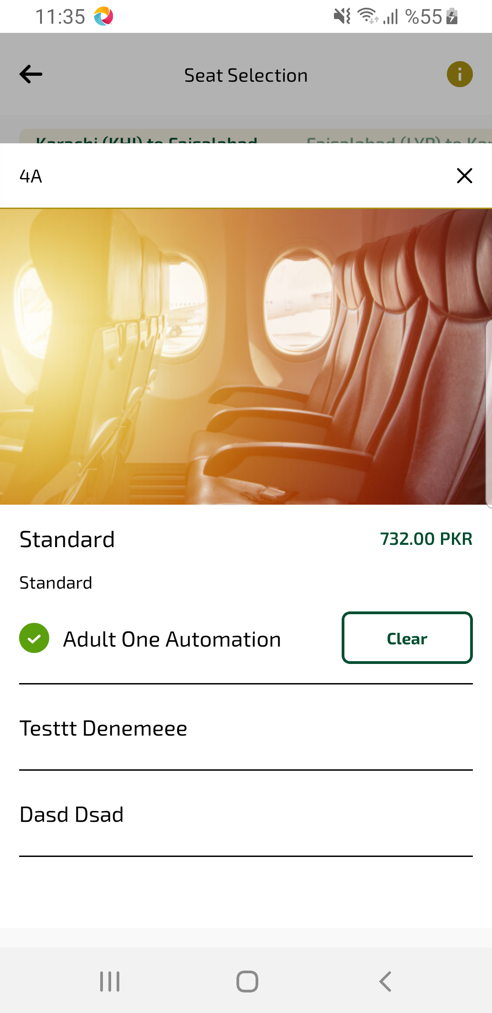
seatDelete sayfası ekran görüntüsü

