Accessibility Report — selectBundle
Tarih: 01.04.2026 11:23 | Platform: ANDROID

Element ID | Page | Type | Label / Text | Value | Resource ID | Status | New Status
selectBundle_element_1 | MainActivity | ViewGroup | LIGHT, Lowest Price, Free Carry-On Baggage, Free Meal/Beverages, Seat Selection (*charges apply), Booking Change (*charges apply), Cancellation/Refund (*charges apply), No Check-in Baggage |  |  | ID Yok | ID Eklenecek (Waiting Dev)
selectBundle_element_2 | MainActivity | ViewGroup | 19,212.00￼PKR |  |  | ID Yok | ID Eklenecek (Waiting Dev)
selectBundle_element_3 | MainActivity | ViewGroup | STANDARD, Free Carry-On Baggage, Free Meal/Beverages, Seat Selection (*charges apply), One change free either side (Bef. 72 hrs), next with a fee, Cancellation/Refund (*charges apply), Check-in Baggage 20 KG |  |  | ID Yok | ID Eklenecek (Waiting Dev)
selectBundle_element_4 | MainActivity | ViewGroup | 20,332.00￼PKR |  |  | ID Yok | ID Eklenecek (Waiting Dev)

📸 Ekran Görüntüsü
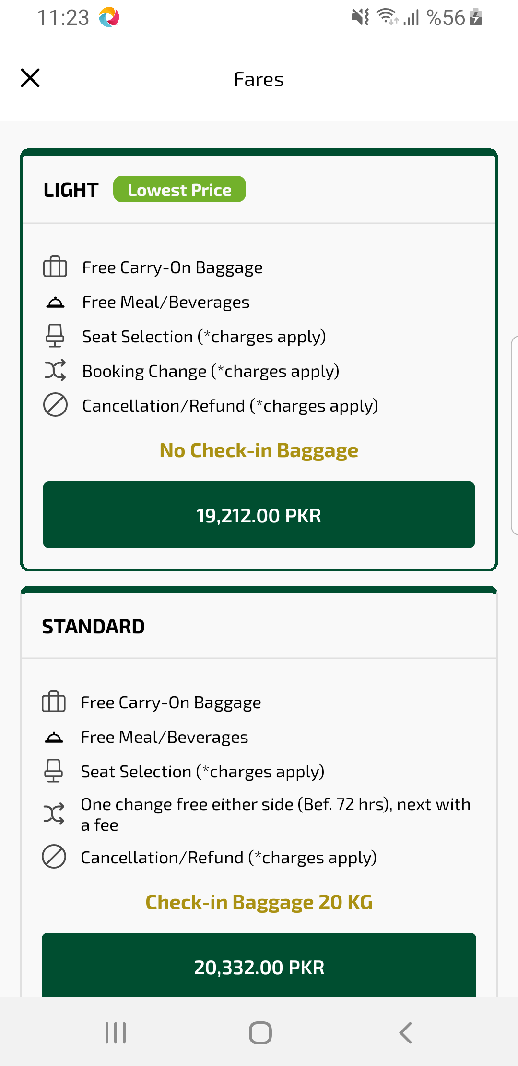
selectBundle sayfası ekran görüntüsü

