Accessibility Report — selectDepFlight
Tarih: 01.04.2026 11:22 | Platform: ANDROID

Element ID | Page | Type | Label / Text | Value | Resource ID | Status | New Status
selectDepFlight_element_1 | MainActivity | ViewGroup | 14 , May, Thu, Search |  |  | ID Yok | ID Eklenecek (Waiting Dev)
selectDepFlight_element_2 | MainActivity | ViewGroup | 15 , May, Fri, 19,212￼PKR |  |  | ID Yok | ID Eklenecek (Waiting Dev)
selectDepFlight_element_3 | MainActivity | ViewGroup | 16 , May, Sat, Search |  |  | ID Yok | ID Eklenecek (Waiting Dev)
selectDepFlight_element_4 | MainActivity | ViewGroup | 17 , May, Sun, Search |  |  | ID Yok | ID Eklenecek (Waiting Dev)
selectDepFlight_element_5 | MainActivity | ViewGroup | Direct |  |  | ID Yok | ID Eklenecek (Waiting Dev)
selectDepFlight_element_6 | MainActivity | ViewGroup | 19,212.00￼PKR |  |  | ID Yok | ID Eklenecek (Waiting Dev)
selectDepFlight_element_7 | MainActivity | ViewGroup | Economy |  | avail_selection_switch_item | Duplicate | ID Eklenecek (Waiting Dev)
selectDepFlight_element_8 | MainActivity | ViewGroup | Executive Economy |  | avail_selection_switch_item | Duplicate | ID Eklenecek (Waiting Dev)
selectDepFlight_element_9 | MainActivity | ViewGroup | Business |  | avail_selection_switch_item | Duplicate | ID Eklenecek (Waiting Dev)
selectDepFlight_element_10 | MainActivity | ViewGroup |  |  | avail_selection_header | ID Var
selectDepFlight_element_11 | MainActivity | ViewGroup | PKR |  | avail_selection_currency_picker | ID Var
selectDepFlight_element_12 | MainActivity | ViewGroup |  |  | avail_selection_calendar_picker | ID Var
selectDepFlight_element_13 | MainActivity | ViewGroup | 21:00, 22:45, 1h 45min, PK 340 |  | avail_selection_flight_item_direct | ID Var

📸 Ekran Görüntüsü
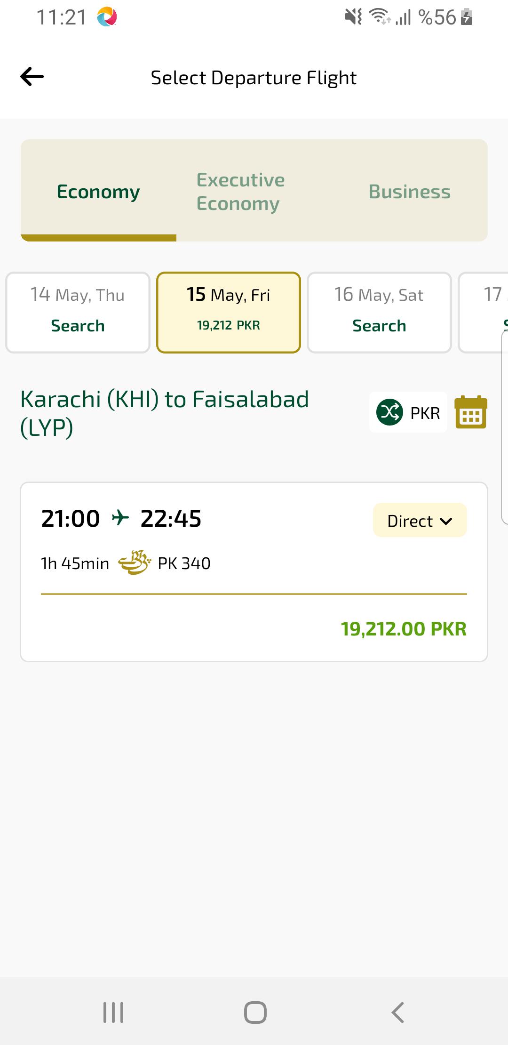
selectDepFlight sayfası ekran görüntüsü

