Accessibility Report — ssrList
Tarih: 01.04.2026 11:55 | Platform: ANDROID

Element ID | Page | Type | Label / Text | Value | Resource ID | Status | New Status
ssrList_element_1 | MainActivity | ViewGroup | Total , 120,064.00￼PKR |  |  | ID Yok | ID Eklenecek (Waiting Dev)
ssrList_element_2 | MainActivity | ViewGroup |  |  | ssr_navigator_header | ID Var
ssrList_element_3 | MainActivity | ViewGroup |  |  | ssr_navigator_back_button | ID Var
ssrList_element_4 | MainActivity | ViewGroup | Seat Selection, 4A |  | ssr_navigator_ssr_item_SEAT | ID Var
ssrList_element_5 | MainActivity | ViewGroup | Extra Baggage Selection, Baggage +5kg x1 |  | ssr_navigator_ssr_item_BAG | ID Var
ssrList_element_6 | MainActivity | ViewGroup | Continue |  | ssr_navigator_continue_button | ID Var

📸 Ekran Görüntüsü
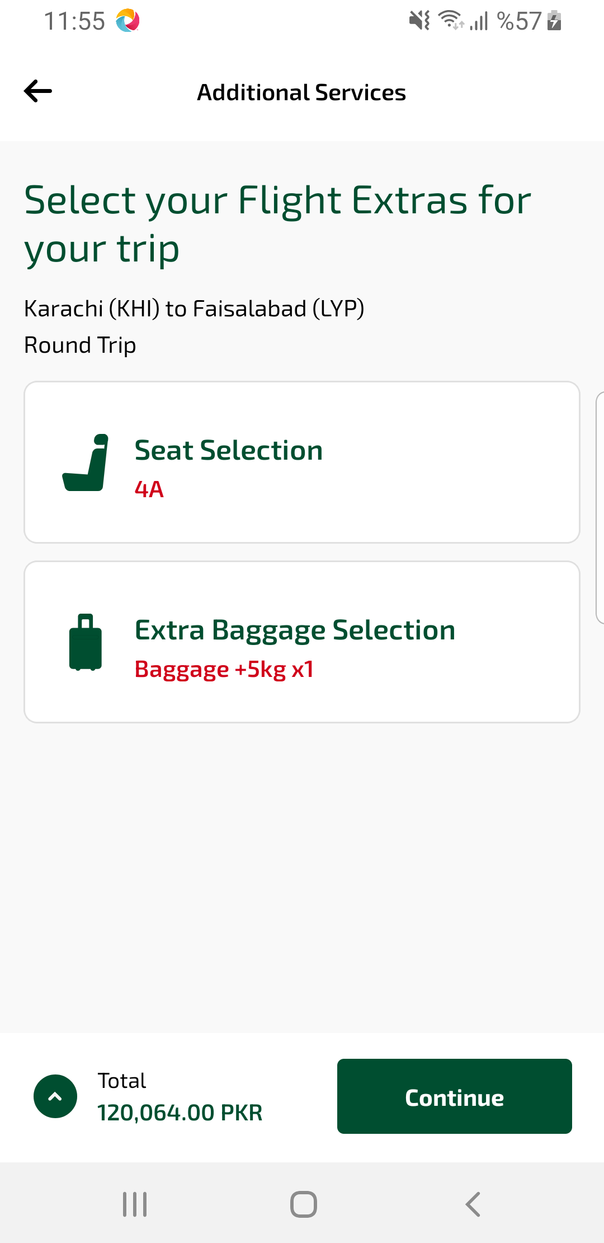
ssrList sayfası ekran görüntüsü

