Accessibility Report — totalPriceDetail
Tarih: 01.04.2026 11:25 | Platform: ANDROID

Element ID | Page | Type | Label / Text | Value | Resource ID | Status | New Status
totalPriceDetail_element_1 | MainActivity | ViewGroup | Price Info |  |  | ID Yok | ID Eklenecek (Waiting Dev)
totalPriceDetail_element_2 | MainActivity | ViewGroup | Air Transportation Charges |  |  | ID Yok | ID Eklenecek (Waiting Dev)
totalPriceDetail_element_3 | MainActivity | ViewGroup | Taxes, Fees & Charges |  |  | ID Yok | ID Eklenecek (Waiting Dev)
totalPriceDetail_element_4 | MainActivity | ViewGroup | Air Transportation Charges |  |  | ID Yok | ID Eklenecek (Waiting Dev)
totalPriceDetail_element_5 | MainActivity | ViewGroup | Taxes, Fees & Charges |  |  | ID Yok | ID Eklenecek (Waiting Dev)
totalPriceDetail_element_6 | MainActivity | ViewGroup | Air Transportation Charges |  |  | ID Yok | ID Eklenecek (Waiting Dev)
totalPriceDetail_element_7 | MainActivity | ViewGroup | Taxes, Fees & Charges |  |  | ID Yok | ID Eklenecek (Waiting Dev)
totalPriceDetail_element_8 | MainActivity | ViewGroup | Ok |  |  | ID Yok | ID Eklenecek (Waiting Dev)
totalPriceDetail_element_9 | MainActivity | ViewGroup | Karachi (KHI) to Faisalabad (LYP), Fri, 15 May - 21:00, 1h 45min - PK 340, ECONOMY |  |  | ID Yok | ID Eklenecek (Waiting Dev)
totalPriceDetail_element_10 | MainActivity | ViewGroup | Direct |  |  | ID Yok | ID Eklenecek (Waiting Dev)
totalPriceDetail_element_11 | MainActivity | ViewGroup | Faisalabad (LYP) to Karachi (KHI), Sun, 17 May - 17:30, 1h 45min - PK 341, ECONOMY |  |  | ID Yok | ID Eklenecek (Waiting Dev)
totalPriceDetail_element_12 | MainActivity | ViewGroup | Direct |  |  | ID Yok | ID Eklenecek (Waiting Dev)
totalPriceDetail_element_13 | MainActivity | ViewGroup | Total , 118,012.00￼PKR |  |  | ID Yok | ID Eklenecek (Waiting Dev)
totalPriceDetail_element_14 | MainActivity | ViewGroup |  |  | your_route_header | ID Var
totalPriceDetail_element_15 | MainActivity | ViewGroup | Continue |  | your_route_continue_button | ID Var

📸 Ekran Görüntüsü
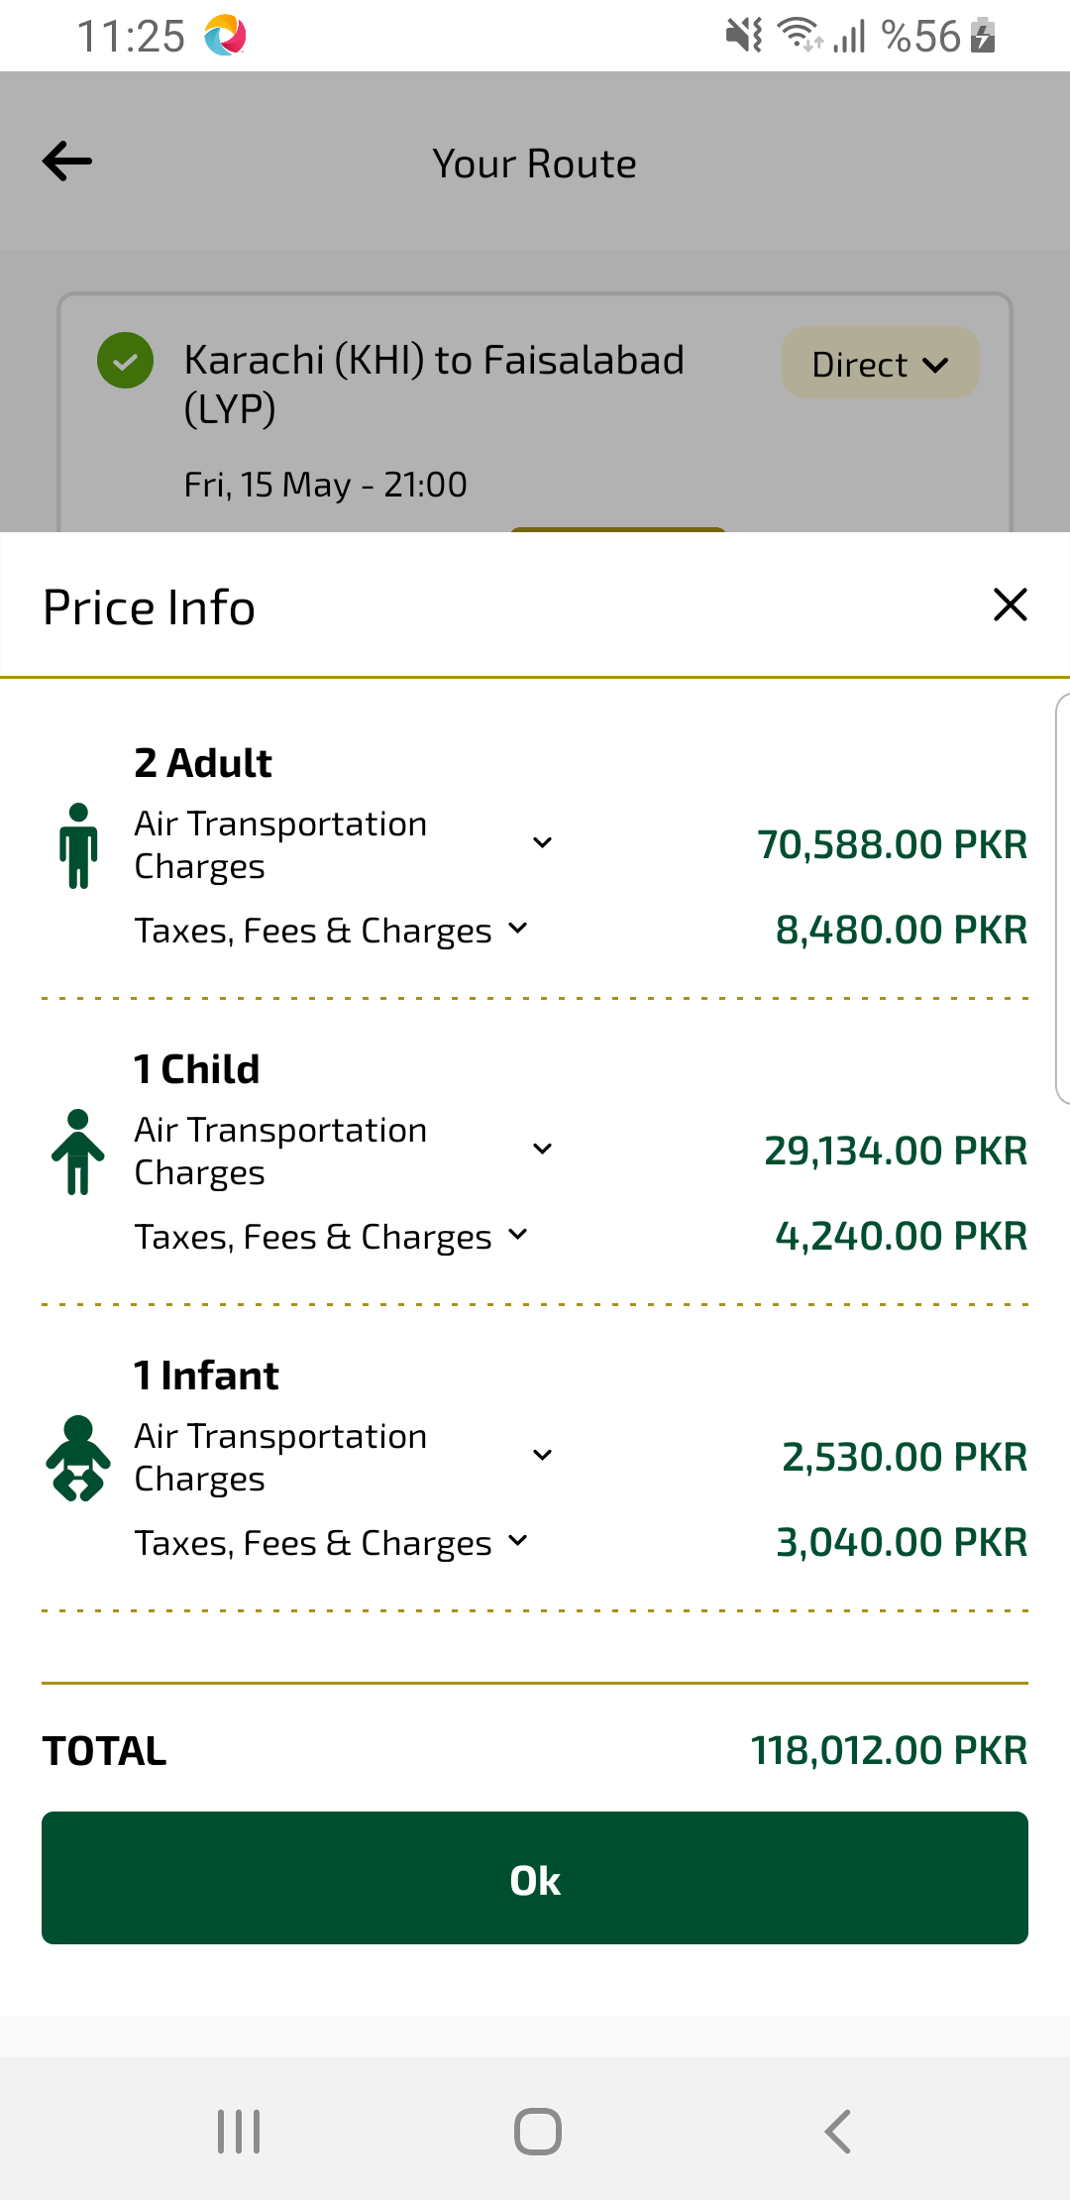
totalPriceDetail sayfası ekran görüntüsü

