Accessibility Report — upcomingFlights
Tarih: 01.04.2026 12:47 | Platform: ANDROID

Element ID | Page | Type | Label / Text | Value | Resource ID | Status | New Status
upcomingFlights_element_1 | MainActivity | ViewGroup | Karachi (KHI) to Faisalabad (LYP), Fri, 03 Apr - 21:00, 1h 45min - PK 340, 1 Adult, Yunus E Sahin |  |  | ID Yok | ID Eklenecek (Waiting Dev)
upcomingFlights_element_2 | MainActivity | ViewGroup | Direct |  |  | ID Yok | ID Eklenecek (Waiting Dev)
upcomingFlights_element_3 | MainActivity | ViewGroup | Manage Booking |  |  | ID Yok | ID Eklenecek (Waiting Dev)
upcomingFlights_element_4 | MainActivity | ViewGroup | Karachi (KHI) to Jeddah (JED), Thu, 02 Apr - 22:25, 4h 35min - PK 731, 1 Adult, Yunus E Sahin |  |  | ID Yok | ID Eklenecek (Waiting Dev)
upcomingFlights_element_5 | MainActivity | ViewGroup | Direct |  |  | ID Yok | ID Eklenecek (Waiting Dev)
upcomingFlights_element_6 | MainActivity | ViewGroup | Manage Booking |  |  | ID Yok | ID Eklenecek (Waiting Dev)
upcomingFlights_element_7 | MainActivity | ViewGroup | Upcoming Flights |  | ly_my_tickets_switch | Duplicate | ID Eklenecek (Waiting Dev)
upcomingFlights_element_8 | MainActivity | ViewGroup | Past Flights |  | ly_my_tickets_switch | Duplicate | ID Eklenecek (Waiting Dev)

📸 Ekran Görüntüsü
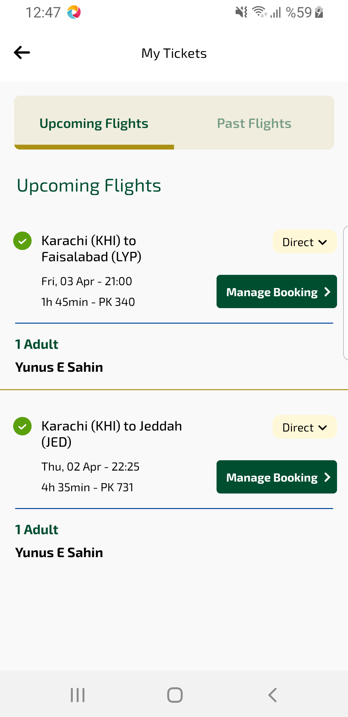
upcomingFlights sayfası ekran görüntüsü

