Accessibility Report — yourRoute
Tarih: 01.04.2026 11:24 | Platform: ANDROID

Element ID | Page | Type | Label / Text | Value | Resource ID | Status | New Status
yourRoute_element_1 | MainActivity | ViewGroup | Karachi (KHI) to Faisalabad (LYP), Fri, 15 May - 21:00, 1h 45min - PK 340, ECONOMY |  |  | ID Yok | ID Eklenecek (Waiting Dev)
yourRoute_element_2 | MainActivity | ViewGroup | Direct |  |  | ID Yok | ID Eklenecek (Waiting Dev)
yourRoute_element_3 | MainActivity | ViewGroup | Faisalabad (LYP) to Karachi (KHI), Sun, 17 May - 17:30, 1h 45min - PK 341, ECONOMY |  |  | ID Yok | ID Eklenecek (Waiting Dev)
yourRoute_element_4 | MainActivity | ViewGroup | Direct |  |  | ID Yok | ID Eklenecek (Waiting Dev)
yourRoute_element_5 | MainActivity | ViewGroup | Total , 118,012.00￼PKR |  |  | ID Yok | ID Eklenecek (Waiting Dev)
yourRoute_element_6 | MainActivity | ViewGroup |  |  | your_route_header | ID Var
yourRoute_element_7 | MainActivity | ViewGroup | Continue |  | your_route_continue_button | ID Var

📸 Ekran Görüntüsü
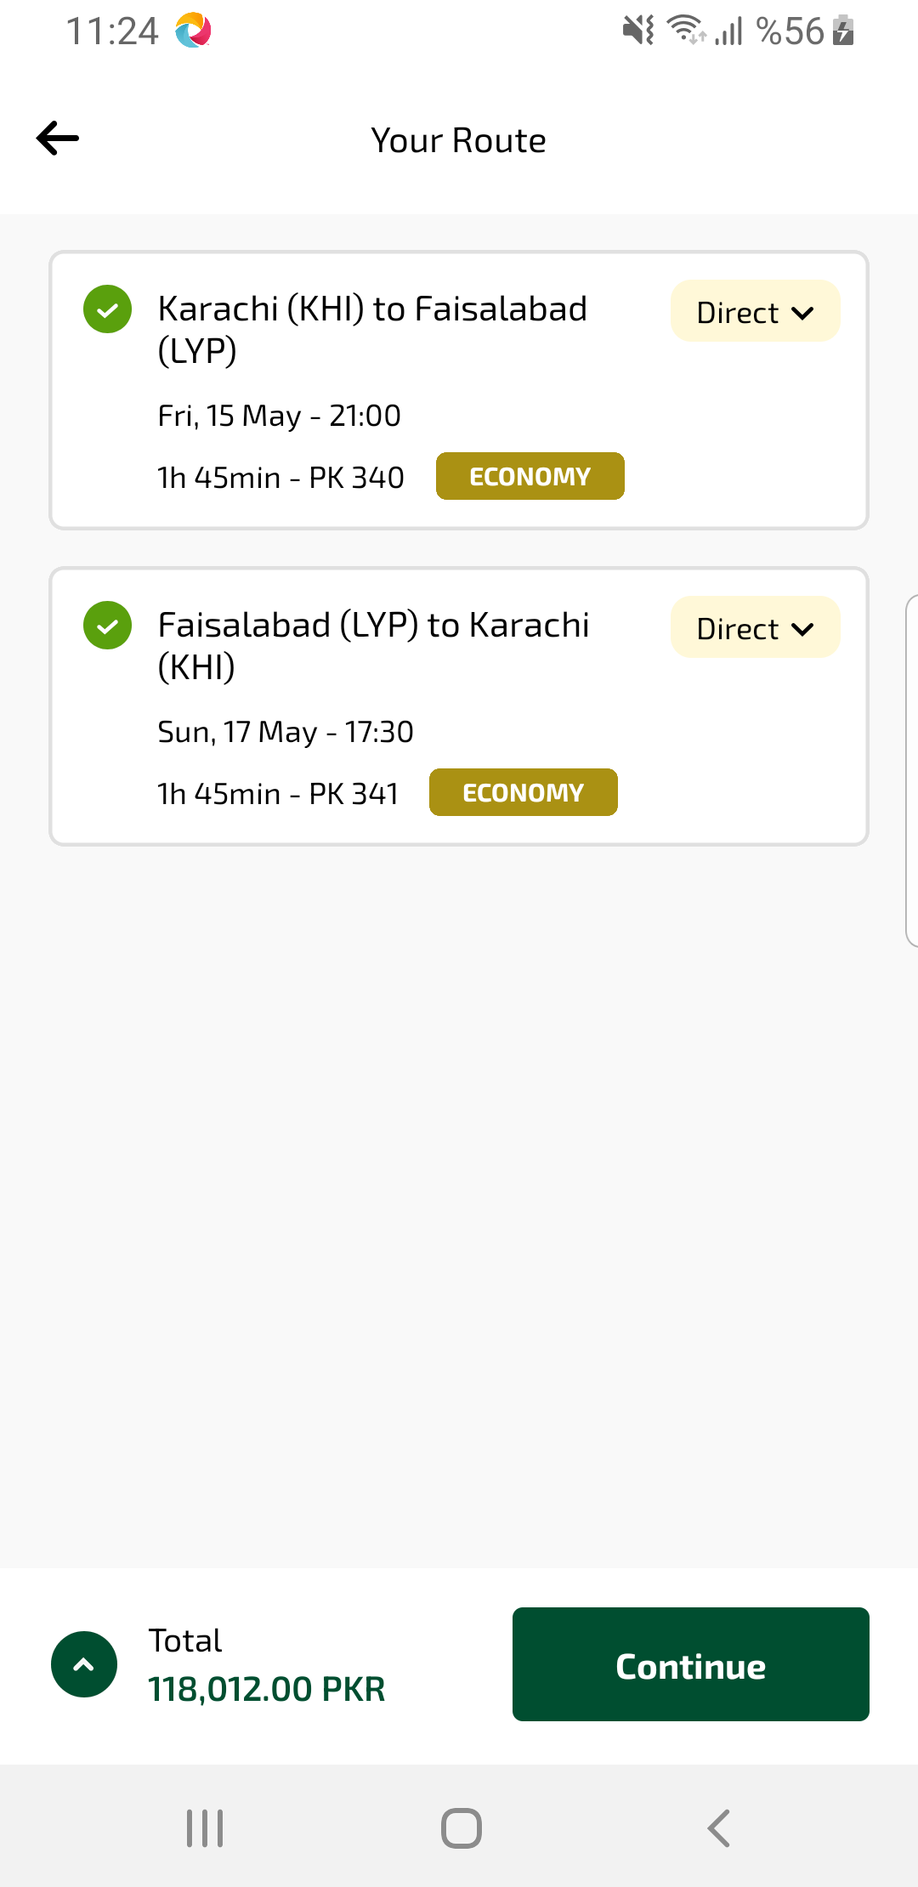
yourRoute sayfası ekran görüntüsü

