Accessibility ID Report — FlightCancelSelectFlight_ios
Tarih: 31.03.2026 11:25 | Platform: iOS

Element ID | Page | Type | Label / Text | Value | Accessibility ID | Status | New Status
FlightCancelSelectFlight_ios_element_1 | Cancel Flight | Other |  |  |  | ID Yok | ID Eklenecek (Waiting Dev)
FlightCancelSelectFlight_ios_element_2 | Cancel Flight | Other | Continue |  | cancel_flight_continue_button | ID Var
FlightCancelSelectFlight_ios_element_3 | Cancel Flight | Other | Karachi (KHI) to Faisalabad (LYP), Fri, 10 Apr - 21:00, 1h 45min - PK 340, ECONOMY, Direct |  | cancel_flight_trip_card | ID Var

📸 Ekran Görüntüsü
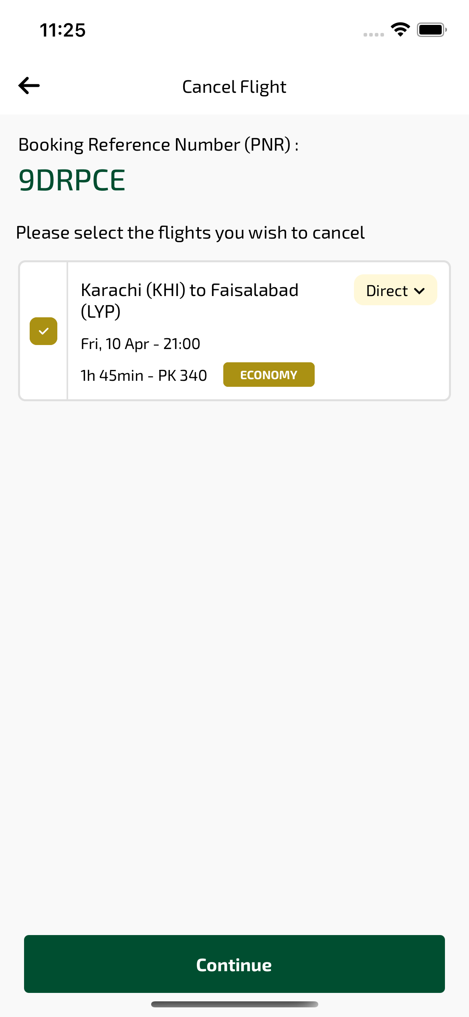
FlightCancelSelectFlight_ios sayfası ekran görüntüsü

