Accessibility ID Report — boardingPass
Tarih: 31.03.2026 15:08 | Platform: iOS

Element ID | Page | Type | Label / Text | Value | Accessibility ID | Status | New Status
boardingPass_element_1 | Boarding Pass | Other |  |  |  | ID Yok | ID Eklenecek (Waiting Dev)
boardingPass_element_2 | Boarding Pass | Other |  |  |  | ID Yok | ID Eklenecek (Waiting Dev)
boardingPass_element_3 | Boarding Pass | Other |  |  |  | ID Yok | ID Eklenecek (Waiting Dev)
boardingPass_element_4 | Boarding Pass | Other |  |  | check_in_success_pass_back_button | ID Var
boardingPass_element_5 | Boarding Pass | Other |  |  | check_in_success_pass_qr_code | ID Var

📸 Ekran Görüntüsü
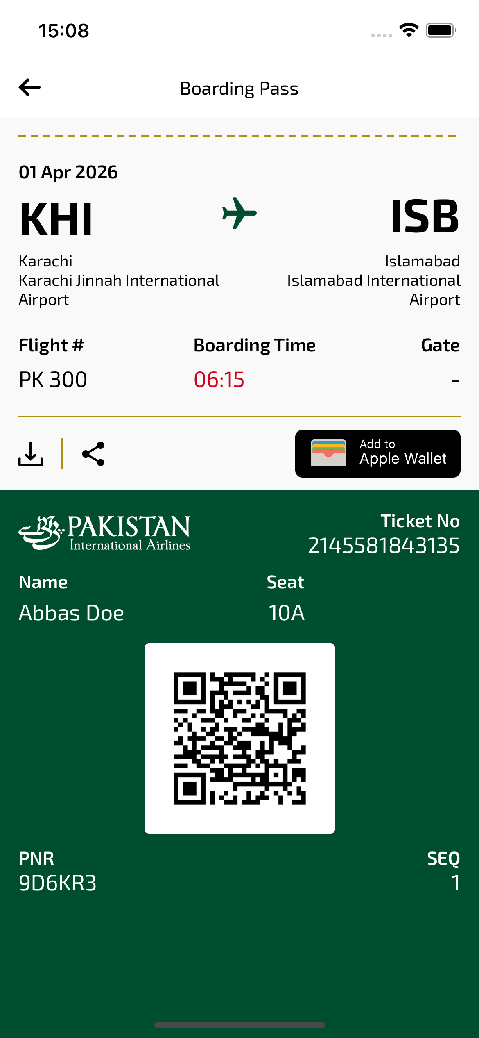
boardingPass sayfası ekran görüntüsü

