Accessibility ID Report — bookingSuccess_ios
Tarih: 31.03.2026 00:56 | Platform: IOS

Element ID | Page | Type | Label / Text | Value | Accessibility ID | Status | New Status
bookingSuccess_ios_element_1 | Payment Success! | Other |  |  |  | ID Yok | ID Eklenecek (Waiting Dev)
bookingSuccess_ios_element_2 | Payment Success! | Other | Log in |  |  | ID Yok | ID Eklenecek (Waiting Dev)
bookingSuccess_ios_element_3 | Payment Success! | Other | Flight Schedule |  |  | ID Yok | ID Eklenecek (Waiting Dev)
bookingSuccess_ios_element_4 | Payment Success! | Other | Flight Status |  |  | ID Yok | ID Eklenecek (Waiting Dev)
bookingSuccess_ios_element_5 | Payment Success! | Other | Feedback |  |  | ID Yok | ID Eklenecek (Waiting Dev)
bookingSuccess_ios_element_6 | Payment Success! | Other | Notifications |  |  | ID Yok | ID Eklenecek (Waiting Dev)
bookingSuccess_ios_element_7 | Payment Success! | Other | Gift Card |  |  | ID Yok | ID Eklenecek (Waiting Dev)
bookingSuccess_ios_element_8 | Payment Success! | Other | Settings |  |  | ID Yok | ID Eklenecek (Waiting Dev)
bookingSuccess_ios_element_9 | Payment Success! | Other | Contact us |  |  | ID Yok | ID Eklenecek (Waiting Dev)
bookingSuccess_ios_element_10 | Payment Success! | Other | PNR No, 9DRPCE |  |  | ID Yok | ID Eklenecek (Waiting Dev)
bookingSuccess_ios_element_11 | Payment Success! | Other | Karachi (KHI) to Faisalabad (LYP), Fri, 10 Apr - 21:00, 1h 45min - PK 340, ECONOMY, Direct |  |  | ID Yok | ID Eklenecek (Waiting Dev)
bookingSuccess_ios_element_12 | Payment Success! | Other | Abc Test, E-Ticket Number:, 2142431220405, Karachi - , Faisalabad, Flight Extras, 4A, 5 KG |  |  | ID Yok | ID Eklenecek (Waiting Dev)
bookingSuccess_ios_element_13 | Payment Success! | Other | Ddf Fgt, E-Ticket Number:, 2142431220406 |  |  | ID Yok | ID Eklenecek (Waiting Dev)
bookingSuccess_ios_element_14 | Payment Success! | Other | Rrr Cff, E-Ticket Number:, 2142431220407 |  |  | ID Yok | ID Eklenecek (Waiting Dev)
bookingSuccess_ios_element_15 | Payment Success! | Other | Ggg Fff, E-Ticket Number:, 2142431220408 |  |  | ID Yok | ID Eklenecek (Waiting Dev)
bookingSuccess_ios_element_16 | Payment Success! | Other | Go to Manage Booking |  | payment_success_mbk_button | ID Var

📸 Ekran Görüntüsü
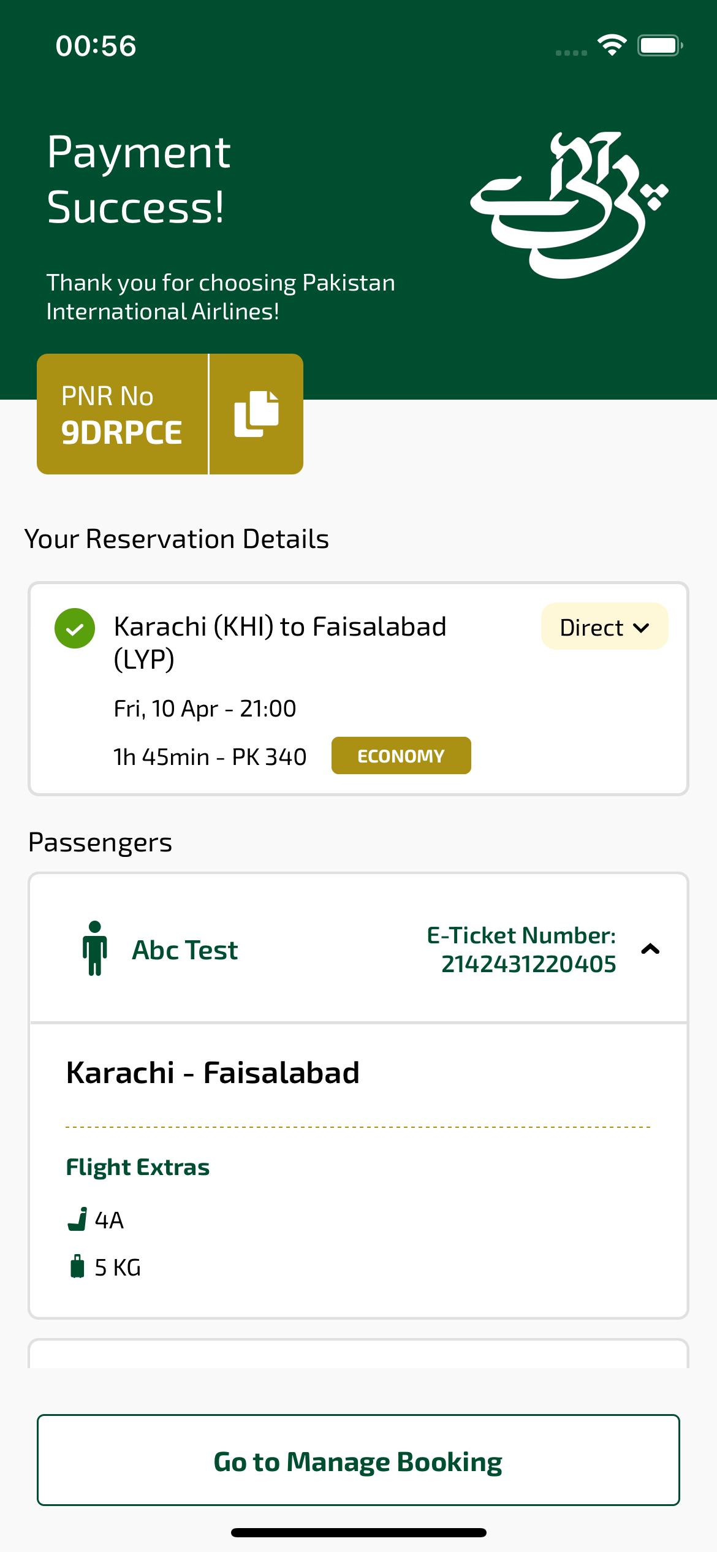
bookingSuccess_ios sayfası ekran görüntüsü

