Accessibility ID Report — cancelFlightSuccess_ios
Tarih: 31.03.2026 11:27 | Platform: iOS

Element ID | Page | Type | Label / Text | Value | Accessibility ID | Status | New Status
cancelFlightSuccess_ios_element_1 | Cancellation  Success! | Other | Karachi (KHI) to Faisalabad (LYP), Fri, 10 Apr - 21:00, 1h 45min - PK 340, ECONOMY, Direct |  |  | ID Yok | ID Eklenecek (Waiting Dev)
cancelFlightSuccess_ios_element_2 | Cancellation  Success! | Other | Back to home |  | cancel_flight_success_mbk_button | ID Var

📸 Ekran Görüntüsü
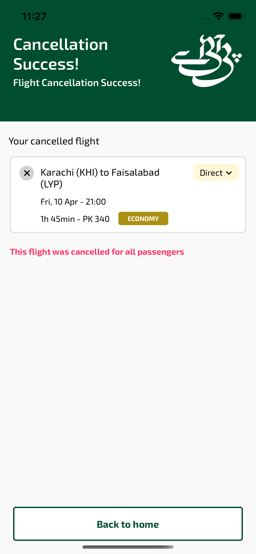
cancelFlightSuccess_ios sayfası ekran görüntüsü

