Accessibility ID Report — cancelFlightYesNoPopup_ios
Tarih: 31.03.2026 11:26 | Platform: iOS

Element ID | Page | Type | Label / Text | Value | Accessibility ID | Status | New Status
cancelFlightYesNoPopup_ios_element_1 | Cancel Flight | Other | Bottom Sheet |  |  | ID Yok | ID Eklenecek (Waiting Dev)
cancelFlightYesNoPopup_ios_element_2 | Cancel Flight | Other |  |  |  | ID Yok | ID Eklenecek (Waiting Dev)
cancelFlightYesNoPopup_ios_element_3 | Cancel Flight | Other |  |  |  | ID Yok | ID Eklenecek (Waiting Dev)
cancelFlightYesNoPopup_ios_element_4 | Cancel Flight | Other | Cancellation Rules |  |  | ID Yok | ID Eklenecek (Waiting Dev)
cancelFlightYesNoPopup_ios_element_5 | Cancel Flight | Other | Karachi (KHI) to Faisalabad (LYP), Fri, 10 Apr - 21:00, 1h 45min - PK 340, ECONOMY, Direct |  |  | ID Yok | ID Eklenecek (Waiting Dev)
cancelFlightYesNoPopup_ios_element_6 | Cancel Flight | Other | Abc Test, E-Ticket Number:, 2142431220405, Karachi - , Faisalabad, Not Checked-in, Check-in Unavailable, Flight Extras, 4A, 5 KG |  |  | ID Yok | ID Eklenecek (Waiting Dev)
cancelFlightYesNoPopup_ios_element_7 | Cancel Flight | Other | Ddf Fgt, E-Ticket Number:, 2142431220406 |  |  | ID Yok | ID Eklenecek (Waiting Dev)
cancelFlightYesNoPopup_ios_element_8 | Cancel Flight | Other | Rrr Cff, E-Ticket Number:, 2142431220407 |  |  | ID Yok | ID Eklenecek (Waiting Dev)
cancelFlightYesNoPopup_ios_element_9 | Cancel Flight | Other | Ggg Fff, E-Ticket Number:, 2142431220408 |  |  | ID Yok | ID Eklenecek (Waiting Dev)
cancelFlightYesNoPopup_ios_element_10 | Cancel Flight | Other | Amount to be returned, 163.78EUR |  |  | ID Yok | ID Eklenecek (Waiting Dev)
cancelFlightYesNoPopup_ios_element_11 | Cancel Flight | Other | No |  | cancel_flight_summary_modal_neg_button | ID Var
cancelFlightYesNoPopup_ios_element_12 | Cancel Flight | Other | Yes |  | cancel_flight_summary_modal_pos_button | ID Var
cancelFlightYesNoPopup_ios_element_13 | Cancel Flight | Other |  |  | cancel_flight_summary_terms_check_box | ID Var
cancelFlightYesNoPopup_ios_element_14 | Cancel Flight | Other | Cancel Flight |  | cancel_flight_summary_continue_button | ID Var

📸 Ekran Görüntüsü
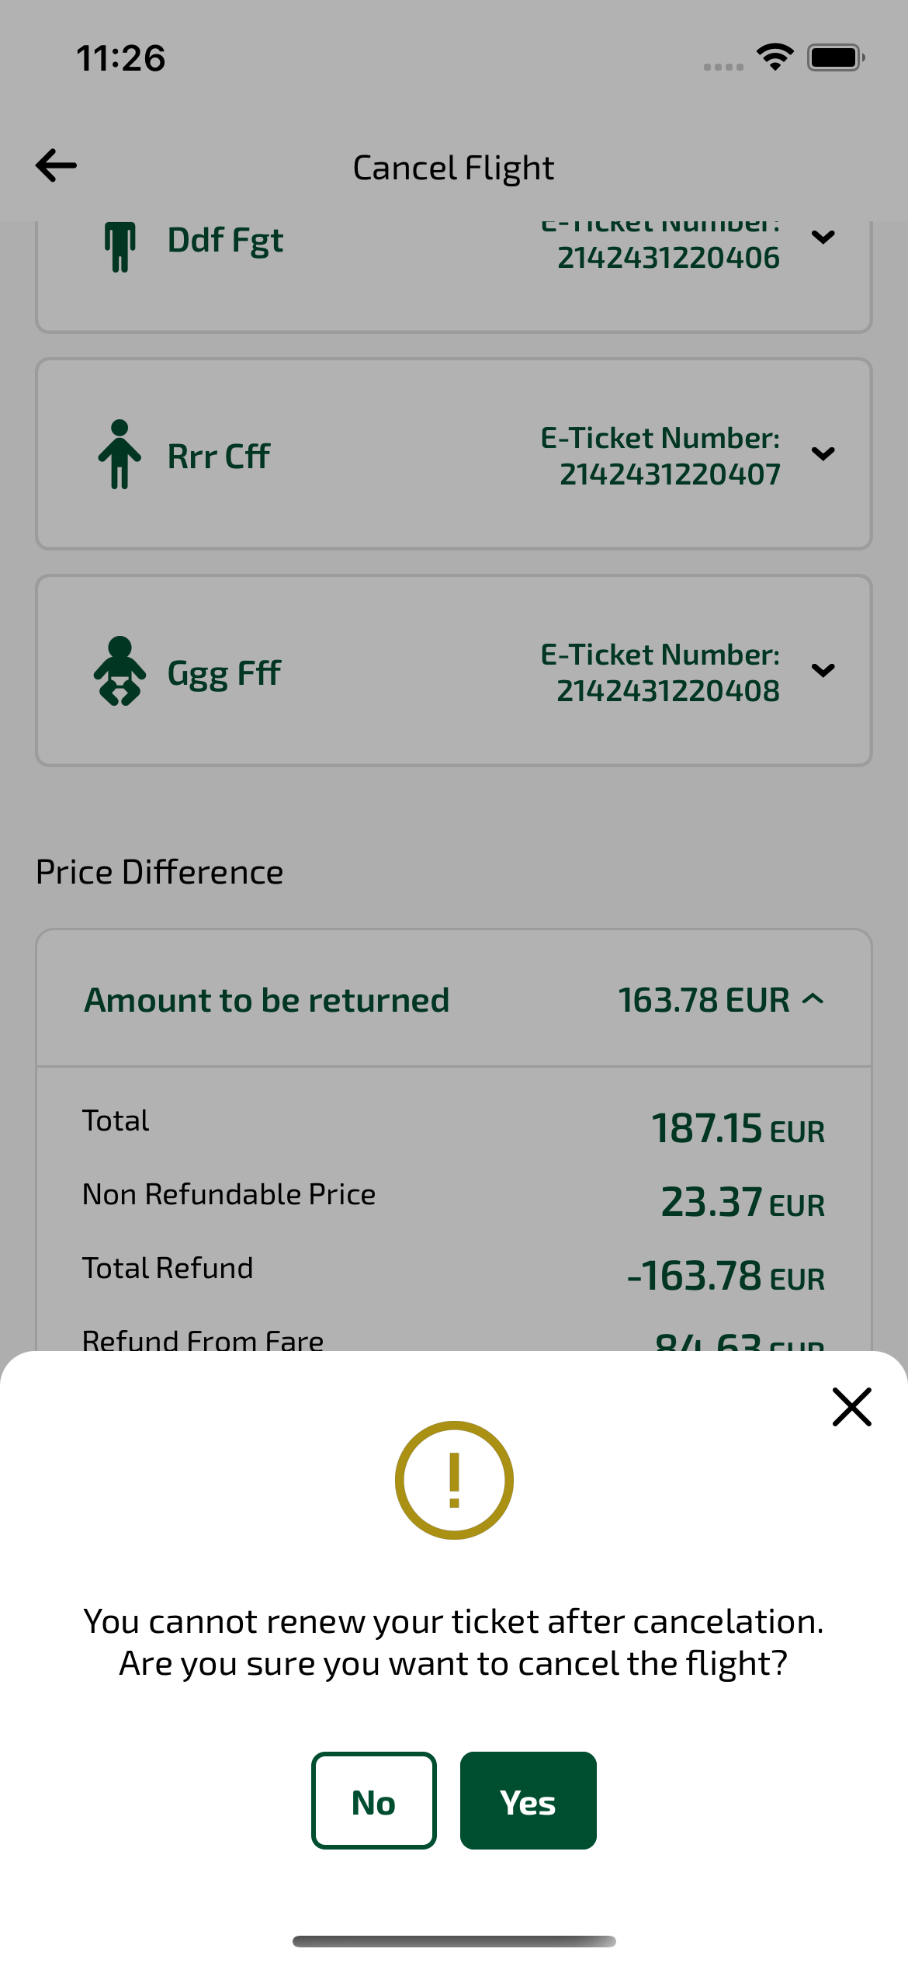
cancelFlightYesNoPopup_ios sayfası ekran görüntüsü

