Accessibility ID Report — changeFlightSearchNewFlight_ios
Tarih: 31.03.2026 11:18 | Platform: iOS

Element ID | Page | Type | Label / Text | Value | Accessibility ID | Status | New Status
changeFlightSearchNewFlight_ios_element_1 | Change Flight | Other |  |  |  | ID Yok | ID Eklenecek (Waiting Dev)
changeFlightSearchNewFlight_ios_element_2 | Change Flight | Other | Passengers, 2 Adult, , 1 Child, , 1 Infant |  |  | ID Yok | ID Eklenecek (Waiting Dev)
changeFlightSearchNewFlight_ios_element_3 | Change Flight | Other | Departure, Karachi - Karachi Jinnah International Airport(KHI) |  |  | ID Yok | ID Eklenecek (Waiting Dev)
changeFlightSearchNewFlight_ios_element_4 | Change Flight | Other | Arrival, Faisalabad - Faisalabad International Airport(LYP) |  |  | ID Yok | ID Eklenecek (Waiting Dev)
changeFlightSearchNewFlight_ios_element_5 | Change Flight | Other | Find a Flight |  | change_flight_search_find_flight_button | ID Var
changeFlightSearchNewFlight_ios_element_6 | Change Flight | Other | Departure Date, Select |  | change_flight_search_dep_date_card | ID Var
changeFlightSearchNewFlight_ios_element_7 | Change Flight | Other | Class, Economy |  | change_flight_search_cabin_class_card | ID Var

📸 Ekran Görüntüsü
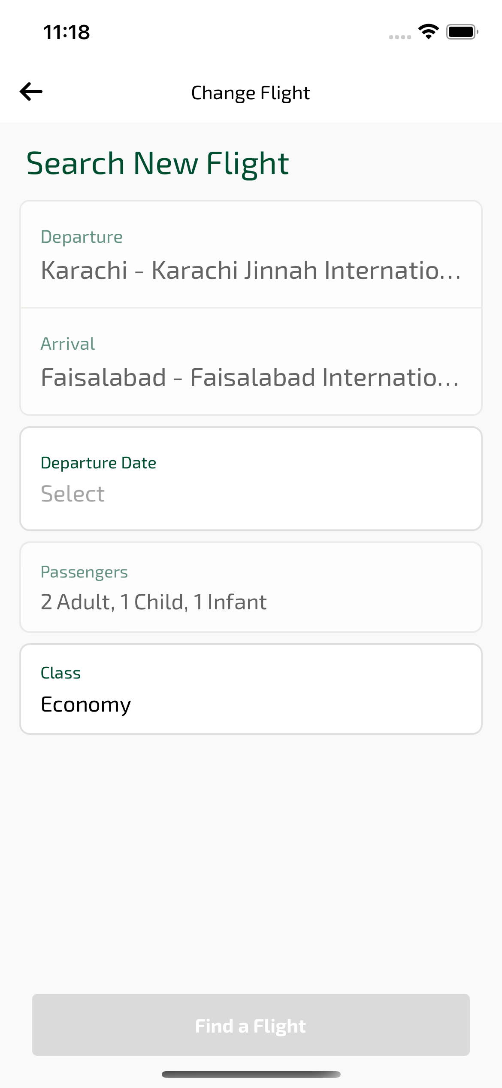
changeFlightSearchNewFlight_ios sayfası ekran görüntüsü

