Accessibility ID Report — changeFlightSelectBundle_ios
Tarih: 31.03.2026 11:20 | Platform: iOS

Element ID | Page | Type | Label / Text | Value | Accessibility ID | Status | New Status
changeFlightSelectBundle_ios_element_1 | Fares | Other |  |  |  | ID Yok | ID Eklenecek (Waiting Dev)
changeFlightSelectBundle_ios_element_2 | Fares | Other | LIGHT, Lowest Price, Free Carry-On Baggage, Free Meal/Beverages, Seat Selection (*charges apply), Booking Change (*charges apply), Cancellation/Refund (*charges apply), No Check-in Baggage, 64.28EUR |  |  | ID Yok | ID Eklenecek (Waiting Dev)
changeFlightSelectBundle_ios_element_3 | Fares | Other | STANDARD, Free Carry-On Baggage, Free Meal/Beverages, Seat Selection (*charges apply), One change free either side (Bef. 72 hrs), next with a fee, Cancellation/Refund (*charges apply), Check-in Baggage 20 KG, 63.28EUR |  |  | ID Yok | ID Eklenecek (Waiting Dev)
changeFlightSelectBundle_ios_element_4 | Fares | Other | FREEDOM, Free Carry-On Baggage, Free Meal/Beverages, Free Standard Seat Selection, One change free on each side (Bef. 48 hrs), next with a fee, Free refund, Before 48 hrs of Departure, Check-in Baggage 30 KG, 66.28EUR |  |  | ID Yok | ID Eklenecek (Waiting Dev)

📸 Ekran Görüntüsü
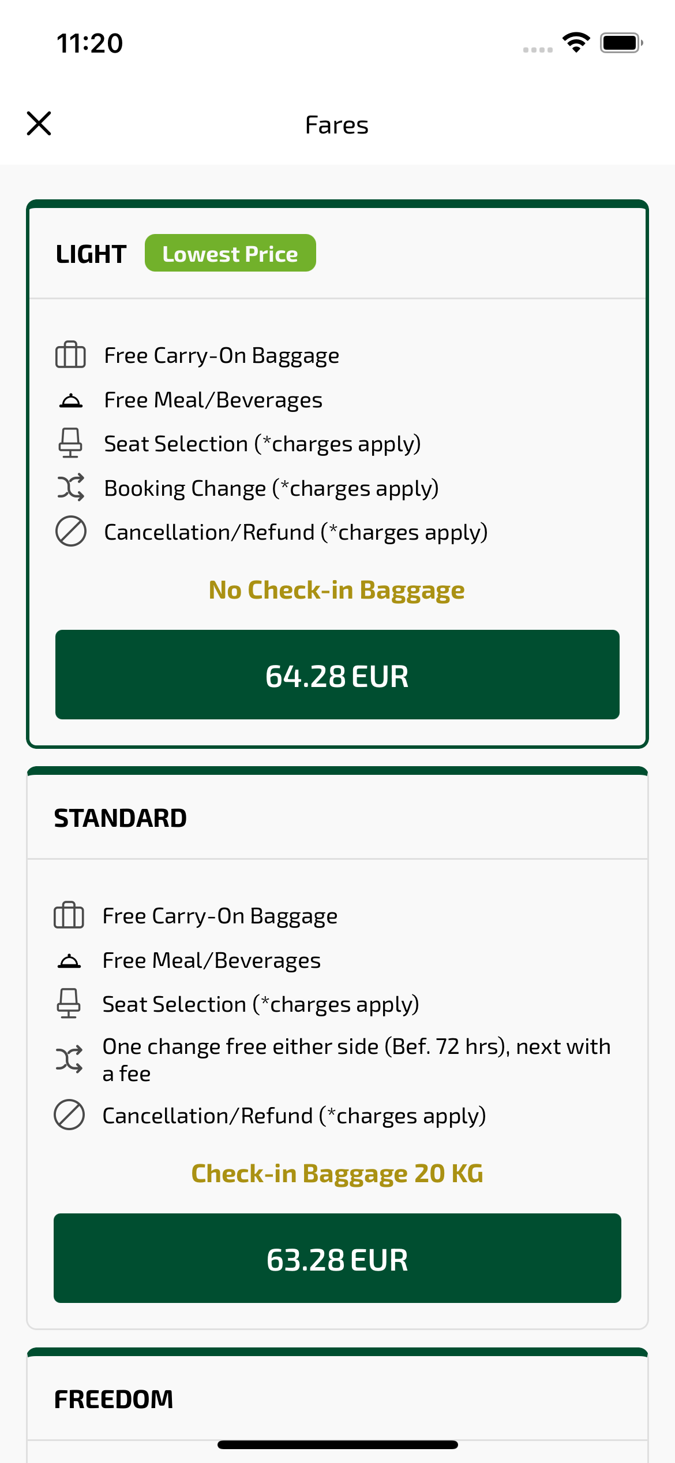
changeFlightSelectBundle_ios sayfası ekran görüntüsü

