Accessibility ID Report — changeFlightSelectDepFlight_ios
Tarih: 31.03.2026 11:19 | Platform: iOS

Element ID | Page | Type | Label / Text | Value | Accessibility ID | Status | New Status
changeFlightSelectDepFlight_ios_element_1 | Select Departure Flight | Other | Bottom Sheet |  |  | ID Yok | ID Eklenecek (Waiting Dev)
changeFlightSelectDepFlight_ios_element_2 | Select Departure Flight | Other | Flight Info |  |  | ID Yok | ID Eklenecek (Waiting Dev)
changeFlightSelectDepFlight_ios_element_3 | Select Departure Flight | Other |  |  |  | ID Yok | ID Eklenecek (Waiting Dev)
changeFlightSelectDepFlight_ios_element_4 | Select Departure Flight | Other | Executive Economy |  |  | ID Yok | ID Eklenecek (Waiting Dev)
changeFlightSelectDepFlight_ios_element_5 | Select Departure Flight | Other | Economy |  |  | ID Yok | ID Eklenecek (Waiting Dev)
changeFlightSelectDepFlight_ios_element_6 | Select Departure Flight | Other | Business |  |  | ID Yok | ID Eklenecek (Waiting Dev)
changeFlightSelectDepFlight_ios_element_7 | Select Departure Flight | Other | 29 , Apr, Wed, Search |  |  | ID Yok | ID Eklenecek (Waiting Dev)
changeFlightSelectDepFlight_ios_element_8 | Select Departure Flight | Other | 30 , Apr, Thu, Search |  |  | ID Yok | ID Eklenecek (Waiting Dev)
changeFlightSelectDepFlight_ios_element_9 | Select Departure Flight | Other | 01 , May, Fri, 63EUR |  |  | ID Yok | ID Eklenecek (Waiting Dev)
changeFlightSelectDepFlight_ios_element_10 | Select Departure Flight | Other | 02 , May, Sat, Search |  |  | ID Yok | ID Eklenecek (Waiting Dev)
changeFlightSelectDepFlight_ios_element_11 | Select Departure Flight | Other | 03 , May, Sun, Search |  |  | ID Yok | ID Eklenecek (Waiting Dev)
changeFlightSelectDepFlight_ios_element_12 | Select Departure Flight | Other | Select |  | change_flight_avail_select_button | ID Var
changeFlightSelectDepFlight_ios_element_13 | Select Departure Flight | Other | 21:00, 22:45, 1h 45min, PK 340, Direct, 63.28EUR |  | change_flight_avail_flight_item_direct | ID Var

📸 Ekran Görüntüsü
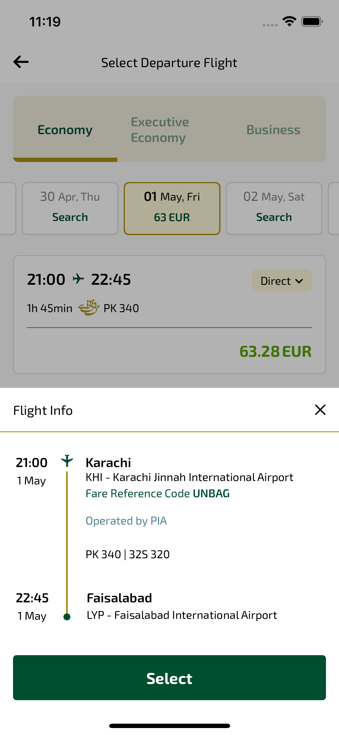
changeFlightSelectDepFlight_ios sayfası ekran görüntüsü

