Accessibility ID Report — changeFlightSelectFlightRt
Tarih: 31.03.2026 15:18 | Platform: iOS

Element ID | Page | Type | Label / Text | Value | Accessibility ID | Status | New Status
changeFlightSelectFlightRt_element_1 | Change Flight | Other |  |  |  | ID Yok | ID Eklenecek (Waiting Dev)
changeFlightSelectFlightRt_element_2 | Change Flight | Other | Islamabad (ISB) to Gilgit (GIL), Wed, 01 Apr - 07:00, 1h 15min - PK 601, ECONOMY, Direct |  | change_flight_trip_card | Duplicate | ID Eklenecek (Waiting Dev)
changeFlightSelectFlightRt_element_3 | Change Flight | Other | Gilgit (GIL) to Islamabad (ISB), Sun, 05 Apr - 09:05, 1h 15min - PK 602, ECONOMY, Direct |  | change_flight_trip_card | Duplicate | ID Eklenecek (Waiting Dev)
changeFlightSelectFlightRt_element_4 | Change Flight | Other | Continue |  | change_flight_continue_button | ID Var

📸 Ekran Görüntüsü
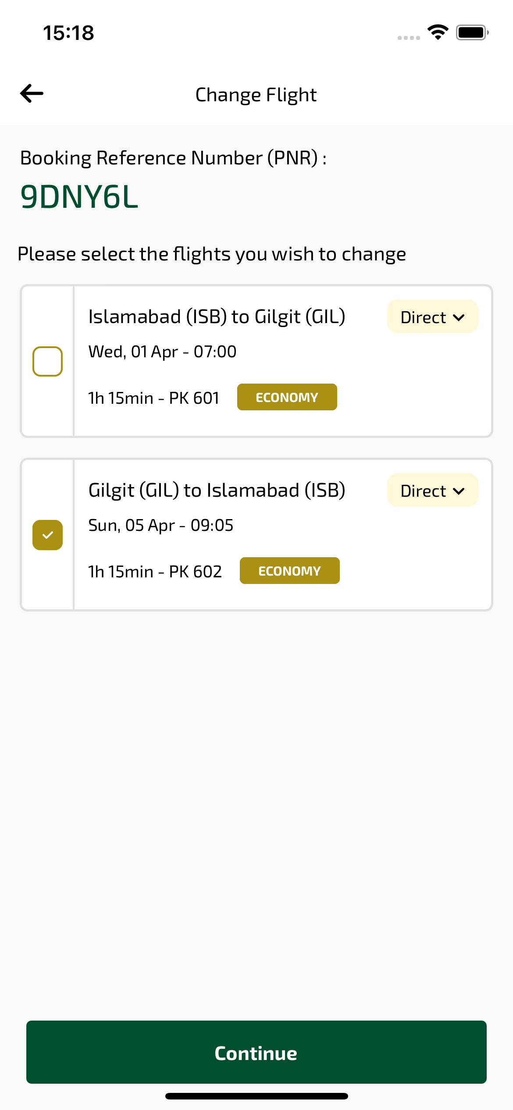
changeFlightSelectFlightRt sayfası ekran görüntüsü

