Accessibility ID Report — changeFlightSelectFlight_ios
Tarih: 31.03.2026 11:18 | Platform: iOS

Element ID | Page | Type | Label / Text | Value | Accessibility ID | Status | New Status
changeFlightSelectFlight_ios_element_1 | Change Flight | Other |  |  |  | ID Yok | ID Eklenecek (Waiting Dev)
changeFlightSelectFlight_ios_element_2 | Change Flight | Other | Continue |  | change_flight_continue_button | ID Var
changeFlightSelectFlight_ios_element_3 | Change Flight | Other | Karachi (KHI) to Faisalabad (LYP), Fri, 10 Apr - 21:00, 1h 45min - PK 340, ECONOMY, Direct |  | change_flight_trip_card | ID Var

📸 Ekran Görüntüsü
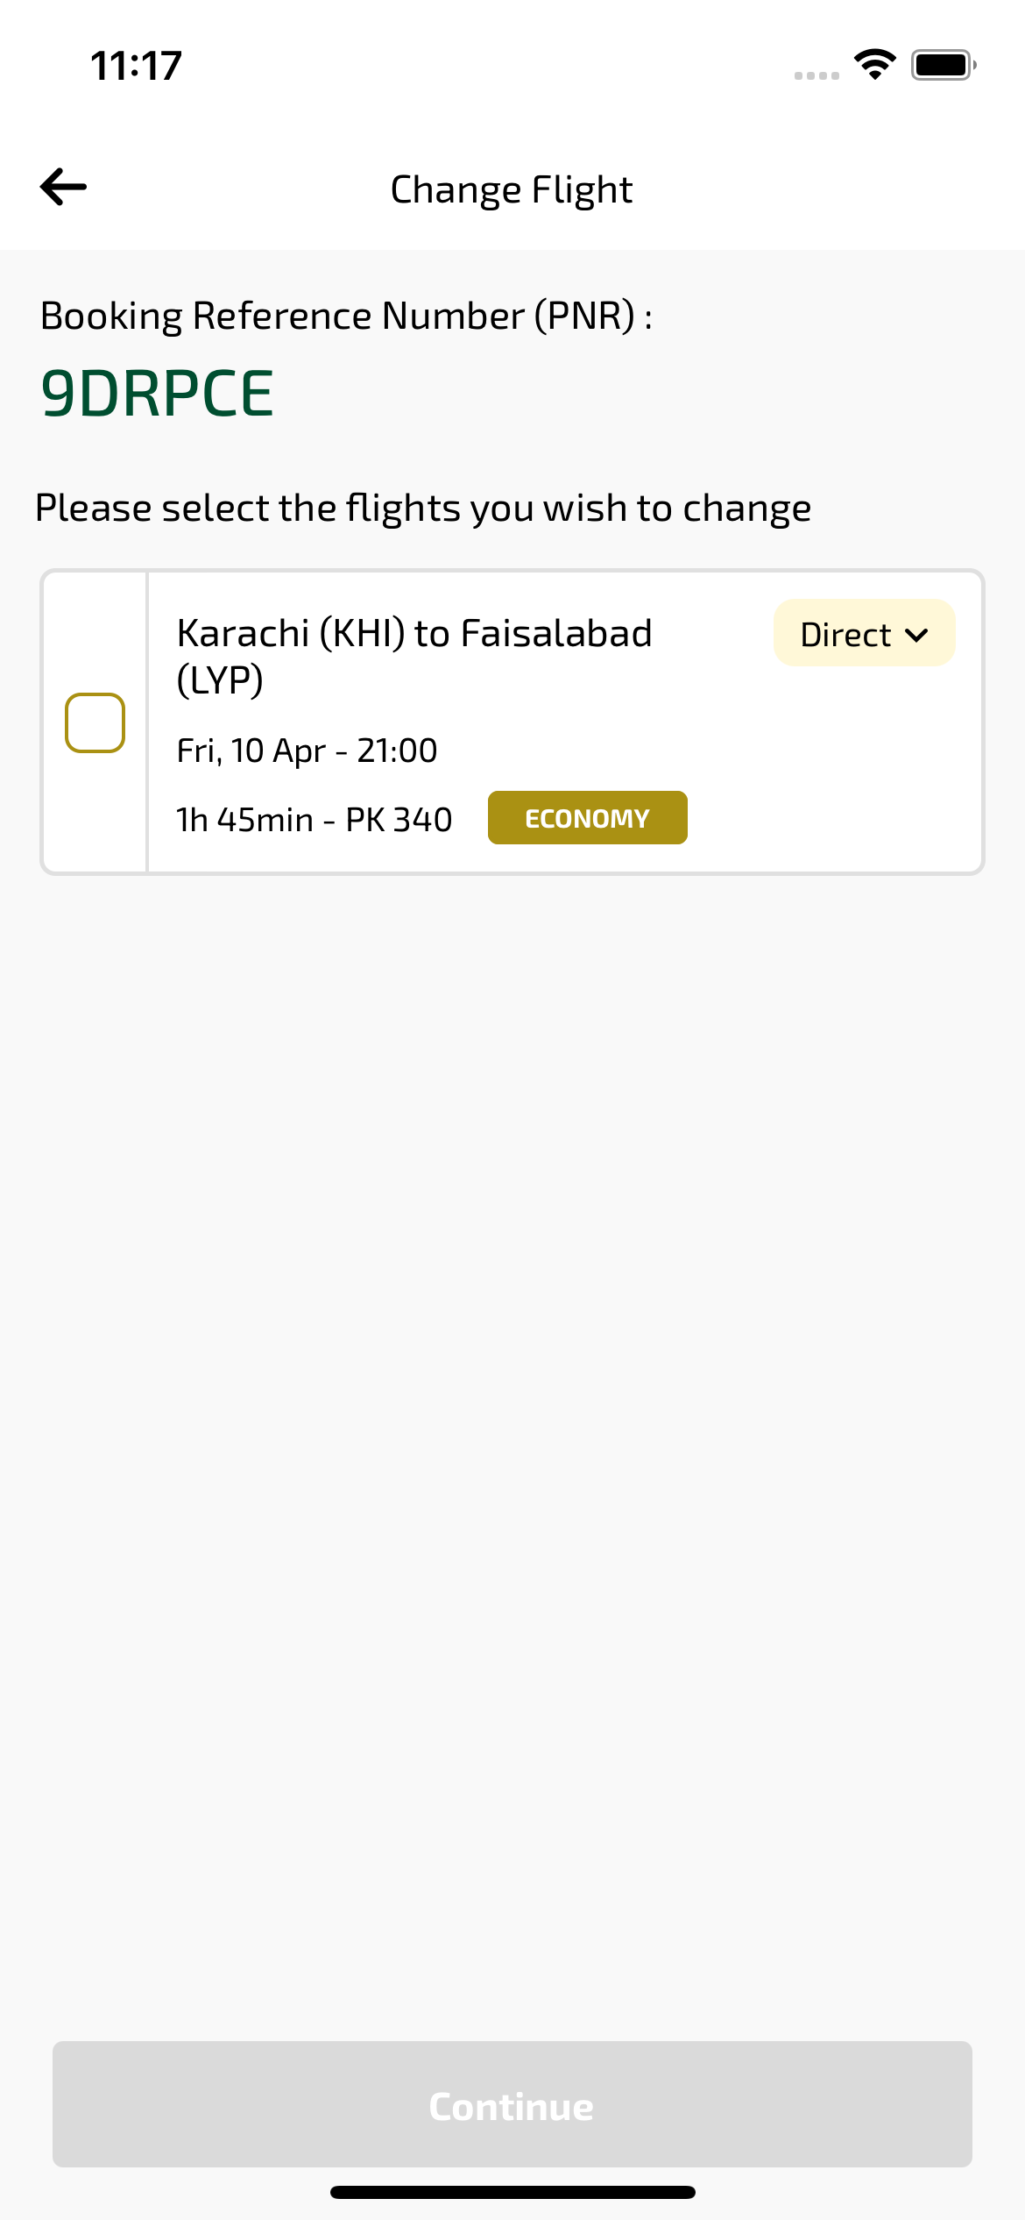
changeFlightSelectFlight_ios sayfası ekran görüntüsü

