Accessibility ID Report — changeFlightYesNoPopup_ios
Tarih: 31.03.2026 11:21 | Platform: iOS

Element ID | Page | Type | Label / Text | Value | Accessibility ID | Status | New Status
changeFlightYesNoPopup_ios_element_1 | Change Flight | Other | Bottom Sheet |  |  | ID Yok | ID Eklenecek (Waiting Dev)
changeFlightYesNoPopup_ios_element_2 | Change Flight | Other |  |  |  | ID Yok | ID Eklenecek (Waiting Dev)
changeFlightYesNoPopup_ios_element_3 | Change Flight | Other |  |  |  | ID Yok | ID Eklenecek (Waiting Dev)
changeFlightYesNoPopup_ios_element_4 | Change Flight | Other | Karachi (KHI) to Faisalabad (LYP), Fri, 10 Apr - 21:00, 1h 45min - PK 340, ECONOMY, Direct |  |  | ID Yok | ID Eklenecek (Waiting Dev)
changeFlightYesNoPopup_ios_element_5 | Change Flight | Other | Karachi (KHI) to Faisalabad (LYP), Fri, 01 May - 21:00, 1h 45min - PK 340, ECONOMY, Direct |  |  | ID Yok | ID Eklenecek (Waiting Dev)
changeFlightYesNoPopup_ios_element_6 | Change Flight | Other | Amount to be paid , 31.69EUR |  |  | ID Yok | ID Eklenecek (Waiting Dev)
changeFlightYesNoPopup_ios_element_7 | Change Flight | Other | Yes |  | change_flight_summary_modal_pos_button | ID Var
changeFlightYesNoPopup_ios_element_8 | Change Flight | Other | No |  | change_flight_summary_modal_neg_button | ID Var
changeFlightYesNoPopup_ios_element_9 | Change Flight | Other | Continue |  | change_flight_summary_continue_button | ID Var

📸 Ekran Görüntüsü
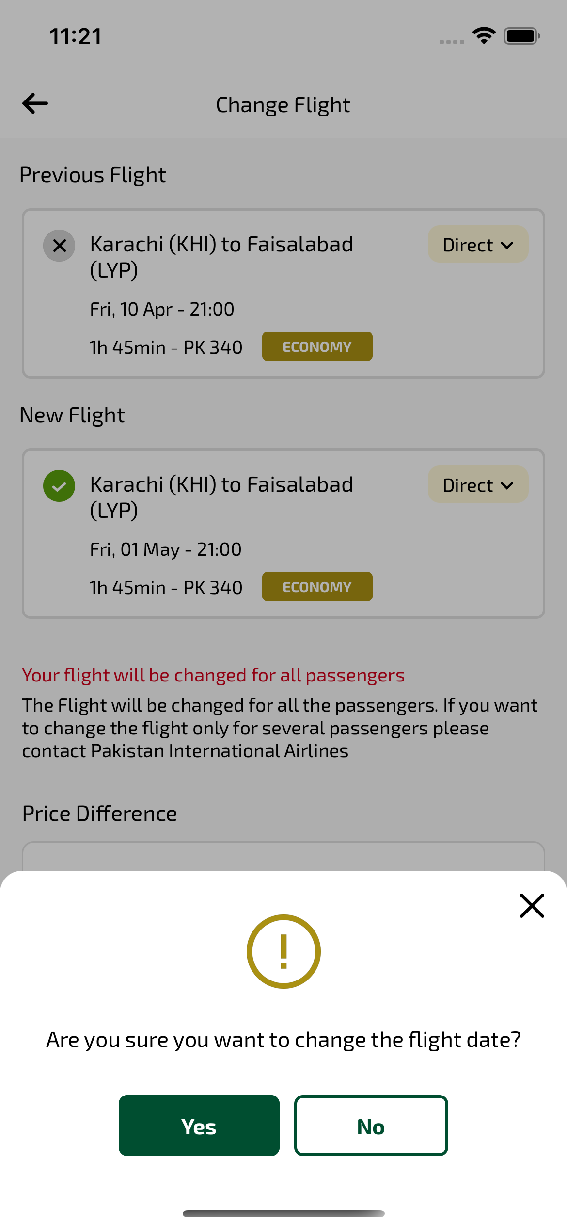
changeFlightYesNoPopup_ios sayfası ekran görüntüsü

