Accessibility ID Report — checkinApisPassport
Tarih: 31.03.2026 15:14 | Platform: iOS

Element ID | Page | Type | Label / Text | Value | Accessibility ID | Status | New Status
checkinApisPassport_element_1 | Traveler Details | TextField | HASSAN | HASSAN | check_in_apis_form_text_field_PAX_INFO.givenName | ID Var
checkinApisPassport_element_2 | Traveler Details | TextField | DOE | DOE | check_in_apis_form_text_field_PAX_INFO.surname | ID Var
checkinApisPassport_element_3 | Traveler Details | TextField | Passport Number | Passport Number | check_in_apis_form_text_field_PASSPORT.docId | ID Var
checkinApisPassport_element_4 | Traveler Details | Other |  |  | check_in_apis_form_back_button | ID Var
checkinApisPassport_element_5 | Traveler Details | Other | Continue |  | check_in_apis_form_continue_button | ID Var
checkinApisPassport_element_6 | Traveler Details | Other | Date of Birth* |  | check_in_apis_form_date_card_PAX_INFO.birthDate | ID Var
checkinApisPassport_element_7 | Traveler Details | Other | Nationality* |  | check_in_apis_form_country_card_PAX_INFO.nationality | ID Var
checkinApisPassport_element_8 | Traveler Details | Other | Expire Date*, Document Expiry Date |  | check_in_apis_form_date_card_PASSPORT.docExpireDate | ID Var
checkinApisPassport_element_9 | Traveler Details | Other | Issue Location*, Document Issue Location |  | check_in_apis_form_country_card_PASSPORT.docIssueLocation | ID Var
checkinApisPassport_element_10 | Traveler Details | Other | Document Holder Nationality*, Passport Nationality |  | check_in_apis_form_country_card_PASSPORT.docHolderNationality | ID Var

📸 Ekran Görüntüsü
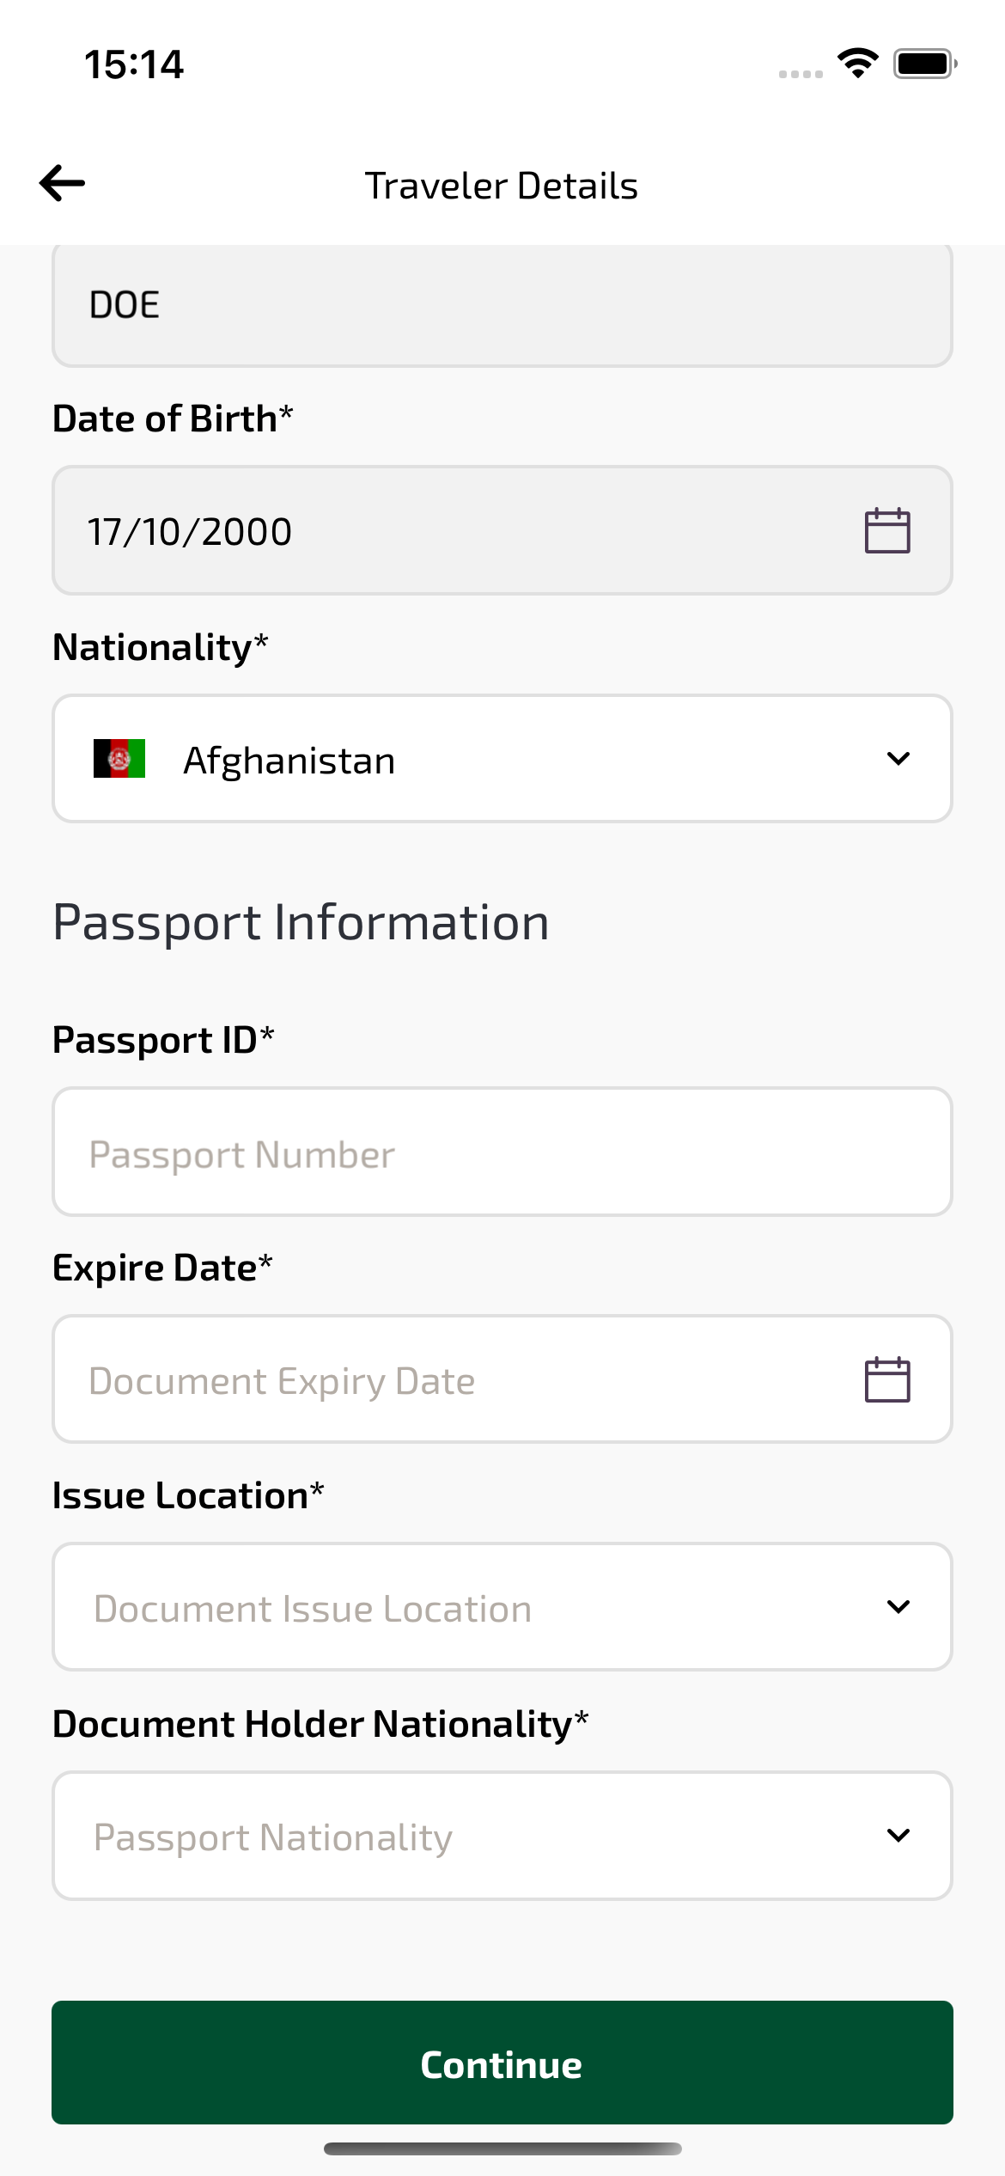
checkinApisPassport sayfası ekran görüntüsü

