Accessibility ID Report — checkinDisclaimer
Tarih: 31.03.2026 14:25 | Platform: iOS

Element ID | Page | Type | Label / Text | Value | Accessibility ID | Status | New Status
checkinDisclaimer_element_1 | Use caution when packing | Other |  |  |  | ID Yok | ID Eklenecek (Waiting Dev)
checkinDisclaimer_element_2 | Use caution when packing | Other | Online Check-In Disclaimer |  |  | ID Yok | ID Eklenecek (Waiting Dev)
checkinDisclaimer_element_3 | Use caution when packing | Other | Baggage Prohibit and Restrictions of Dangerous Goods. |  |  | ID Yok | ID Eklenecek (Waiting Dev)
checkinDisclaimer_element_4 | Use caution when packing | Other |  |  | check_in_dangerous_check_box | ID Var
checkinDisclaimer_element_5 | Use caution when packing | Other | Continue |  | check_in_dangerous_continue_button | ID Var

📸 Ekran Görüntüsü
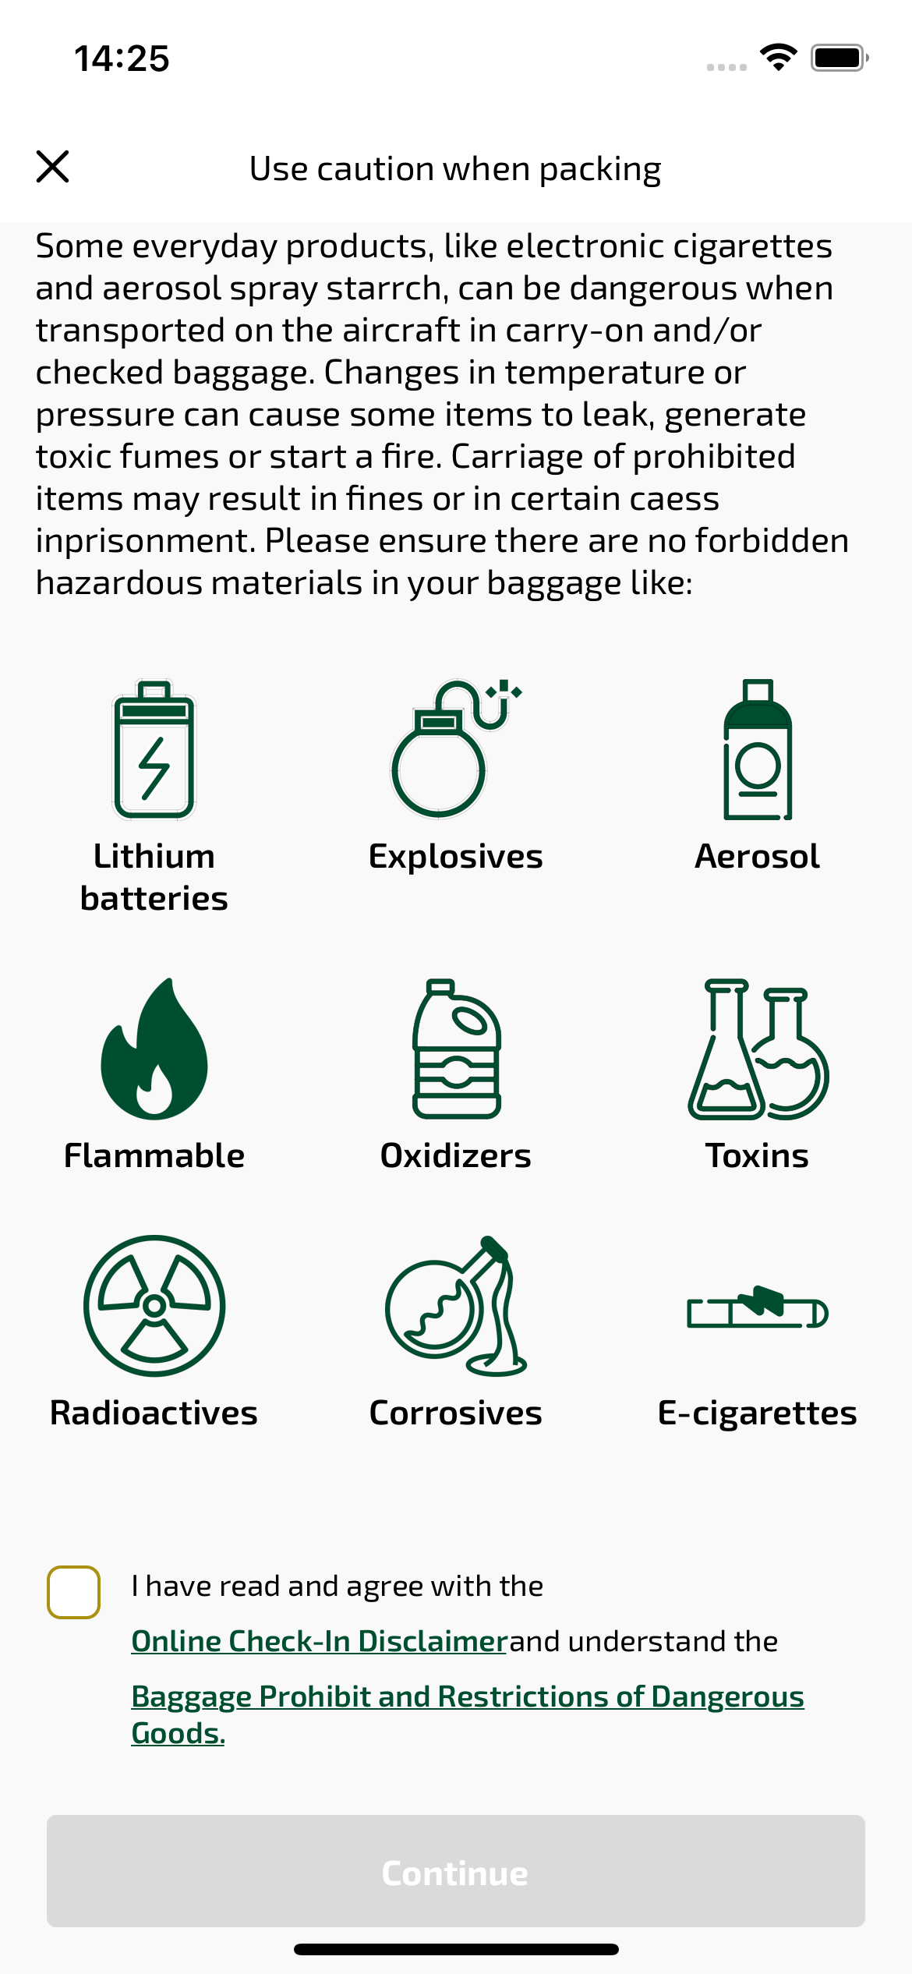
checkinDisclaimer sayfası ekran görüntüsü

