Accessibility ID Report — checkinFlightSelect
Tarih: 31.03.2026 14:19 | Platform: iOS

Element ID | Page | Type | Label / Text | Value | Accessibility ID | Status | New Status
checkinFlightSelect_element_1 | Online Check-in | Other |  |  |  | ID Yok | ID Eklenecek (Waiting Dev)
checkinFlightSelect_element_2 | Online Check-in | Other | Continue |  | check_in_trip_continue_button | ID Var
checkinFlightSelect_element_3 | Online Check-in | Other | Karachi (KHI) to Islamabad (ISB), Wed, 01 Apr - 07:00, 1h 55min - PK 300, ECONOMY, Direct |  | check_in_trip_card | ID Var

📸 Ekran Görüntüsü
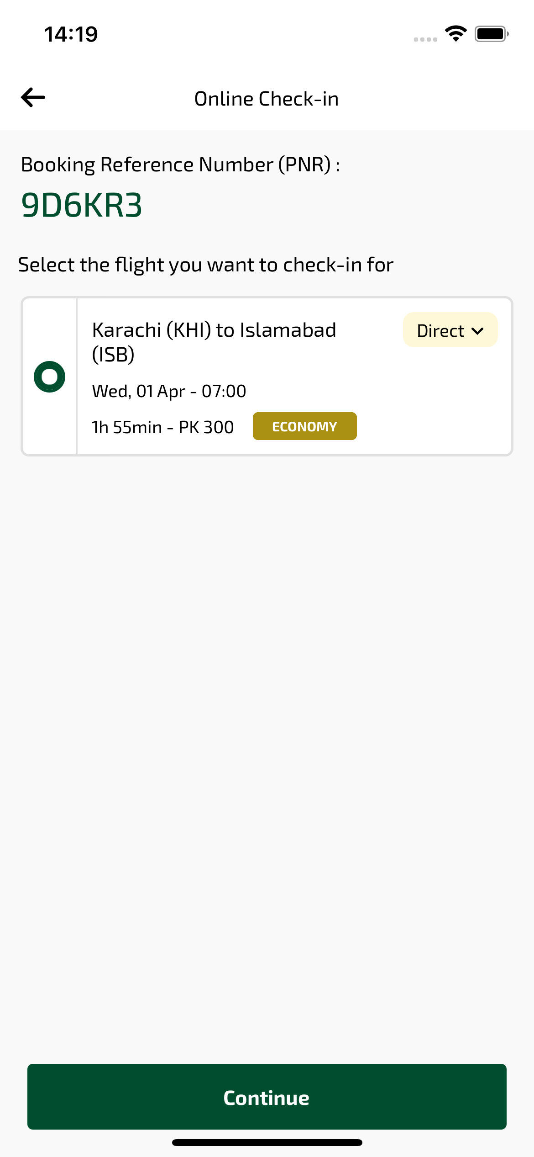
checkinFlightSelect sayfası ekran görüntüsü

