Accessibility ID Report — checkinPassengersSelect
Tarih: 31.03.2026 14:24 | Platform: iOS

Element ID | Page | Type | Label / Text | Value | Accessibility ID | Status | New Status
checkinPassengersSelect_element_1 | Online Check-in | Other |  |  |  | ID Yok | ID Eklenecek (Waiting Dev)
checkinPassengersSelect_element_2 | Online Check-in | Other | I have read and accepted , Online Check-in Rules |  |  | ID Yok | ID Eklenecek (Waiting Dev)
checkinPassengersSelect_element_3 | Online Check-in | Other | Karachi (KHI) to Islamabad (ISB), Wed, 01 Apr - 07:00, 1h 55min - PK 300, ECONOMY, Direct |  |  | ID Yok | ID Eklenecek (Waiting Dev)
checkinPassengersSelect_element_4 | Online Check-in | Other | Continue |  | check_in_pax_continue_button | ID Var
checkinPassengersSelect_element_5 | Online Check-in | Other | Abbas Doe |  | check_in_pax_card_abbas_doe | ID Var
checkinPassengersSelect_element_6 | Online Check-in | Other | Raja Doe |  | check_in_pax_card_raja_doe | ID Var
checkinPassengersSelect_element_7 | Online Check-in | Other | Muhammad Doe |  | check_in_pax_card_muhammad_doe | ID Var

📸 Ekran Görüntüsü
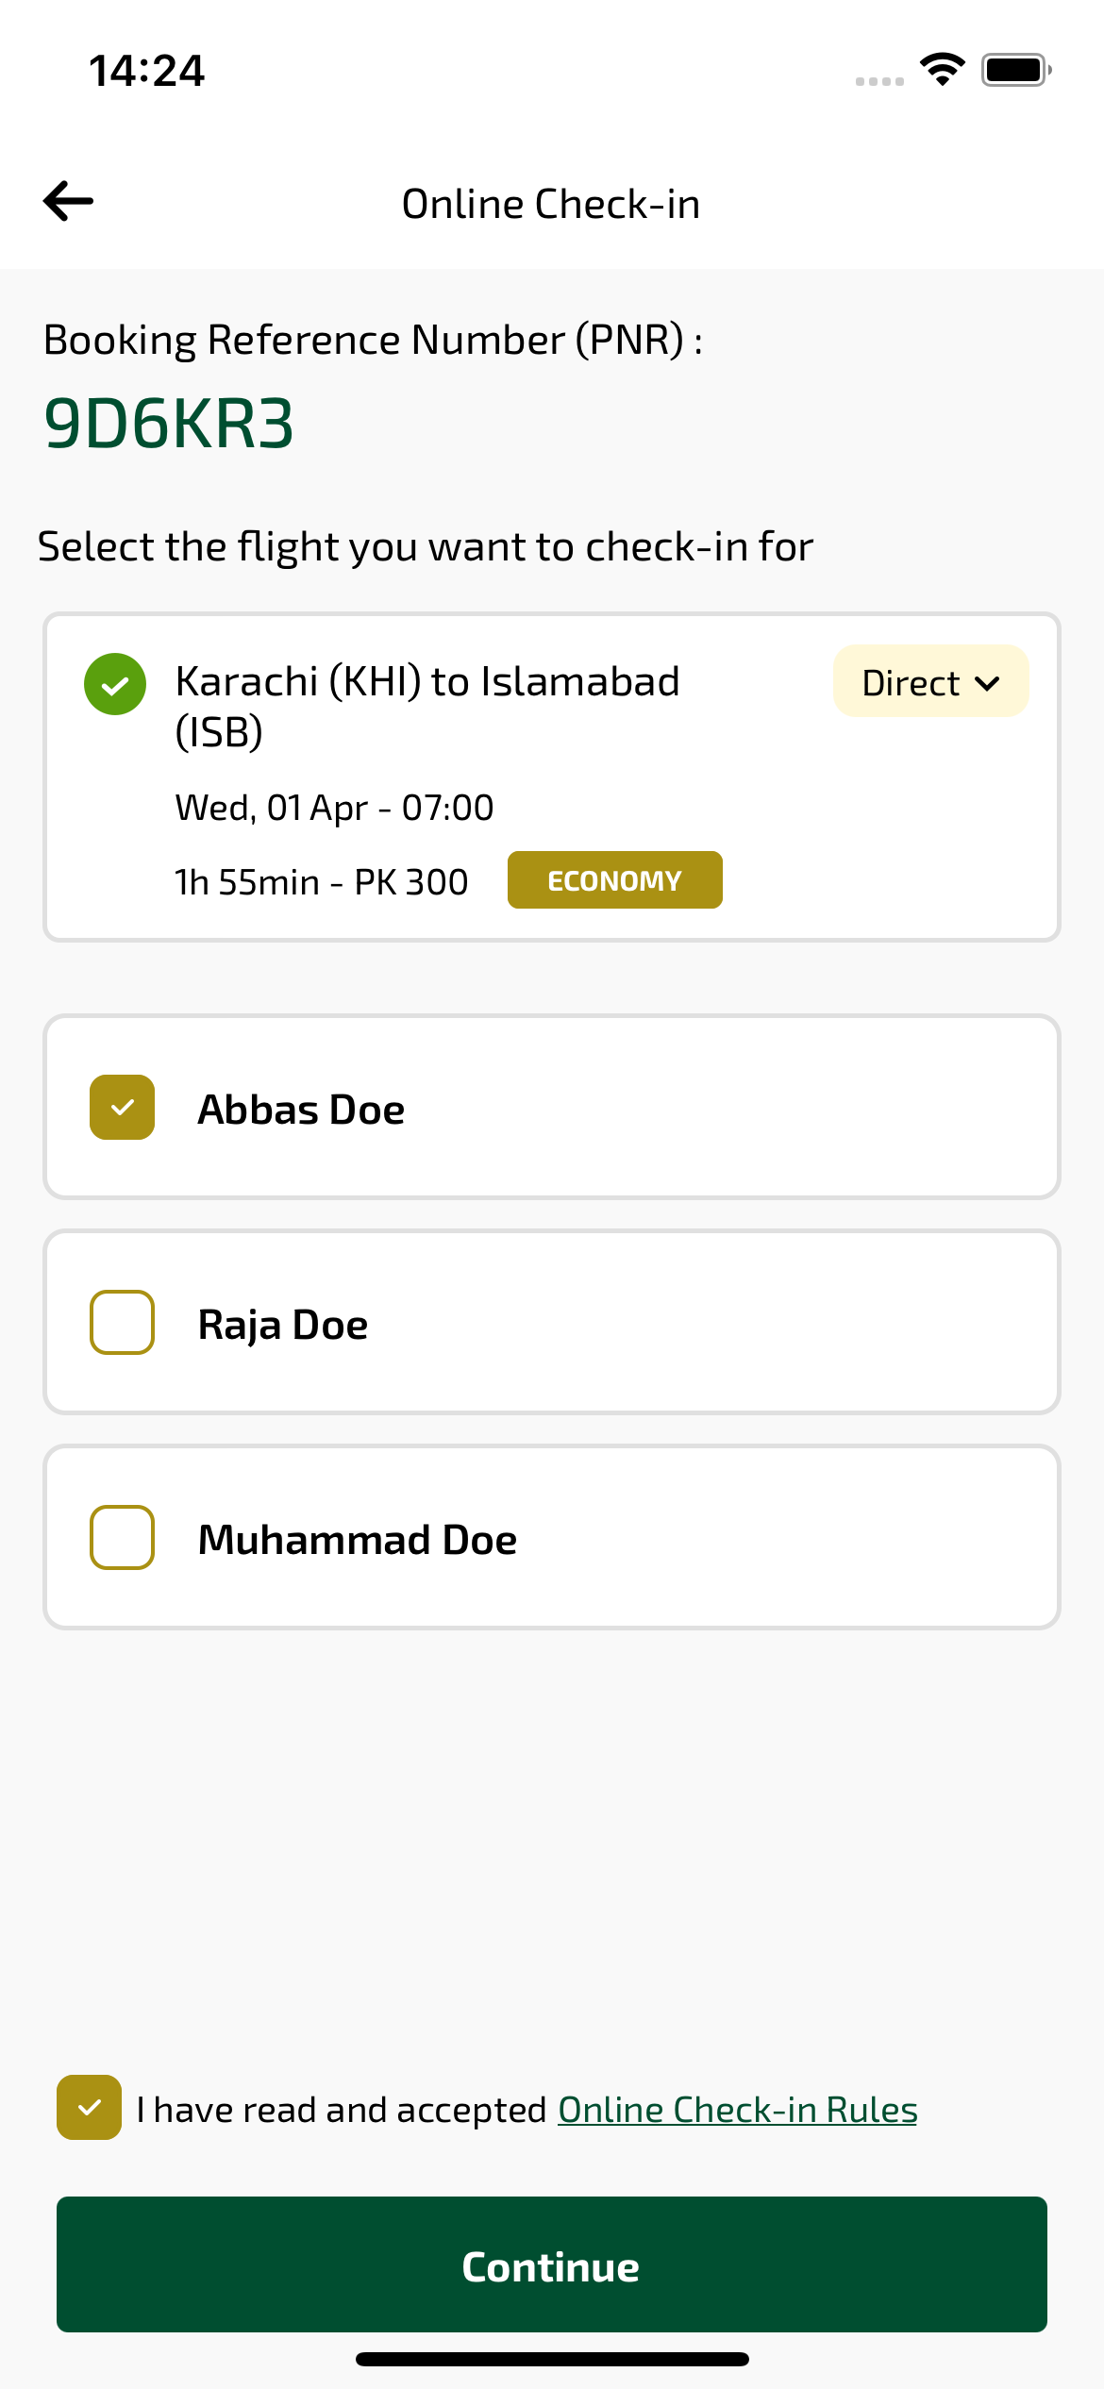
checkinPassengersSelect sayfası ekran görüntüsü

