Accessibility ID Report — checkinSuccess
Tarih: 31.03.2026 14:29 | Platform: iOS

Element ID | Page | Type | Label / Text | Value | Accessibility ID | Status | New Status
checkinSuccess_element_1 | Boarding Pass | Other | See Important Notice |  |  | ID Yok | ID Eklenecek (Waiting Dev)
checkinSuccess_element_2 | Boarding Pass | Other | Go to Manage Booking |  | check_in_success_mbk_button | ID Var
checkinSuccess_element_3 | Boarding Pass | Other | Abbas Doe |  | check_in_success_pax_card | ID Var

📸 Ekran Görüntüsü
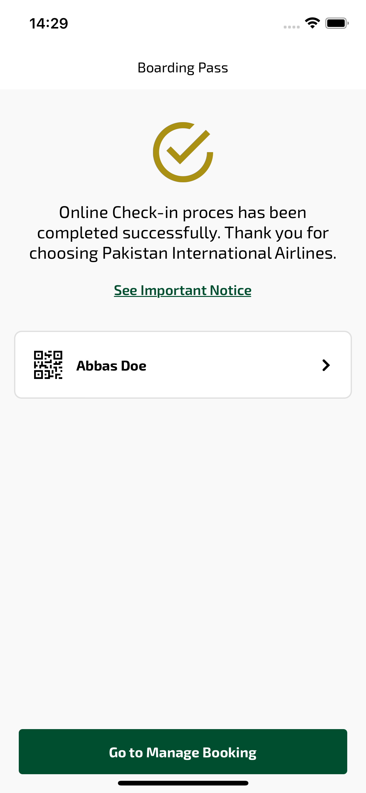
checkinSuccess sayfası ekran görüntüsü

