Accessibility ID Report — contactPerson_ios
Tarih: 31.03.2026 00:48 | Platform: IOS

Element ID | Page | Type | Label / Text | Value | Accessibility ID | Status | New Status
contactPerson_ios_element_1 | Contact Person | Other |  |  |  | ID Yok | ID Eklenecek (Waiting Dev)
contactPerson_ios_element_2 | Contact Person | Other | Log in |  |  | ID Yok | ID Eklenecek (Waiting Dev)
contactPerson_ios_element_3 | Contact Person | Other | Flight Schedule |  |  | ID Yok | ID Eklenecek (Waiting Dev)
contactPerson_ios_element_4 | Contact Person | Other | Flight Status |  |  | ID Yok | ID Eklenecek (Waiting Dev)
contactPerson_ios_element_5 | Contact Person | Other | Feedback |  |  | ID Yok | ID Eklenecek (Waiting Dev)
contactPerson_ios_element_6 | Contact Person | Other | Notifications |  |  | ID Yok | ID Eklenecek (Waiting Dev)
contactPerson_ios_element_7 | Contact Person | Other | Gift Card |  |  | ID Yok | ID Eklenecek (Waiting Dev)
contactPerson_ios_element_8 | Contact Person | Other | Settings |  |  | ID Yok | ID Eklenecek (Waiting Dev)
contactPerson_ios_element_9 | Contact Person | Other | Contact us |  |  | ID Yok | ID Eklenecek (Waiting Dev)
contactPerson_ios_element_10 | Contact Person | Other | Total , 188.34EUR |  |  | ID Yok | ID Eklenecek (Waiting Dev)
contactPerson_ios_element_11 | Contact Person | Other | Adult 1 |  | pax_form_tab_bar_item | Duplicate | ID Eklenecek (Waiting Dev)
contactPerson_ios_element_12 | Contact Person | Other | Adult 2 |  | pax_form_tab_bar_item | Duplicate | ID Eklenecek (Waiting Dev)
contactPerson_ios_element_13 | Contact Person | Other | Child 1 |  | pax_form_tab_bar_item | Duplicate | ID Eklenecek (Waiting Dev)
contactPerson_ios_element_14 | Contact Person | Other | Infant 1 |  | pax_form_tab_bar_item | Duplicate | ID Eklenecek (Waiting Dev)
contactPerson_ios_element_15 | Contact Person | Other | Contact Person |  | pax_form_tab_bar_item | Duplicate | ID Eklenecek (Waiting Dev)
contactPerson_ios_element_16 | Contact Person | TextField | Abc | Abc | pax_form_text_field_givenName | ID Var
contactPerson_ios_element_17 | Contact Person | TextField | Test | Test | pax_form_text_field_surname | ID Var
contactPerson_ios_element_18 | Contact Person | TextField | hh@hh.hh | hh@hh.hh | pax_form_text_field_email | ID Var
contactPerson_ios_element_19 | Contact Person | Other |  |  | pax_form_back_button | ID Var
contactPerson_ios_element_20 | Contact Person | Other | Continue |  | pax_form_continue_button | ID Var
contactPerson_ios_element_21 | Contact Person | Other |  |  | pax_form_phone_dial_code_phoneNumber | ID Var

📸 Ekran Görüntüsü
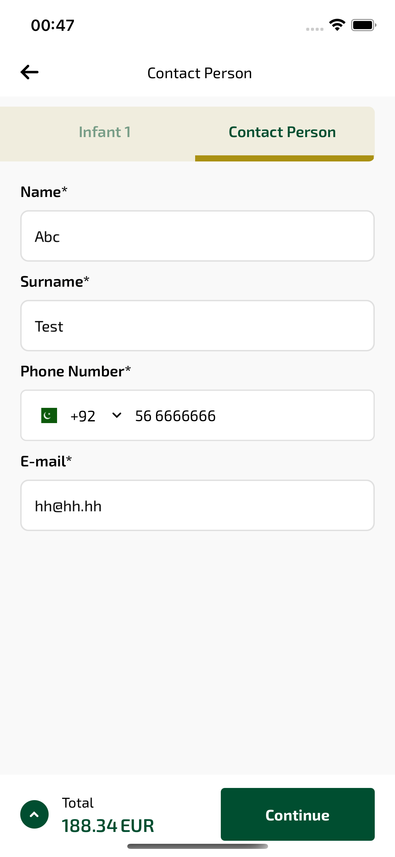
contactPerson_ios sayfası ekran görüntüsü

