Accessibility ID Report — familyInvite_ios
Tarih: 31.03.2026 11:50 | Platform: iOS

Element ID | Page | Type | Label / Text | Value | Accessibility ID | Status | New Status
familyInvite_ios_element_1 | Relationship Management | TextField | Family Head | Family Head |  | ID Yok | ID Eklenecek (Waiting Dev)
familyInvite_ios_element_2 | Relationship Management | TextField | Select | Select |  | ID Yok | ID Eklenecek (Waiting Dev)
familyInvite_ios_element_3 | Relationship Management | Other |  |  |  | ID Yok | ID Eklenecek (Waiting Dev)
familyInvite_ios_element_4 | Relationship Management | Other | Management |  |  | ID Yok | ID Eklenecek (Waiting Dev)
familyInvite_ios_element_5 | Relationship Management | Other | Invite |  |  | ID Yok | ID Eklenecek (Waiting Dev)
familyInvite_ios_element_6 | Relationship Management | Other | Requests |  |  | ID Yok | ID Eklenecek (Waiting Dev)
familyInvite_ios_element_7 | Relationship Management | Other | Choose File |  |  | ID Yok | ID Eklenecek (Waiting Dev)
familyInvite_ios_element_8 | Relationship Management | Other | Take a Photo |  |  | ID Yok | ID Eklenecek (Waiting Dev)
familyInvite_ios_element_9 | Relationship Management | Other | Submit |  |  | ID Yok | ID Eklenecek (Waiting Dev)
familyInvite_ios_element_10 | Relationship Management | TextField | Enter | Enter | undefinedmembershipId | Undefined ID | ID Eklenecek (Waiting Dev)
familyInvite_ios_element_11 | Relationship Management | TextField | Enter | Enter | undefinedgivenName | Undefined ID | ID Eklenecek (Waiting Dev)
familyInvite_ios_element_12 | Relationship Management | TextField | Enter | Enter | undefinedsurname | Undefined ID | ID Eklenecek (Waiting Dev)
familyInvite_ios_element_13 | Relationship Management | Other |  |  | undefinedrelationType | Undefined ID | ID Eklenecek (Waiting Dev)
familyInvite_ios_element_14 | Relationship Management | Other | Select |  | undefinedRelationSubtype | Undefined ID | ID Eklenecek (Waiting Dev)

📸 Ekran Görüntüsü
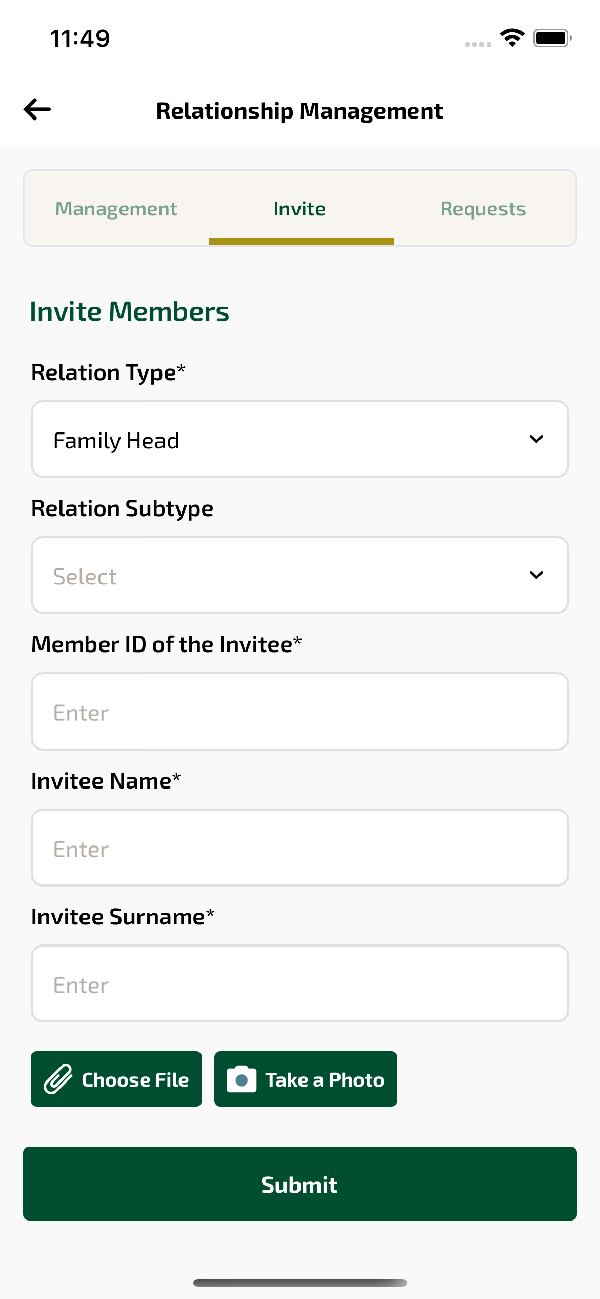
familyInvite_ios sayfası ekran görüntüsü

