Accessibility ID Report — flightSchedule_ios
Tarih: 30.03.2026 23:53 | Platform: IOS

Element ID | Page | Type | Label / Text | Value | Accessibility ID | Status | New Status
flightSchedule_ios_element_1 | Flight Schedule | Other |  |  |  | ID Yok | ID Eklenecek (Waiting Dev)
flightSchedule_ios_element_2 | Flight Schedule | Other | Log in |  |  | ID Yok | ID Eklenecek (Waiting Dev)
flightSchedule_ios_element_3 | Flight Schedule | Other | Flight Schedule |  |  | ID Yok | ID Eklenecek (Waiting Dev)
flightSchedule_ios_element_4 | Flight Schedule | Other | Flight Status |  |  | ID Yok | ID Eklenecek (Waiting Dev)
flightSchedule_ios_element_5 | Flight Schedule | Other | Feedback |  |  | ID Yok | ID Eklenecek (Waiting Dev)
flightSchedule_ios_element_6 | Flight Schedule | Other | Notifications |  |  | ID Yok | ID Eklenecek (Waiting Dev)
flightSchedule_ios_element_7 | Flight Schedule | Other | Gift Card |  |  | ID Yok | ID Eklenecek (Waiting Dev)
flightSchedule_ios_element_8 | Flight Schedule | Other | Settings |  |  | ID Yok | ID Eklenecek (Waiting Dev)
flightSchedule_ios_element_9 | Flight Schedule | Other | Contact us |  |  | ID Yok | ID Eklenecek (Waiting Dev)
flightSchedule_ios_element_10 | Flight Schedule | Other |  |  |  | ID Yok | ID Eklenecek (Waiting Dev)
flightSchedule_ios_element_11 | Flight Schedule | Other | Departure Date, Fri, 03 Apr |  |  | ID Yok | ID Eklenecek (Waiting Dev)
flightSchedule_ios_element_12 | Flight Schedule | Other | Return Date, Sun, 05 Apr |  |  | ID Yok | ID Eklenecek (Waiting Dev)
flightSchedule_ios_element_13 | Flight Schedule | Other | Search Now |  |  | ID Yok | ID Eklenecek (Waiting Dev)
flightSchedule_ios_element_14 | Flight Schedule | Other | Departure, Karachi - Karachi Jinnah International Airport(KHI) |  |  | ID Yok | ID Eklenecek (Waiting Dev)
flightSchedule_ios_element_15 | Flight Schedule | Other | Arrival, Dubai - Dubai International Airport(DXB) |  |  | ID Yok | ID Eklenecek (Waiting Dev)
flightSchedule_ios_element_16 | Flight Schedule | Other | Test Operational Notice For Testing In UAT1 Test Operational Notice For Testing In UAT2 |  |  | ID Yok | ID Eklenecek (Waiting Dev)
flightSchedule_ios_element_17 | Flight Schedule | Other | Information for Credit Card Holders |  |  | ID Yok | ID Eklenecek (Waiting Dev)
flightSchedule_ios_element_18 | Flight Schedule | Other | Long Lon Long Operational Notice One Two |  |  | ID Yok | ID Eklenecek (Waiting Dev)
flightSchedule_ios_element_19 | Flight Schedule | Other |  |  |  | ID Yok | ID Eklenecek (Waiting Dev)

📸 Ekran Görüntüsü
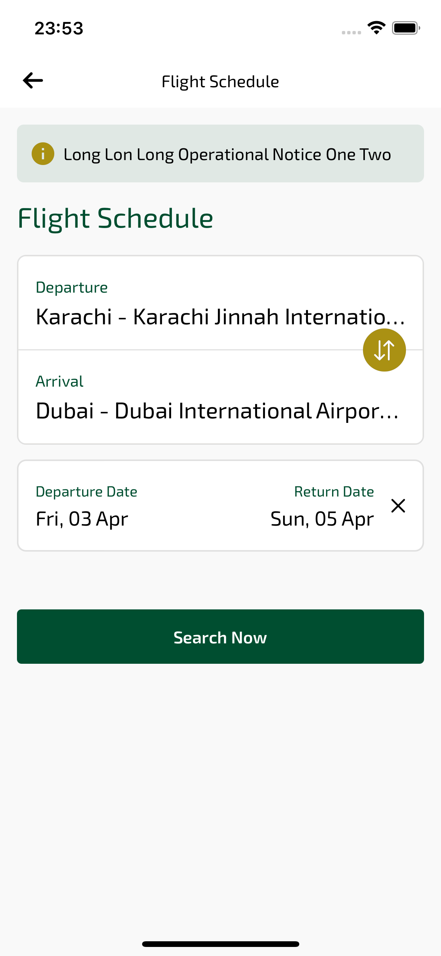
flightSchedule_ios sayfası ekran görüntüsü

