Accessibility ID Report — giftCardContactInfo_ios
Tarih: 30.03.2026 23:56 | Platform: IOS

Element ID | Page | Type | Label / Text | Value | Accessibility ID | Status | New Status
giftCardContactInfo_ios_element_1 | Contact Info | Other |  |  |  | ID Yok | ID Eklenecek (Waiting Dev)
giftCardContactInfo_ios_element_2 | Contact Info | Other | Log in |  |  | ID Yok | ID Eklenecek (Waiting Dev)
giftCardContactInfo_ios_element_3 | Contact Info | Other | Flight Schedule |  |  | ID Yok | ID Eklenecek (Waiting Dev)
giftCardContactInfo_ios_element_4 | Contact Info | Other | Flight Status |  |  | ID Yok | ID Eklenecek (Waiting Dev)
giftCardContactInfo_ios_element_5 | Contact Info | Other | Feedback |  |  | ID Yok | ID Eklenecek (Waiting Dev)
giftCardContactInfo_ios_element_6 | Contact Info | Other | Notifications |  |  | ID Yok | ID Eklenecek (Waiting Dev)
giftCardContactInfo_ios_element_7 | Contact Info | Other | Gift Card |  |  | ID Yok | ID Eklenecek (Waiting Dev)
giftCardContactInfo_ios_element_8 | Contact Info | Other | Settings |  |  | ID Yok | ID Eklenecek (Waiting Dev)
giftCardContactInfo_ios_element_9 | Contact Info | Other | Contact us |  |  | ID Yok | ID Eklenecek (Waiting Dev)
giftCardContactInfo_ios_element_10 | Contact Info | Other |  |  |  | ID Yok | ID Eklenecek (Waiting Dev)
giftCardContactInfo_ios_element_11 | Contact Info | Other | Preview and Payment |  |  | ID Yok | ID Eklenecek (Waiting Dev)
giftCardContactInfo_ios_element_12 | Contact Info | Other | Male |  |  | ID Yok | ID Eklenecek (Waiting Dev)
giftCardContactInfo_ios_element_13 | Contact Info | Other | Female |  |  | ID Yok | ID Eklenecek (Waiting Dev)
giftCardContactInfo_ios_element_14 | Contact Info | Other | Purchase gift card for self |  |  | ID Yok | ID Eklenecek (Waiting Dev)
giftCardContactInfo_ios_element_15 | Contact Info | Other | Purchase gift card for Family & Friends |  |  | ID Yok | ID Eklenecek (Waiting Dev)
giftCardContactInfo_ios_element_16 | Contact Info | TextField | Adult | Adult | undefinedsenderName | Undefined ID | ID Eklenecek (Waiting Dev)
giftCardContactInfo_ios_element_17 | Contact Info | TextField | Automation | Automation | undefinedsenderSurname | Undefined ID | ID Eklenecek (Waiting Dev)
giftCardContactInfo_ios_element_18 | Contact Info | TextField | bb@bb.bb | bb@bb.bb | undefinedsenderEmail | Undefined ID | ID Eklenecek (Waiting Dev)
giftCardContactInfo_ios_element_19 | Contact Info | TextField | 56 5666666 | 56 5666666 | undefinedsenderPhoneNumber | Undefined ID | ID Eklenecek (Waiting Dev)
giftCardContactInfo_ios_element_20 | Contact Info | Other |  |  | undefinedsenderPhoneNumber | Undefined ID | ID Eklenecek (Waiting Dev)

📸 Ekran Görüntüsü
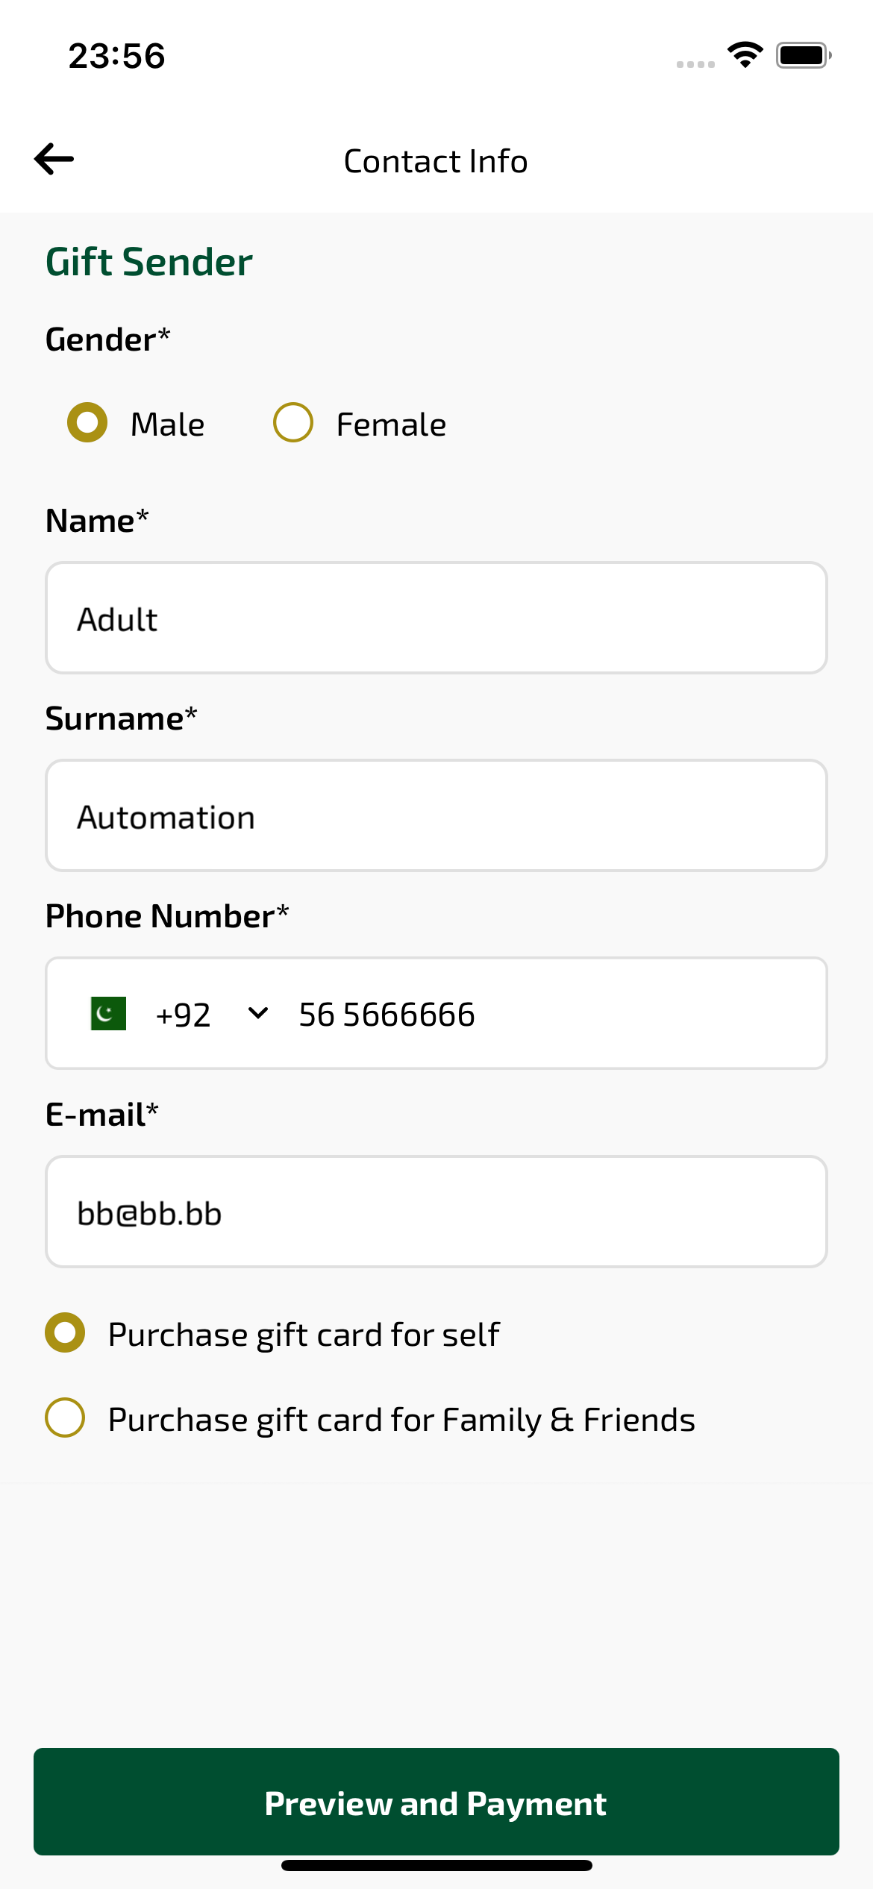
giftCardContactInfo_ios sayfası ekran görüntüsü

