Accessibility ID Report — giftCardSuccess_ios
Tarih: 31.03.2026 00:10 | Platform: IOS

Element ID | Page | Type | Label / Text | Value | Accessibility ID | Status | New Status
giftCardSuccess_ios_element_1 | Your gift card has been created successfully! | Other |  |  |  | ID Yok | ID Eklenecek (Waiting Dev)
giftCardSuccess_ios_element_2 | Your gift card has been created successfully! | Other | Log in |  |  | ID Yok | ID Eklenecek (Waiting Dev)
giftCardSuccess_ios_element_3 | Your gift card has been created successfully! | Other | Flight Schedule |  |  | ID Yok | ID Eklenecek (Waiting Dev)
giftCardSuccess_ios_element_4 | Your gift card has been created successfully! | Other | Flight Status |  |  | ID Yok | ID Eklenecek (Waiting Dev)
giftCardSuccess_ios_element_5 | Your gift card has been created successfully! | Other | Feedback |  |  | ID Yok | ID Eklenecek (Waiting Dev)
giftCardSuccess_ios_element_6 | Your gift card has been created successfully! | Other | Notifications |  |  | ID Yok | ID Eklenecek (Waiting Dev)
giftCardSuccess_ios_element_7 | Your gift card has been created successfully! | Other | Gift Card |  |  | ID Yok | ID Eklenecek (Waiting Dev)
giftCardSuccess_ios_element_8 | Your gift card has been created successfully! | Other | Settings |  |  | ID Yok | ID Eklenecek (Waiting Dev)
giftCardSuccess_ios_element_9 | Your gift card has been created successfully! | Other | Contact us |  |  | ID Yok | ID Eklenecek (Waiting Dev)
giftCardSuccess_ios_element_10 | Your gift card has been created successfully! | Other | Go to Home |  |  | ID Yok | ID Eklenecek (Waiting Dev)
giftCardSuccess_ios_element_11 | Your gift card has been created successfully! | Other | Ticket No, 2144202222424 |  |  | ID Yok | ID Eklenecek (Waiting Dev)

📸 Ekran Görüntüsü
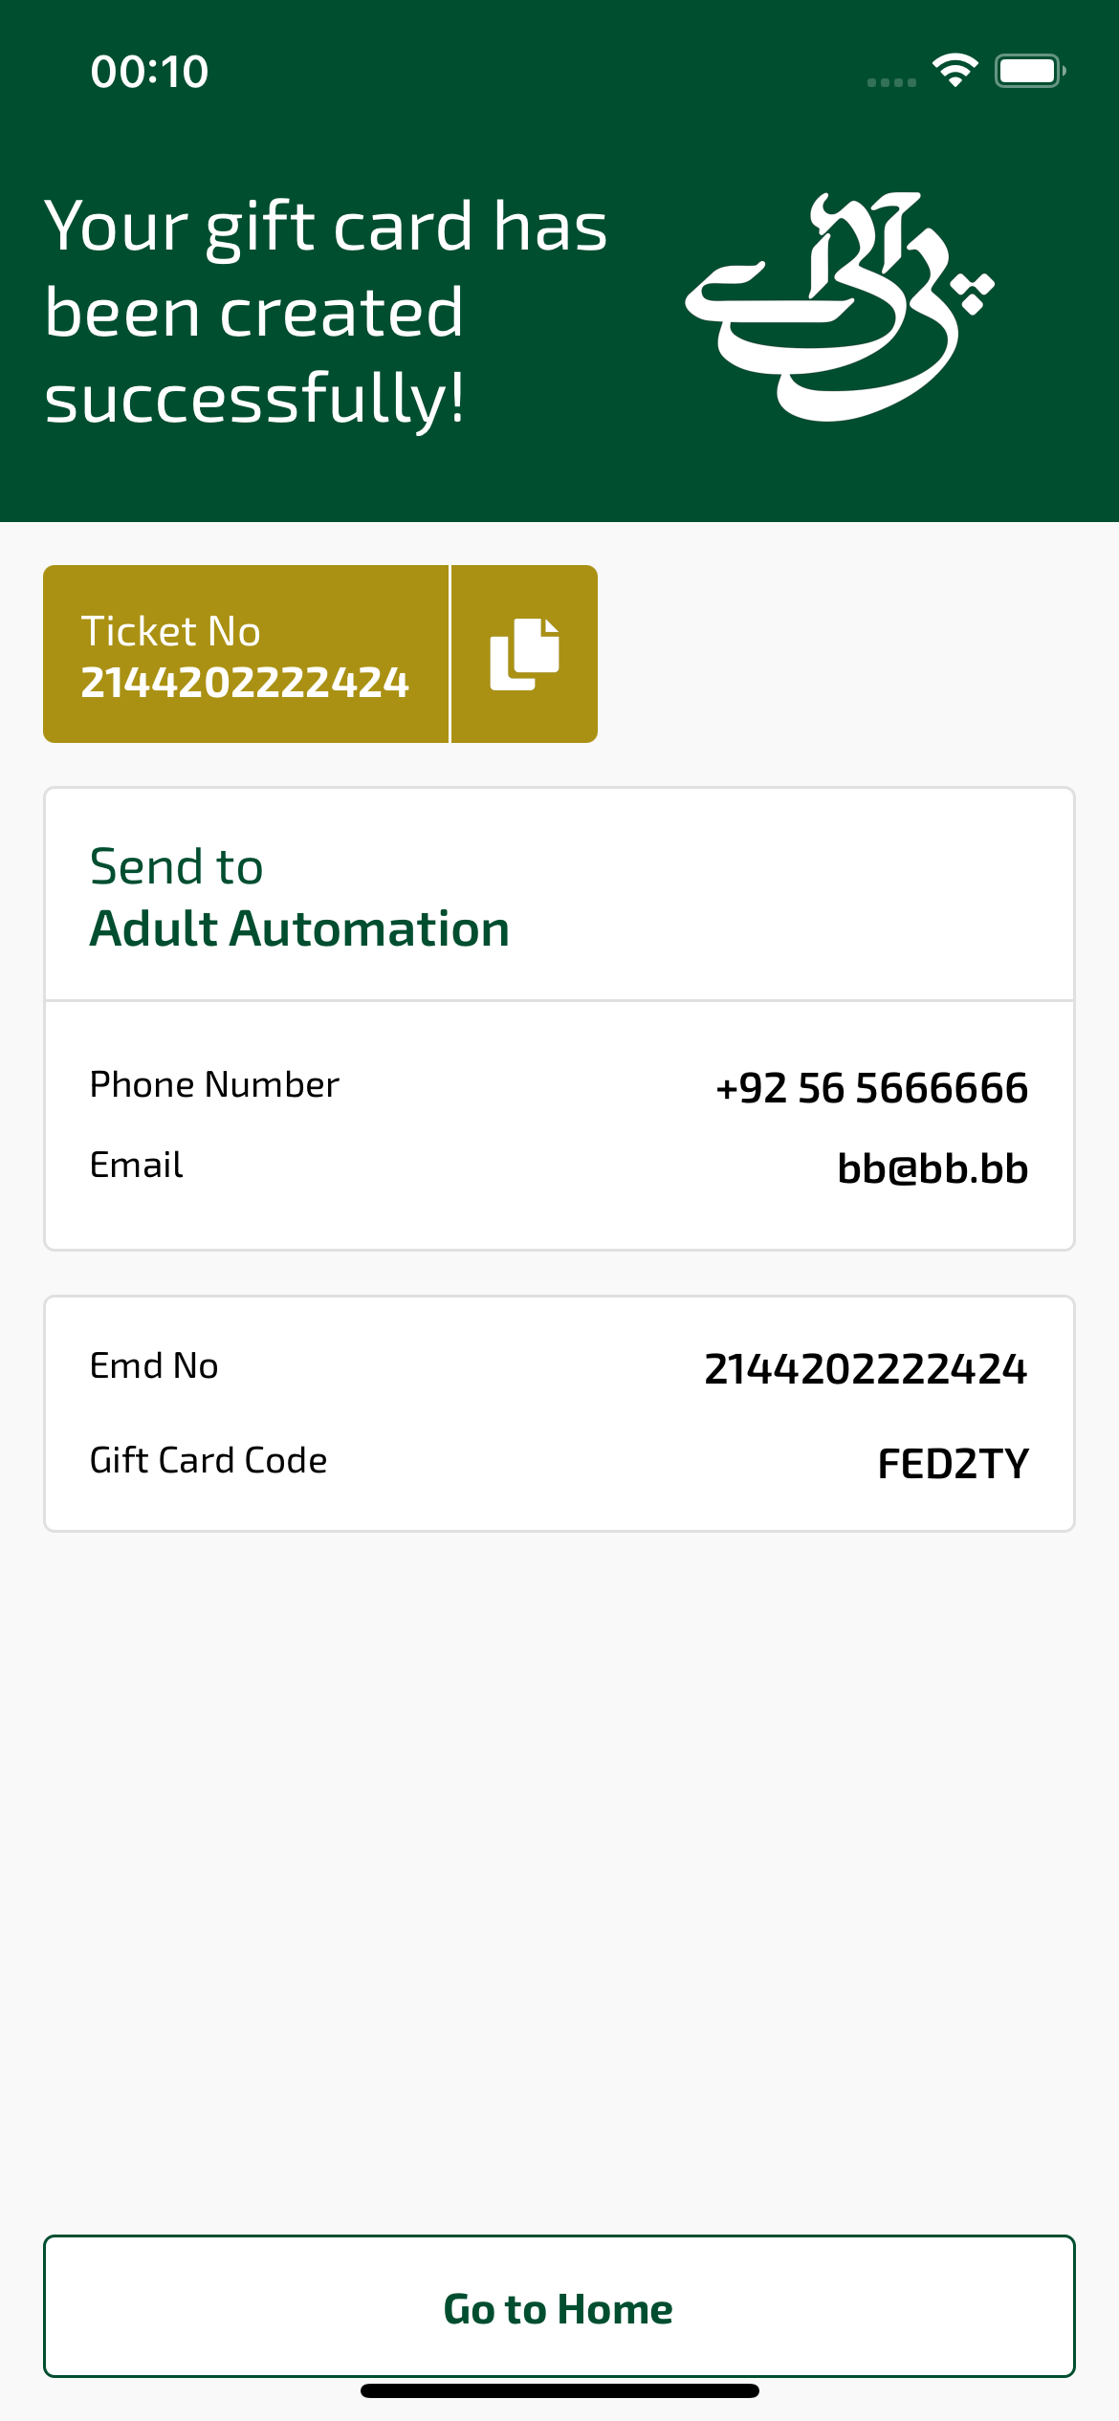
giftCardSuccess_ios sayfası ekran görüntüsü

