Accessibility ID Report — login_ios
Tarih: 30.03.2026 23:51 | Platform: IOS

Element ID | Page | Type | Label / Text | Value | Accessibility ID | Status | New Status
login_ios_element_1 | Log in to Award +Plus | Button | HOME, tab, 1 of 5 |  |  | ID Yok | ID Eklenecek (Waiting Dev)
login_ios_element_2 | Log in to Award +Plus | Button | AVAILABILITY_SEARCH, tab, 2 of 5 |  |  | ID Yok | ID Eklenecek (Waiting Dev)
login_ios_element_3 | Log in to Award +Plus | Button | MY_TRIPS_INITIAL, tab, 3 of 5 |  |  | ID Yok | ID Eklenecek (Waiting Dev)
login_ios_element_4 | Log in to Award +Plus | Button | CHECKIN, tab, 4 of 5 |  |  | ID Yok | ID Eklenecek (Waiting Dev)
login_ios_element_5 | Log in to Award +Plus | Button | LOYALTY, tab, 5 of 5 | 1 |  | ID Yok | ID Eklenecek (Waiting Dev)
login_ios_element_6 | Log in to Award +Plus | Other |  |  |  | ID Yok | ID Eklenecek (Waiting Dev)
login_ios_element_7 | Log in to Award +Plus | Other | Log in |  |  | ID Yok | ID Eklenecek (Waiting Dev)
login_ios_element_8 | Log in to Award +Plus | Other | Flight Schedule |  |  | ID Yok | ID Eklenecek (Waiting Dev)
login_ios_element_9 | Log in to Award +Plus | Other | Flight Status |  |  | ID Yok | ID Eklenecek (Waiting Dev)
login_ios_element_10 | Log in to Award +Plus | Other | Feedback |  |  | ID Yok | ID Eklenecek (Waiting Dev)
login_ios_element_11 | Log in to Award +Plus | Other | Notifications |  |  | ID Yok | ID Eklenecek (Waiting Dev)
login_ios_element_12 | Log in to Award +Plus | Other | Gift Card |  |  | ID Yok | ID Eklenecek (Waiting Dev)
login_ios_element_13 | Log in to Award +Plus | Other | Settings |  |  | ID Yok | ID Eklenecek (Waiting Dev)
login_ios_element_14 | Log in to Award +Plus | Other | Contact us |  |  | ID Yok | ID Eklenecek (Waiting Dev)
login_ios_element_15 | Log in to Award +Plus | Other |  |  |  | ID Yok | ID Eklenecek (Waiting Dev)
login_ios_element_16 | Log in to Award +Plus | Other | Long Lon Long Operational Notice One Two |  |  | ID Yok | ID Eklenecek (Waiting Dev)
login_ios_element_17 | Log in to Award +Plus | Other | Test Operational Notice For Testing In UAT1 Test Operational Notice For Testing In UAT2 |  |  | ID Yok | ID Eklenecek (Waiting Dev)
login_ios_element_18 | Log in to Award +Plus | Other | Information for Credit Card Holders |  |  | ID Yok | ID Eklenecek (Waiting Dev)
login_ios_element_19 | Log in to Award +Plus | Other | Remember Me |  |  | ID Yok | ID Eklenecek (Waiting Dev)
login_ios_element_20 | Log in to Award +Plus | Other | Forgot Password? |  |  | ID Yok | ID Eklenecek (Waiting Dev)
login_ios_element_21 | Log in to Award +Plus | Other | Sign Up |  |  | ID Yok | ID Eklenecek (Waiting Dev)
login_ios_element_22 | Log in to Award +Plus | TextField | Enter | Enter | loyalty_login_text_field_emailOrMembership | ID Var
login_ios_element_23 | Log in to Award +Plus | SecureTextField | Enter | Enter | loyalty_login_text_field_password | ID Var
login_ios_element_24 | Log in to Award +Plus | Other | Log in |  | loyalty_login_login_button | ID Var

📸 Ekran Görüntüsü
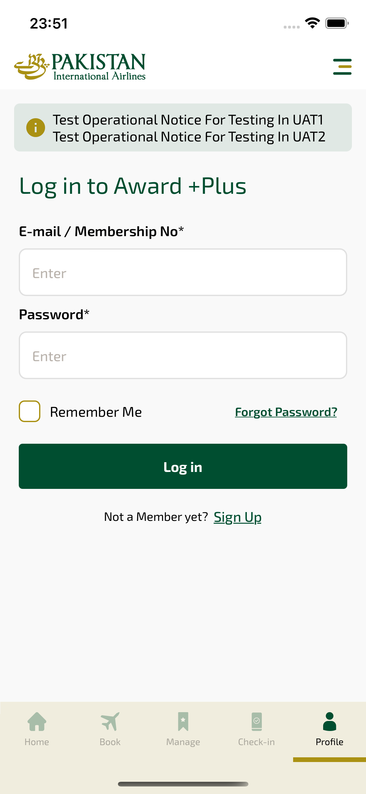
login_ios sayfası ekran görüntüsü

