Accessibility ID Report — loyaltyPastFlights_ios
Tarih: 31.03.2026 11:35 | Platform: iOS

Element ID | Page | Type | Label / Text | Value | Accessibility ID | Status | New Status
loyaltyPastFlights_ios_element_1 | My Tickets | Other |  |  |  | ID Yok | ID Eklenecek (Waiting Dev)
loyaltyPastFlights_ios_element_2 | My Tickets | Other |  |  |  | ID Yok | ID Eklenecek (Waiting Dev)
loyaltyPastFlights_ios_element_3 | My Tickets | Other | Karachi (KHI) to Faisalabad (LYP), Tue, 31 Mar - 11:30, 1h 45min - PK 340, Direct, 1 Adult, Yunus E Sahin |  |  | ID Yok | ID Eklenecek (Waiting Dev)
loyaltyPastFlights_ios_element_4 | My Tickets | Other | Karachi (KHI) to Faisalabad (LYP), Sun, 29 Mar - 21:00, 1h 45min - PK 340, Direct, 1 Adult, Yunus E Sahin |  |  | ID Yok | ID Eklenecek (Waiting Dev)
loyaltyPastFlights_ios_element_5 | My Tickets | Other | Karachi (KHI) to Faisalabad (LYP), Sun, 29 Mar - 21:00, 1h 45min - PK 340, Direct, 1 Adult, Yunus E Sahin |  |  | ID Yok | ID Eklenecek (Waiting Dev)
loyaltyPastFlights_ios_element_6 | My Tickets | Other | Karachi (KHI) to Faisalabad (LYP), Fri, 27 Mar - 20:30, 1h 45min - PK 340, Direct, 1 Adult, Yunus E Sahin |  |  | ID Yok | ID Eklenecek (Waiting Dev)
loyaltyPastFlights_ios_element_7 | My Tickets | Other | Lahore (LHE) to Karachi (KHI), Thu, 26 Mar - 11:00, 1h 45min , Direct, 1 Adult, Yunus E Sahin |  |  | ID Yok | ID Eklenecek (Waiting Dev)
loyaltyPastFlights_ios_element_8 | My Tickets | Other | Upcoming Flights |  | ly_my_tickets_switch | Duplicate | ID Eklenecek (Waiting Dev)
loyaltyPastFlights_ios_element_9 | My Tickets | Other | Past Flights |  | ly_my_tickets_switch | Duplicate | ID Eklenecek (Waiting Dev)

📸 Ekran Görüntüsü
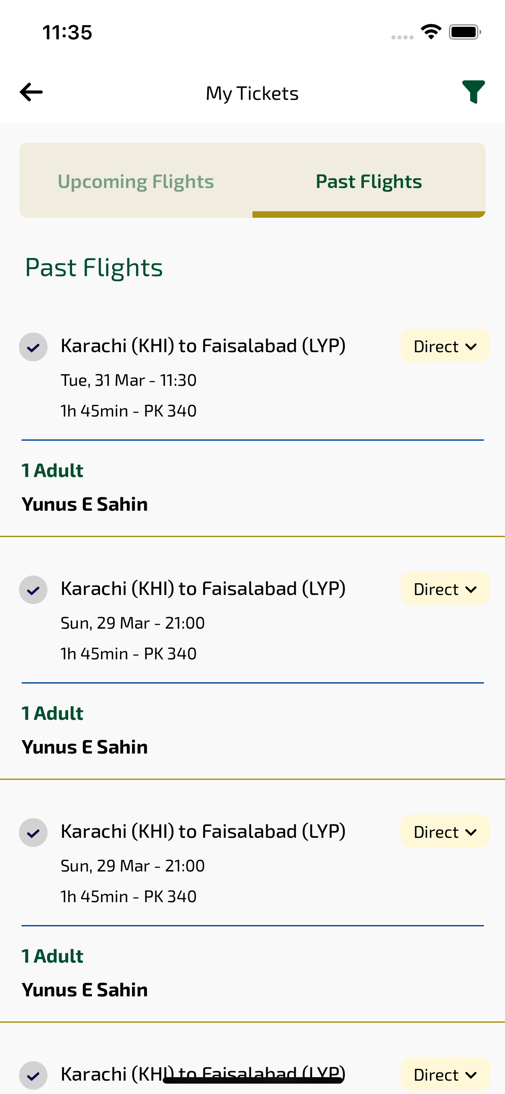
loyaltyPastFlights_ios sayfası ekran görüntüsü

