Accessibility ID Report — loyaltyPersonalInformation_ios
Tarih: 31.03.2026 11:34 | Platform: iOS

Element ID | Page | Type | Label / Text | Value | Accessibility ID | Status | New Status
loyaltyPersonalInformation_ios_element_1 | Personal Details | TextField | PROF | PROF |  | ID Yok | ID Eklenecek (Waiting Dev)
loyaltyPersonalInformation_ios_element_2 | Personal Details | TextField | BUSINESS | BUSINESS |  | ID Yok | ID Eklenecek (Waiting Dev)
loyaltyPersonalInformation_ios_element_3 | Personal Details | TextField | MOBILE | MOBILE |  | ID Yok | ID Eklenecek (Waiting Dev)
loyaltyPersonalInformation_ios_element_4 | Personal Details | Other |  |  |  | ID Yok | ID Eklenecek (Waiting Dev)
loyaltyPersonalInformation_ios_element_5 | Personal Details | Other | Personal Information |  |  | ID Yok | ID Eklenecek (Waiting Dev)
loyaltyPersonalInformation_ios_element_6 | Personal Details | Other | Change Password |  |  | ID Yok | ID Eklenecek (Waiting Dev)
loyaltyPersonalInformation_ios_element_7 | Personal Details | Other | Save |  |  | ID Yok | ID Eklenecek (Waiting Dev)
loyaltyPersonalInformation_ios_element_8 | Personal Details | Other | I want to be informed through SMS. |  |  | ID Yok | ID Eklenecek (Waiting Dev)
loyaltyPersonalInformation_ios_element_9 | Personal Details | Other | I want to be informed through E-mail. |  |  | ID Yok | ID Eklenecek (Waiting Dev)
loyaltyPersonalInformation_ios_element_10 | Personal Details | Other | E-mail |  |  | ID Yok | ID Eklenecek (Waiting Dev)
loyaltyPersonalInformation_ios_element_11 | Personal Details | Other | Add |  |  | ID Yok | ID Eklenecek (Waiting Dev)
loyaltyPersonalInformation_ios_element_12 | Personal Details | Other | Phone |  |  | ID Yok | ID Eklenecek (Waiting Dev)
loyaltyPersonalInformation_ios_element_13 | Personal Details | Other | Add |  |  | ID Yok | ID Eklenecek (Waiting Dev)
loyaltyPersonalInformation_ios_element_14 | Personal Details | Other | Address |  |  | ID Yok | ID Eklenecek (Waiting Dev)
loyaltyPersonalInformation_ios_element_15 | Personal Details | Other | Add |  |  | ID Yok | ID Eklenecek (Waiting Dev)
loyaltyPersonalInformation_ios_element_16 | Personal Details | Other | Male |  |  | ID Yok | ID Eklenecek (Waiting Dev)
loyaltyPersonalInformation_ios_element_17 | Personal Details | Other | Female |  |  | ID Yok | ID Eklenecek (Waiting Dev)
loyaltyPersonalInformation_ios_element_18 | Personal Details | Other | Preferred |  |  | ID Yok | ID Eklenecek (Waiting Dev)
loyaltyPersonalInformation_ios_element_19 | Personal Details | Other | Preferred |  |  | ID Yok | ID Eklenecek (Waiting Dev)
loyaltyPersonalInformation_ios_element_20 | Personal Details | Other | Preferred |  |  | ID Yok | ID Eklenecek (Waiting Dev)
loyaltyPersonalInformation_ios_element_21 | Personal Details | TextField | Yunus E | Yunus E | undefinedgivenName | Undefined ID | ID Eklenecek (Waiting Dev)
loyaltyPersonalInformation_ios_element_22 | Personal Details | TextField | Sahin | Sahin | undefinedsurname | Undefined ID | ID Eklenecek (Waiting Dev)
loyaltyPersonalInformation_ios_element_23 | Personal Details | TextField | 1112321218 | 1112321218 | undefinedpassportNumber | Undefined ID | ID Eklenecek (Waiting Dev)
loyaltyPersonalInformation_ios_element_24 | Personal Details | TextField | yunus.sahin@testinium.com | yunus.sahin@testinium.com | undefinedemailList.0.email | Undefined ID | ID Eklenecek (Waiting Dev)
loyaltyPersonalInformation_ios_element_25 | Personal Details | TextField | Mimar Sinan Mah. | Mimar Sinan Mah. | undefinedaddressList.0.apartmentNo | Undefined ID | ID Eklenecek (Waiting Dev)
loyaltyPersonalInformation_ios_element_26 | Personal Details | TextField | Nil Sok. | Nil Sok. | undefinedaddressList.0.streetNo | Undefined ID | ID Eklenecek (Waiting Dev)
loyaltyPersonalInformation_ios_element_27 | Personal Details | TextField | No:9-11A | No:9-11A | undefinedaddressList.0.area | Undefined ID | ID Eklenecek (Waiting Dev)
loyaltyPersonalInformation_ios_element_28 | Personal Details | TextField | 555666 | 555666 | undefinedaddressList.0.postalCode | Undefined ID | ID Eklenecek (Waiting Dev)
loyaltyPersonalInformation_ios_element_29 | Personal Details | TextField | 555 555 33 22 | 555 555 33 22 | undefinedphoneNumberList.0.phoneNumber | Undefined ID | ID Eklenecek (Waiting Dev)
loyaltyPersonalInformation_ios_element_30 | Personal Details | Other |  |  | undefinedlanguage | Undefined ID | ID Eklenecek (Waiting Dev)
loyaltyPersonalInformation_ios_element_31 | Personal Details | Other |  |  | undefinedtitle | Undefined ID | ID Eklenecek (Waiting Dev)
loyaltyPersonalInformation_ios_element_32 | Personal Details | Other | Date of Birth* |  | undefinedbirthDate | Undefined ID | ID Eklenecek (Waiting Dev)
loyaltyPersonalInformation_ios_element_33 | Personal Details | Other | Nationality* |  | undefinednationality | Undefined ID | ID Eklenecek (Waiting Dev)
loyaltyPersonalInformation_ios_element_34 | Personal Details | Other |  |  | undefinedemailList.0.emailUseType | Undefined ID | ID Eklenecek (Waiting Dev)
loyaltyPersonalInformation_ios_element_35 | Personal Details | Other |  |  | undefinedphoneNumberList.0.phoneNumberUseType | Undefined ID | ID Eklenecek (Waiting Dev)
loyaltyPersonalInformation_ios_element_36 | Personal Details | Other |  |  | undefinedaddressList.0.addressUseType | Undefined ID | ID Eklenecek (Waiting Dev)
loyaltyPersonalInformation_ios_element_37 | Personal Details | Other | Country of Residence* |  | undefinedaddressList.0.country | Undefined ID | ID Eklenecek (Waiting Dev)
loyaltyPersonalInformation_ios_element_38 | Personal Details | Other | City, Select |  | undefinedaddressList.0.city | Undefined ID | ID Eklenecek (Waiting Dev)
loyaltyPersonalInformation_ios_element_39 | Personal Details | Other | State, Select |  | undefinedaddressList.0.state | Undefined ID | ID Eklenecek (Waiting Dev)
loyaltyPersonalInformation_ios_element_40 | Personal Details | Other |  |  | undefinedphoneNumberList.0.phoneNumber | Undefined ID | ID Eklenecek (Waiting Dev)

📸 Ekran Görüntüsü
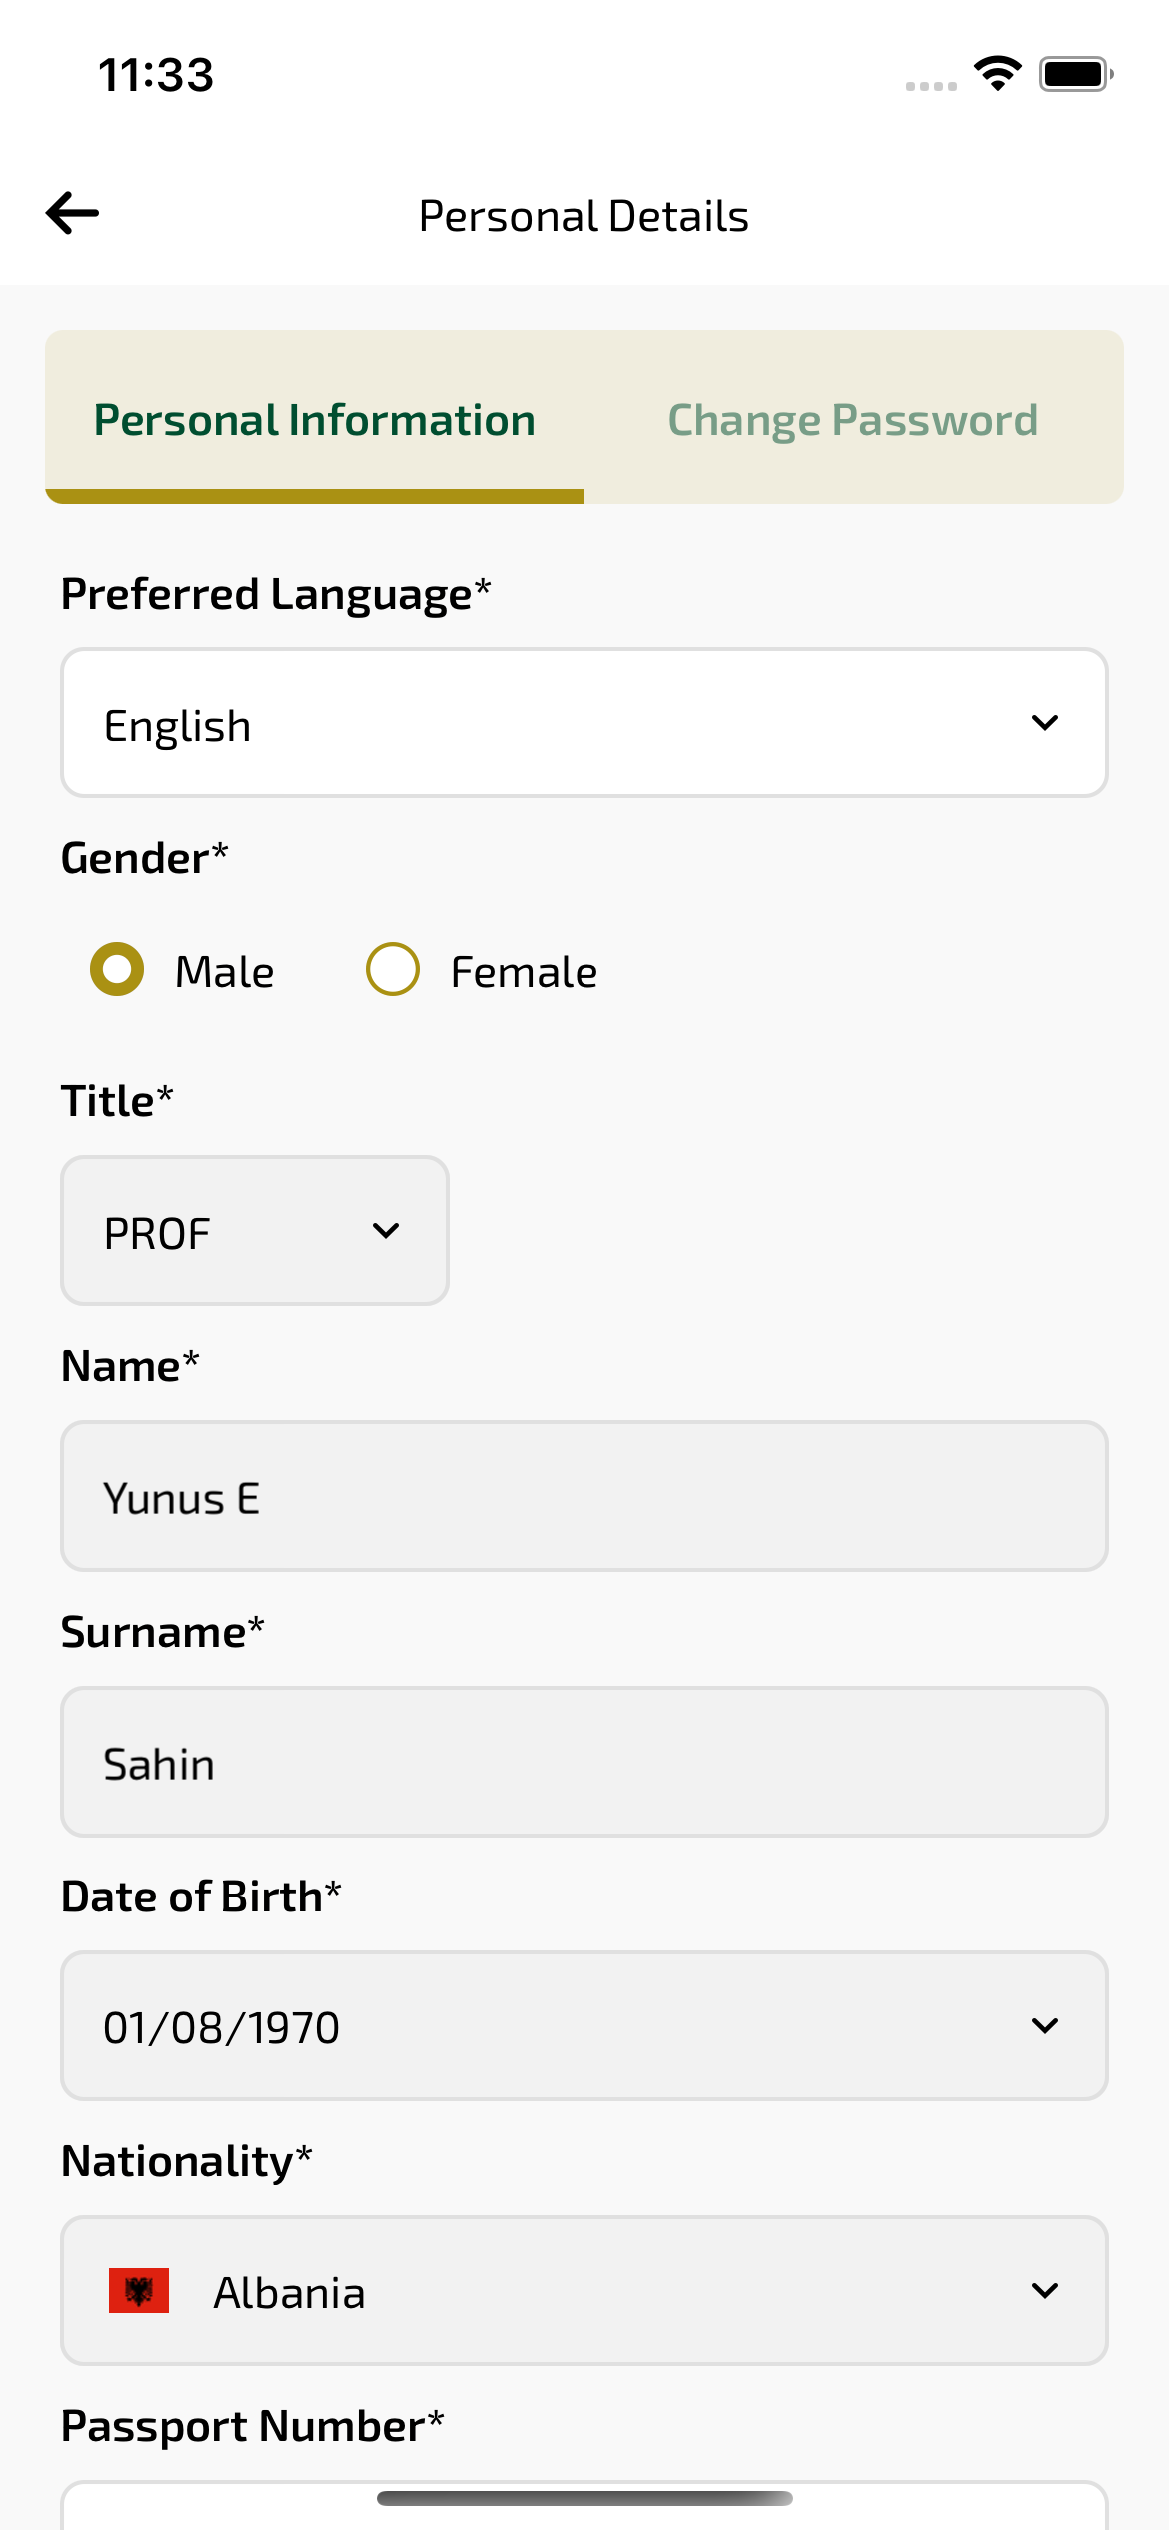
loyaltyPersonalInformation_ios sayfası ekran görüntüsü

