Accessibility ID Report — mbChangeContact_ios
Tarih: 31.03.2026 11:16 | Platform: iOS

Element ID | Page | Type | Label / Text | Value | Accessibility ID | Status | New Status
mbChangeContact_ios_element_1 | Change Contact | TextField | ABC | ABC | change_contact_text_field_givenName | ID Var
mbChangeContact_ios_element_2 | Change Contact | TextField | TEST | TEST | change_contact_text_field_surname | ID Var
mbChangeContact_ios_element_3 | Change Contact | TextField | yunus.sahin@testinium.com | yunus.sahin@testinium.com | change_contact_text_field_email | ID Var
mbChangeContact_ios_element_4 | Change Contact | TextField | 56 6666666 | 56 6666666 | change_contact_phone_input_value_phoneNumber | ID Var
mbChangeContact_ios_element_5 | Change Contact | Other |  |  | change_contact_back_button | ID Var
mbChangeContact_ios_element_6 | Change Contact | Other | Continue |  | change_contact_change_button | ID Var
mbChangeContact_ios_element_7 | Change Contact | Other |  |  | change_contact_phone_dial_code_phoneNumber | ID Var

📸 Ekran Görüntüsü
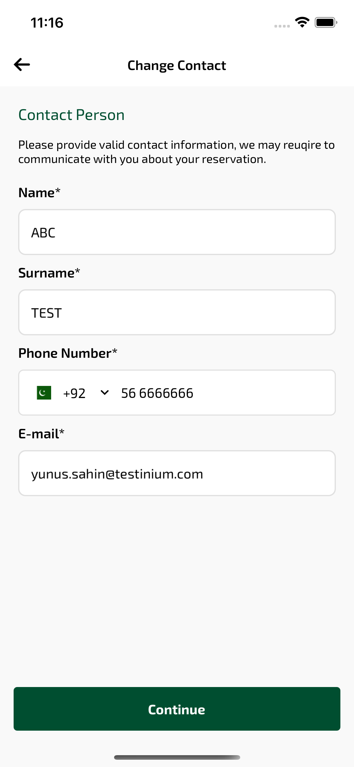
mbChangeContact_ios sayfası ekran görüntüsü

