Accessibility ID Report — mbMyFlights_ios
Tarih: 31.03.2026 11:15 | Platform: iOS

Element ID | Page | Type | Label / Text | Value | Accessibility ID | Status | New Status
mbMyFlights_ios_element_1 | Trip Details | Other | Karachi (KHI) to Faisalabad (LYP), Fri, 10 Apr - 21:00, 1h 45min - PK 340, ECONOMY, Direct |  |  | ID Yok | ID Eklenecek (Waiting Dev)
mbMyFlights_ios_element_2 | Trip Details | Other | My Flight(s) |  | mbk_home_switch_item | Duplicate | ID Eklenecek (Waiting Dev)
mbMyFlights_ios_element_3 | Trip Details | Other | Passengers |  | mbk_home_switch_item | Duplicate | ID Eklenecek (Waiting Dev)
mbMyFlights_ios_element_4 | Trip Details | Other |  |  | mbk_home_back_button | ID Var
mbMyFlights_ios_element_5 | Trip Details | Other | Change Flight |  | mbk_action_change_flight_button | ID Var
mbMyFlights_ios_element_6 | Trip Details | Other | Buy  Service+ |  | mbk_action_flight_extras_button | ID Var
mbMyFlights_ios_element_7 | Trip Details | Other | Cancel  Flight |  | mbk_action_cancel_flight_button | ID Var

📸 Ekran Görüntüsü
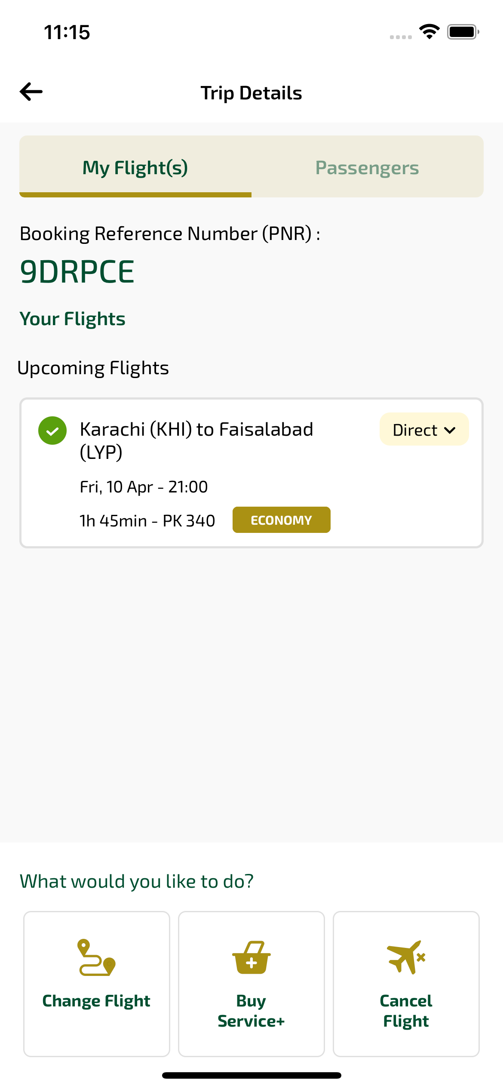
mbMyFlights_ios sayfası ekran görüntüsü

