Accessibility ID Report — mbPassengersSeeBoardingPass
Tarih: 31.03.2026 14:54 | Platform: iOS

Element ID | Page | Type | Label / Text | Value | Accessibility ID | Status | New Status
mbPassengersSeeBoardingPass_element_1 | Trip Details | Other | Abbas Doe, E-Ticket Number:, 2145581843135, Enter your Award Plus membership number, Award Plus Member ID, Add, Karachi - , Islamabad, Checked-in, See Boarding Pass, Included In Your Package, 20 KG, [missing "en~~~ssr_explanation_CTCR" translation] |  |  | ID Yok | ID Eklenecek (Waiting Dev)
mbPassengersSeeBoardingPass_element_2 | Trip Details | Other | Raja Doe, E-Ticket Number:, 2145581843136 |  |  | ID Yok | ID Eklenecek (Waiting Dev)
mbPassengersSeeBoardingPass_element_3 | Trip Details | Other | Muhammad Doe, E-Ticket Number:, 2145581843137 |  |  | ID Yok | ID Eklenecek (Waiting Dev)
mbPassengersSeeBoardingPass_element_4 | Trip Details | Other | Test Tessttt, +90 531 5554433, yunus.sahin@testinium.com, Change Contact Person |  |  | ID Yok | ID Eklenecek (Waiting Dev)
mbPassengersSeeBoardingPass_element_5 | Trip Details | Other | My Flight(s) |  | mbk_home_switch_item | Duplicate | ID Eklenecek (Waiting Dev)
mbPassengersSeeBoardingPass_element_6 | Trip Details | Other | Passengers |  | mbk_home_switch_item | Duplicate | ID Eklenecek (Waiting Dev)
mbPassengersSeeBoardingPass_element_7 | Trip Details | Other |  |  | mbk_home_back_button | ID Var

📸 Ekran Görüntüsü
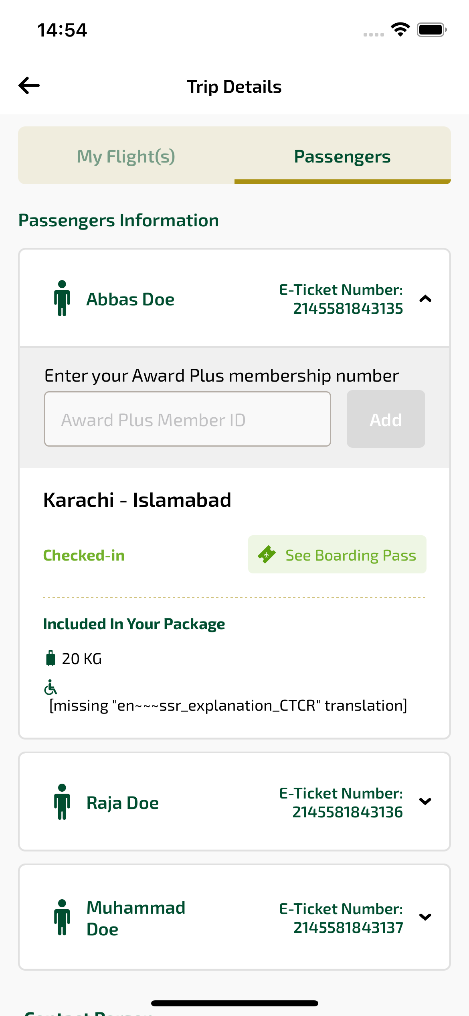
mbPassengersSeeBoardingPass sayfası ekran görüntüsü

