Accessibility ID Report — mbPassengersTab_ios
Tarih: 31.03.2026 11:16 | Platform: iOS

Element ID | Page | Type | Label / Text | Value | Accessibility ID | Status | New Status
mbPassengersTab_ios_element_1 | Trip Details | Other | Abc Test, E-Ticket Number:, 2142431220405, Enter your Award Plus membership number, Add, Karachi - , Faisalabad, Not Checked-in, Check-in Unavailable, Flight Extras, 4A, 5 KG |  |  | ID Yok | ID Eklenecek (Waiting Dev)
mbPassengersTab_ios_element_2 | Trip Details | Other | Ddf Fgt, E-Ticket Number:, 2142431220406 |  |  | ID Yok | ID Eklenecek (Waiting Dev)
mbPassengersTab_ios_element_3 | Trip Details | Other | Rrr Cff, E-Ticket Number:, 2142431220407 |  |  | ID Yok | ID Eklenecek (Waiting Dev)
mbPassengersTab_ios_element_4 | Trip Details | Other | Ggg Fff, E-Ticket Number:, 2142431220408 |  |  | ID Yok | ID Eklenecek (Waiting Dev)
mbPassengersTab_ios_element_5 | Trip Details | Other | Abc Test, +92 56 6666666, yunus.sahin@testinium.com, Change Contact Person |  |  | ID Yok | ID Eklenecek (Waiting Dev)
mbPassengersTab_ios_element_6 | Trip Details | Other | My Flight(s) |  | mbk_home_switch_item | Duplicate | ID Eklenecek (Waiting Dev)
mbPassengersTab_ios_element_7 | Trip Details | Other | Passengers |  | mbk_home_switch_item | Duplicate | ID Eklenecek (Waiting Dev)
mbPassengersTab_ios_element_8 | Trip Details | Other |  |  | mbk_home_back_button | ID Var

📸 Ekran Görüntüsü
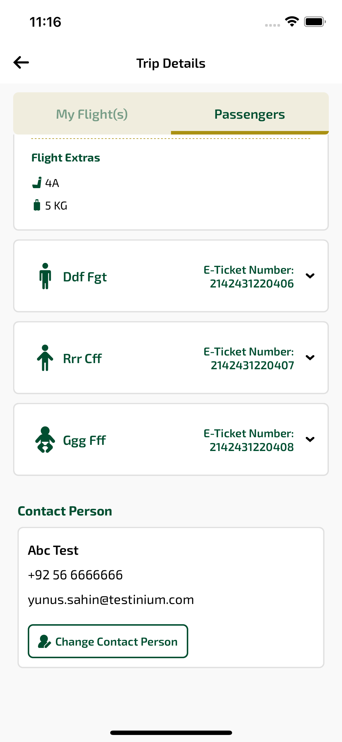
mbPassengersTab_ios sayfası ekran görüntüsü

