Accessibility ID Report — passengersDetailAdult2_ios
Tarih: 31.03.2026 00:34 | Platform: IOS

Element ID | Page | Type | Label / Text | Value | Accessibility ID | Status | New Status
passengersDetailAdult2_ios_element_1 | Passengers | Other |  |  |  | ID Yok | ID Eklenecek (Waiting Dev)
passengersDetailAdult2_ios_element_2 | Passengers | Other | Log in |  |  | ID Yok | ID Eklenecek (Waiting Dev)
passengersDetailAdult2_ios_element_3 | Passengers | Other | Flight Schedule |  |  | ID Yok | ID Eklenecek (Waiting Dev)
passengersDetailAdult2_ios_element_4 | Passengers | Other | Flight Status |  |  | ID Yok | ID Eklenecek (Waiting Dev)
passengersDetailAdult2_ios_element_5 | Passengers | Other | Feedback |  |  | ID Yok | ID Eklenecek (Waiting Dev)
passengersDetailAdult2_ios_element_6 | Passengers | Other | Notifications |  |  | ID Yok | ID Eklenecek (Waiting Dev)
passengersDetailAdult2_ios_element_7 | Passengers | Other | Gift Card |  |  | ID Yok | ID Eklenecek (Waiting Dev)
passengersDetailAdult2_ios_element_8 | Passengers | Other | Settings |  |  | ID Yok | ID Eklenecek (Waiting Dev)
passengersDetailAdult2_ios_element_9 | Passengers | Other | Contact us |  |  | ID Yok | ID Eklenecek (Waiting Dev)
passengersDetailAdult2_ios_element_10 | Passengers | Other | Total , 188.34EUR |  |  | ID Yok | ID Eklenecek (Waiting Dev)
passengersDetailAdult2_ios_element_11 | Passengers | Other | Save Passenger Info |  |  | ID Yok | ID Eklenecek (Waiting Dev)
passengersDetailAdult2_ios_element_12 | Passengers | Other | Select as a Contact Person |  |  | ID Yok | ID Eklenecek (Waiting Dev)
passengersDetailAdult2_ios_element_13 | Passengers | Other | Adult 1 |  | pax_form_tab_bar_item | Duplicate | ID Eklenecek (Waiting Dev)
passengersDetailAdult2_ios_element_14 | Passengers | Other | Adult 2 |  | pax_form_tab_bar_item | Duplicate | ID Eklenecek (Waiting Dev)
passengersDetailAdult2_ios_element_15 | Passengers | Other | Child 1 |  | pax_form_tab_bar_item | Duplicate | ID Eklenecek (Waiting Dev)
passengersDetailAdult2_ios_element_16 | Passengers | Other | Infant 1 |  | pax_form_tab_bar_item | Duplicate | ID Eklenecek (Waiting Dev)
passengersDetailAdult2_ios_element_17 | Passengers | Other | Contact Person |  | pax_form_tab_bar_item | Duplicate | ID Eklenecek (Waiting Dev)
passengersDetailAdult2_ios_element_18 | Passengers | TextField | Ddf | Ddf | pax_form_text_field_givenName | ID Var
passengersDetailAdult2_ios_element_19 | Passengers | TextField | Fgt | Fgt | pax_form_text_field_surname | ID Var
passengersDetailAdult2_ios_element_20 | Passengers | TextField | p1 | p1 | pax_form_text_field_passportNumber | ID Var
passengersDetailAdult2_ios_element_21 | Passengers | TextField | Award Plus Member ID | Award Plus Member ID | pax_form_text_field_membershipId | ID Var
passengersDetailAdult2_ios_element_22 | Passengers | Other |  |  | pax_form_back_button | ID Var
passengersDetailAdult2_ios_element_23 | Passengers | Other | Proceed to  Passenger 3 |  | pax_form_continue_button | ID Var
passengersDetailAdult2_ios_element_24 | Passengers | Other |  |  | pax_form_menu_card_title | ID Var
passengersDetailAdult2_ios_element_25 | Passengers | Other | Date of Birth* |  | pax_form_date_card_birthDate | ID Var
passengersDetailAdult2_ios_element_26 | Passengers | Other | Nationality* |  | pax_form_country_card_nationality | ID Var
passengersDetailAdult2_ios_element_27 | Passengers | Other | Passport Issue Country* |  | pax_form_country_card_docIssueCountry | ID Var
passengersDetailAdult2_ios_element_28 | Passengers | Other | Passport Expire Date* |  | pax_form_date_card_docExpireDate | ID Var
passengersDetailAdult2_ios_element_29 | Passengers | Other | Medical Assistance |  | pax_form_special_assistance | ID Var

📸 Ekran Görüntüsü
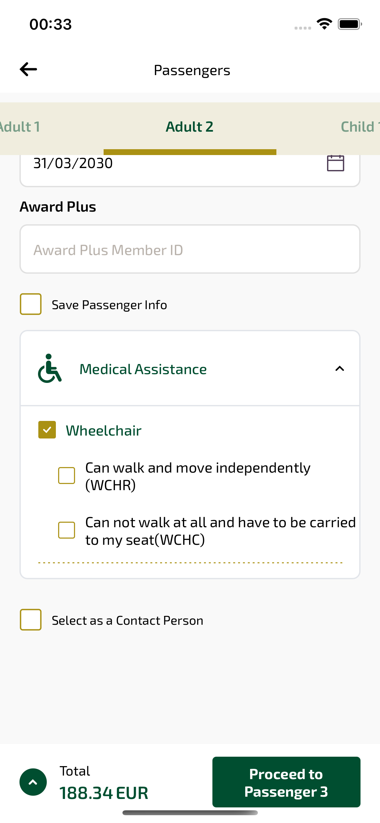
passengersDetailAdult2_ios sayfası ekran görüntüsü

