Accessibility ID Report — rtFlightSearch_ios
Tarih: 31.03.2026 00:22 | Platform: IOS

Element ID | Page | Type | Label / Text | Value | Accessibility ID | Status | New Status
rtFlightSearch_ios_element_1 | Book a Flight | Button | HOME, tab, 1 of 5 |  |  | ID Yok | ID Eklenecek (Waiting Dev)
rtFlightSearch_ios_element_2 | Book a Flight | Button | AVAILABILITY_SEARCH, tab, 2 of 5 | 1 |  | ID Yok | ID Eklenecek (Waiting Dev)
rtFlightSearch_ios_element_3 | Book a Flight | Button | MY_TRIPS_INITIAL, tab, 3 of 5 |  |  | ID Yok | ID Eklenecek (Waiting Dev)
rtFlightSearch_ios_element_4 | Book a Flight | Button | CHECKIN, tab, 4 of 5 |  |  | ID Yok | ID Eklenecek (Waiting Dev)
rtFlightSearch_ios_element_5 | Book a Flight | Button | LOYALTY, tab, 5 of 5 |  |  | ID Yok | ID Eklenecek (Waiting Dev)
rtFlightSearch_ios_element_6 | Book a Flight | Other | Bottom Sheet |  |  | ID Yok | ID Eklenecek (Waiting Dev)
rtFlightSearch_ios_element_7 | Book a Flight | Other |  |  |  | ID Yok | ID Eklenecek (Waiting Dev)
rtFlightSearch_ios_element_8 | Book a Flight | Other |  |  |  | ID Yok | ID Eklenecek (Waiting Dev)
rtFlightSearch_ios_element_9 | Book a Flight | Other | Log in |  |  | ID Yok | ID Eklenecek (Waiting Dev)
rtFlightSearch_ios_element_10 | Book a Flight | Other | Flight Schedule |  |  | ID Yok | ID Eklenecek (Waiting Dev)
rtFlightSearch_ios_element_11 | Book a Flight | Other | Flight Status |  |  | ID Yok | ID Eklenecek (Waiting Dev)
rtFlightSearch_ios_element_12 | Book a Flight | Other | Feedback |  |  | ID Yok | ID Eklenecek (Waiting Dev)
rtFlightSearch_ios_element_13 | Book a Flight | Other | Notifications |  |  | ID Yok | ID Eklenecek (Waiting Dev)
rtFlightSearch_ios_element_14 | Book a Flight | Other | Gift Card |  |  | ID Yok | ID Eklenecek (Waiting Dev)
rtFlightSearch_ios_element_15 | Book a Flight | Other | Settings |  |  | ID Yok | ID Eklenecek (Waiting Dev)
rtFlightSearch_ios_element_16 | Book a Flight | Other | Contact us |  |  | ID Yok | ID Eklenecek (Waiting Dev)
rtFlightSearch_ios_element_17 | Book a Flight | Other |  |  |  | ID Yok | ID Eklenecek (Waiting Dev)
rtFlightSearch_ios_element_18 | Book a Flight | Other | Information for Credit Card Holders |  |  | ID Yok | ID Eklenecek (Waiting Dev)
rtFlightSearch_ios_element_19 | Book a Flight | Other | Long Lon Long Operational Notice One Two |  |  | ID Yok | ID Eklenecek (Waiting Dev)
rtFlightSearch_ios_element_20 | Book a Flight | Other | Test Operational Notice For Testing In UAT1 Test Operational Notice For Testing In UAT2 |  |  | ID Yok | ID Eklenecek (Waiting Dev)
rtFlightSearch_ios_element_21 | Book a Flight | Other |  |  |  | ID Yok | ID Eklenecek (Waiting Dev)
rtFlightSearch_ios_element_22 | Book a Flight | Other | One Way |  | avail_selection_switch_item | Duplicate | ID Eklenecek (Waiting Dev)
rtFlightSearch_ios_element_23 | Book a Flight | Other | Round Trip |  | avail_selection_switch_item | Duplicate | ID Eklenecek (Waiting Dev)
rtFlightSearch_ios_element_24 | Book a Flight | Other | Multi City |  | avail_selection_switch_item | Duplicate | ID Eklenecek (Waiting Dev)
rtFlightSearch_ios_element_25 | Book a Flight | Other | Passengers, 2 Adult, , 1 Child, , 1 Infant |  | avail_search_pax_count_card | Duplicate | ID Eklenecek (Waiting Dev)
rtFlightSearch_ios_element_26 | Book a Flight | Other | Class, Economy |  | avail_search_pax_count_card | Duplicate | ID Eklenecek (Waiting Dev)
rtFlightSearch_ios_element_27 | Book a Flight | Other |  |  | pax_count_picker_dec_button_ADLT | ID Var
rtFlightSearch_ios_element_28 | Book a Flight | Other |  |  | pax_count_picker_inc_button_ADLT | ID Var
rtFlightSearch_ios_element_29 | Book a Flight | Other |  |  | pax_count_picker_dec_button_CHLD | ID Var
rtFlightSearch_ios_element_30 | Book a Flight | Other |  |  | pax_count_picker_inc_button_CHLD | ID Var
rtFlightSearch_ios_element_31 | Book a Flight | Other |  |  | pax_count_picker_dec_button_INFT | ID Var
rtFlightSearch_ios_element_32 | Book a Flight | Other |  |  | pax_count_picker_inc_button_INFT | ID Var
rtFlightSearch_ios_element_33 | Book a Flight | Other | Done |  | pax_count_picker_done_button | ID Var
rtFlightSearch_ios_element_34 | Book a Flight | Other | Search |  | avail_search_search_flight_button | ID Var
rtFlightSearch_ios_element_35 | Book a Flight | Other | Departure Date, Sat, 09 May |  | avail_search_dep_date_card | ID Var
rtFlightSearch_ios_element_36 | Book a Flight | Other | Return Date, Sun, 17 May |  | avail_search_ret_date_card | ID Var
rtFlightSearch_ios_element_37 | Book a Flight | Other | Departure, Karachi - Karachi Jinnah International Airport(KHI) |  | avail_search_dep_port_card | ID Var
rtFlightSearch_ios_element_38 | Book a Flight | Other | Arrival, Faisalabad - Faisalabad International Airport(LYP) |  | avail_search_arr_port_card | ID Var

📸 Ekran Görüntüsü
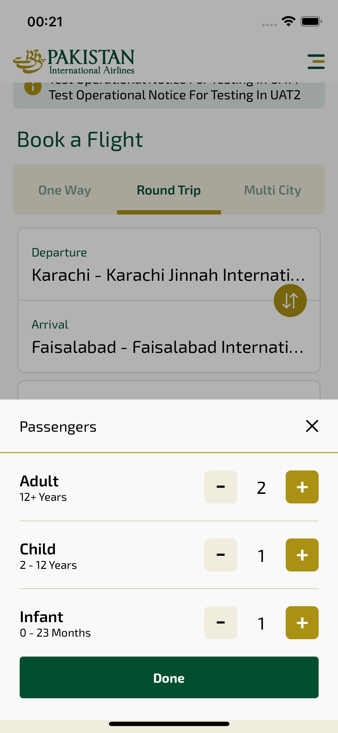
rtFlightSearch_ios sayfası ekran görüntüsü

