Accessibility ID Report — seatSelect_ios
Tarih: 31.03.2026 00:50 | Platform: IOS

Element ID | Page | Type | Label / Text | Value | Accessibility ID | Status | New Status
seatSelect_ios_element_1 | Seat Selection | Other | Bottom Sheet |  |  | ID Yok | ID Eklenecek (Waiting Dev)
seatSelect_ios_element_2 | Seat Selection | Other | 4B |  |  | ID Yok | ID Eklenecek (Waiting Dev)
seatSelect_ios_element_3 | Seat Selection | Other |  |  |  | ID Yok | ID Eklenecek (Waiting Dev)
seatSelect_ios_element_4 | Seat Selection | Other | Log in |  |  | ID Yok | ID Eklenecek (Waiting Dev)
seatSelect_ios_element_5 | Seat Selection | Other | Flight Schedule |  |  | ID Yok | ID Eklenecek (Waiting Dev)
seatSelect_ios_element_6 | Seat Selection | Other | Flight Status |  |  | ID Yok | ID Eklenecek (Waiting Dev)
seatSelect_ios_element_7 | Seat Selection | Other | Feedback |  |  | ID Yok | ID Eklenecek (Waiting Dev)
seatSelect_ios_element_8 | Seat Selection | Other | Notifications |  |  | ID Yok | ID Eklenecek (Waiting Dev)
seatSelect_ios_element_9 | Seat Selection | Other | Gift Card |  |  | ID Yok | ID Eklenecek (Waiting Dev)
seatSelect_ios_element_10 | Seat Selection | Other | Settings |  |  | ID Yok | ID Eklenecek (Waiting Dev)
seatSelect_ios_element_11 | Seat Selection | Other | Contact us |  |  | ID Yok | ID Eklenecek (Waiting Dev)
seatSelect_ios_element_12 | Seat Selection | Other |  |  |  | ID Yok | ID Eklenecek (Waiting Dev)
seatSelect_ios_element_13 | Seat Selection | Other | Total , 181.87EUR |  |  | ID Yok | ID Eklenecek (Waiting Dev)
seatSelect_ios_element_14 | Seat Selection | Other | Karachi (KHI) to Faisalabad (LYP), Fri, 10 Apr - 21:00 |  |  | ID Yok | ID Eklenecek (Waiting Dev)
seatSelect_ios_element_15 | Seat Selection | Other | Change |  | seat_selection_seat_change_button_abc_test | ID Var
seatSelect_ios_element_16 | Seat Selection | Other | Assign Seat |  | seat_selection_seat_assign_button_ddf_fgt | ID Var
seatSelect_ios_element_17 | Seat Selection | Other | Assign Seat |  | seat_selection_seat_assign_button_rrr_cff | ID Var
seatSelect_ios_element_18 | Seat Selection | Other |  |  | seat_selection_back_button | ID Var
seatSelect_ios_element_19 | Seat Selection | Other | Continue |  | seat_selection_continue_button | ID Var

📸 Ekran Görüntüsü
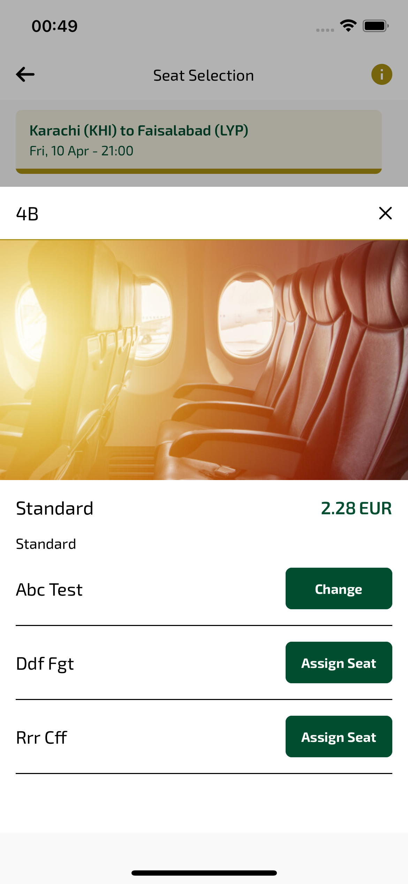
seatSelect_ios sayfası ekran görüntüsü

